

**CAPSTONE PROJECT REPORT**

**Report 3 – Software Requirement Specification**

– Ho Chi Minh, September 2023 –

**Table of Contents**

I. Record of Changes 3

II. Software Requirement Specification 4

1. Product Overview 4

2. User Requirements 5

2.1 Actors 5

2.2 Use Cases 6

3. Functional Requirements 15

3.1 System Functional Overview 15

3.2 Web Application 60

4. Non-Functional Requirements 143

4.1 External Interfaces 143

4.2 Quality Attributes 143

5. Requirement Appendix 144

5.1 Business Rules 144

5.2 Common Requirements 145

# I. Record of Changes

| **Date** | **A* M, D** | **In charge** | **Change Description** |
| --- | --- | --- | --- |
|  |  |  |  |
|  |  |  |  |
|  |  |  |  |
|  |  |  |  |
|  |  |  |  |
|  |  |  |  |
|  |  |  |  |
|  |  |  |  |
|  |  |  |  |
|  |  |  |  |
|  |  |  |  |
|  |  |  |  |
|  |  |  |  |

*A - Added M - Modified D - Deleted

# II. Software Requirement Specification

## 1. Product Overview

The Science Research Activity Support System (SRASS) was designed to meet the specific requirements of the FPT University, Ho Chi Minh Campus's Library and Research Department, primarily focusing on streamlining the management of scientific conferences, with the initial deployment taking place at the HCM Campus. The context diagram below outlines the external entities and system interfaces involved. The system's objective is to facilitate conference management activities and effectively coordinate various aspects such as paper submission, review management, decision-making, manuscript submission, and conference progress tracking.

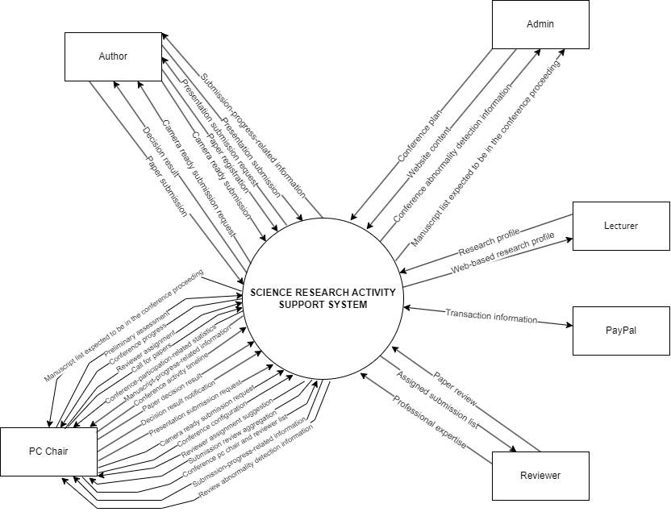

## 2. User Requirements

**2.1 Actors**

| **#** | **Actor** | **Description** |
| --- | --- | --- |
| 1 | Unauthenticated user | An unauthenticated user is a person who has not logged in the SRASS. An unauthenticated user has limited permission to some functions, only:  + Sign up  + Login |
| 2 | Authenticated user | An authenticated user is a person who has logged in to the SRASS. An authenticated user has permission with the following functions:  + Get conference list  + Get action reminder message  + Logout |
| 3 | Admin | An admin is an authenticated user who has the authority to initialize a conference based on the conference plan. An admin has permission with the following functions:  + Initialize conference  + Create a conference's website content  + Export a conference website's content  + Export conference reports |
| 4 | PC chair | A PC chair is an authenticated user who has the authority to monitor and manage the conference from the initial phase up to the end of the conference. A PC chair has permission with the following functions:  + Acquire conference summary  + Modify a conference's track list  + Create a track plan  + Update a track's activity timeline  + Adjust conference general settings (is the PC chair is a chair)  + Adjust track settings  + Get list of conference users  + Define a track's subject area list  + Call for papers  + Submit a conference paper  + Aggregate list of conference submissions  + Make statistical information about conference submissions  + View a submission summary  + Desk check a submission  + Invite a reviewer  + View the reviewer invitation list  + Get list of recommended reviewers for a submission  + Assign reviewers to submission evaluation  + View aggregation reviews of a submission  + Decide on paper  + Set up email templates  + Notify result to authors  + Request for camera ready submission  + View order  + Aggregate list of conference manuscripts  + Make statistical information about conference manuscripts  + Request for presentation submission  + Track essential activities and tasks  + Export conference reports |
| 5 | Author | An author is an authenticated user who wants or has submitted papers to a conference. An author has permission with the following functions:  + Submit a conference paper  + Declare submission conflicts of interest  + Submit supplementary materials  + Get the list of author submissions  + View a submission summary  + Upload revision  + Upload camera-ready  + Register an author's qualified papers  + View order  + Get an author's list of registered papers  + Upload presentation |
| 6 | Reviewer | A reviewer is an authenticated user who joins a conference as a reviewer to evaluate assigned submissions. A reviewer has permission with the following functions:  + Specifying reviewing information  + Get list submission assigned to reviewer  + Enter review  + Declare reviewer conflicts of interest |
| 7 | Research lecturer | A research lecturer is an authenticated user who has registered the email of the domain "fe.edu.vn". A research lecturer has  permission with the following functions:  + Input research profile information  + View the research profile |
| 8 | System handler | A system handler is a system actor that performs some system's special tasks. These tasks include:  + Update automatically conference progress over time  + Detect submission conflicts of interest  + Detect reviewer conflicts of interest  + Detect potential review issues of conferences |

### 2.2 Use Cases

#### 2.2.1 Diagram(s)

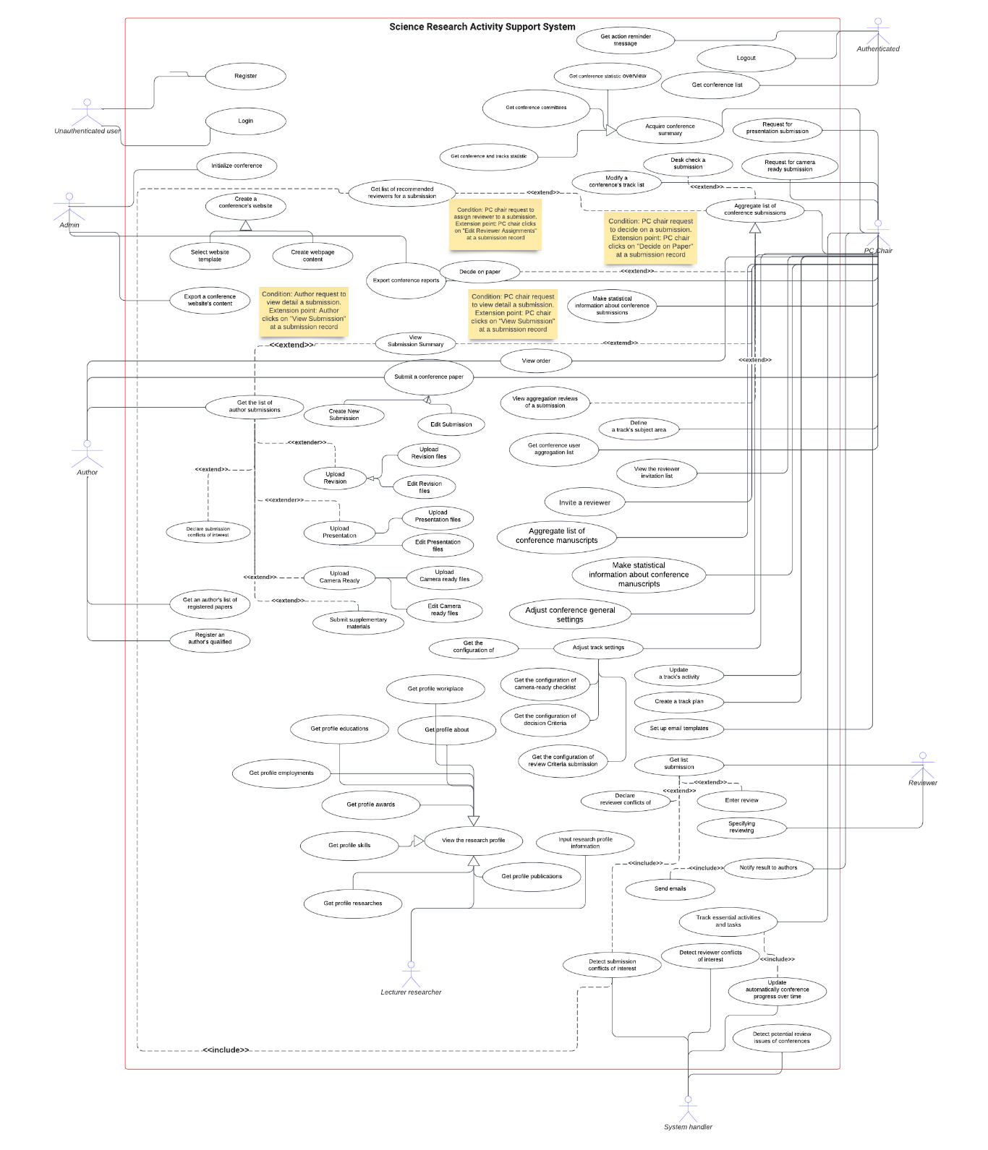

#### 2.2.2 Descriptions

| **ID** | **Use cases** | **Actors** | **Use case description** |
| --- | --- | --- | --- |
| 1 | Sign up | Unauthenticated user | This use case allows an unauthenticated user to sign up for an account that is later used to log in to the system to gain access to other functionality. Email confirmation is required to fulfill sign-up activity. |
| 2 | Login | Unauthenticated user | This use case allows an unauthenticated user to log in with their active account to gain access to other functionality of the system. |
| 3 | Logout | Authenticated user | This use case allows an authenticated user to log out of the system. |
| 4 | Get conference list | Authenticated user | This use case allows an authenticated user to access the list of conferences with their brief information on each conference role. |
| 5 | Initialize conference | Admin | This use case allows an admin to initialize a conference from its conference plan to ensure its authenticity |
| 6 | Create a conference's website content | Admin | This use case allows an admin to initialize a conference website content which includes the following actions:  + Select a website template  + Create the website navbar  + Fill the website content |
| 7 | Export a conference website's content | Admin | This use case allows an admin to export the website content created from the [Create a conference's website content] use cases to ready-to-deploy HTML files |
| 8 | Export conference reports | Admin, PC chair | This use case allows: + An admin to download the final zip files, including:  - The final aggregation report of the conference program committee and conference manuscripts expected to be in the conference proceeding  - The files attachment of conference manuscripts expected to be in the conference proceeding + A PC chair to download zip files, including:  - The aggregation report of the conference manuscripts which are expected to be in the conference proceeding  - The corresponding manuscript files attachment |
| 9 | Acquire conference summary | PC chair | This use case allows a PC chair to get the conference summary, including: overview information, program committee, participation information of submissions and reviewers |
| 10 | Modify a conference's track list | PC chair | This use case allows a PC chair to modify the track list of a conference: + Add a new track + Update track name + Delete a track if the track does not have any related incumbents |
| 11 | Create a track plan | PC chair | This use case allows a PC chair to define the chronological schedule of track phases. The number of revisions MUST be stipulated first. |
| 12 | Update a track's activity timeline | PC chair | This use case allows a PC chair to update deadlines in a track activity timeline: + Extend a deadline + Complete explicitly a phase |
| 13 | Adjust track settings | PC chair | This use case allows a PC chair to adjust the track-related settings, which include:  + Submission instruction + Submission questions + Submission settings + Review criteria + Decision checklist + Factors affecting selection + Factors for disqualifying papers + Camera ready settings + Camera ready checklist + Presentation settings + Subject area relevance coefficients |
| 14 | Adjust conference general settings | Chair | This use case allows a chair to adjust the general settings, which include: + Registration settings + Review issue detection settings |
| 15 | Get list of conference users | PC chair | This use case allows a PC chair to: + Get statistical information about conference users + Get conference user list |
| 16 | Define a list of a track's subject areas | PC chair | This use case allows a PC chair to take the following actions to define a track's subject area list: + Add a subject area + Update a subject area + Delete a subject area if this subject area is not involved with any submissions |
| 17 | Update automatically conference progress over time | System handler | In this use case, the system will automatically update the current phase of tracks immediately after the deadline. |
| 18 | Call for papers | PC chair | This use case allows a PC chair to import a list of emails to which he wants to send the invitation email (call for papers email) that announces an upcoming conference and invites researchers to submit their work for consideration. This use case can also be enhanced by updating the call-for-papers-related content on the conference website for publicity. |
| 19 | Submit a conference paper | Author, PC chair | This use case allows: + An author to submit papers when a conference is open for submission + A PC chair to submit conference papers on behalf of the authors when necessary |
| 20 | Detect submission conflicts of interest | System handler | In this use case, the system will automatically detect the following potential conflicts of interest between a reviewer of the conference and submissions: + Has (a) domain conflicts + Is an author/co-author |
| 21 | Declare submission conflicts of interest | Author | This use case allows an author to declare conflicts of interest between their submission and reviewers of the conference. Each conflict of interest can be one of the following cases: + Is an author/co-author + Is a relative or a friend + Is/Was a Primary Thesis Advisor at any time + Is/Was a colleague (in last 2 years) + Is/Was a collaborator (in last 2 years) + Has (a) domain conflicts |
| 22 | Submit supplementary materials | Author | This use case allows an author to submit supplementary materials for their submission. |
| 23 | Aggregate list of conference submissions | PC chair | This use case allows a PC chair to access the list of submissions aggregated with the following information:  - Basic information (title, abstract, authors, subject areas)  - Track  - Number of conflicts of interest (submission conflicts of interest, reviewer conflicts of interest)  - Reviewer assignments  - Reviewing progress  - Review average score  - Status and notified status  - Request for camera-ready submission |
| 24 | Make statistical information about conference submissions | PC Chair | This use case allows a PC chair to access the following statistical information on paper-submission-related activities: + Overview:  - Total number of submissions + Review: number of  - Papers  - Papers assigned to reviewers  - Papers not assigned to reviewers  - Review paper complete  - Review paper incomplete + Statuses: number of  - Papers awaiting decision  - Desk rejected papers  - Accepted papers  - Revision papers  - Rejected papers + Notified statuses: number of  - Paper awaiting decision  - Desk rejected papers  - Accepted papers  - Revision papers  - Rejected papers + Revision: number of  - papers with submitted revisions  - papers without revisions + Camera ready:  - Number of requested camera-ready submission papers |
| 25 | Get the list of an author's submissions | Author | This use case allows an author to access the list of their submissions with the following information:  - Basic information (title, abstract, authors, subject areas)  - Track  - Submitted files  - Notified status  - Action(s) needed to be done and the deadline for the action(s) |
| 26 | View a submission summary | Author, PC chair | This use case allows an author or PC chair to view a submission summary that summarizes the following information: + Conference and track that the conference paper submitted to + Submission's basic information (ID, title, abstract, creation time, authors, subject areas) + Submission's conflicts of interest + Supplementary materials + Last revision files + Camera-ready and copyright files + Presentation files + Submission questions response |
| 27 | Desk check a submission | PC chair | This use case allows a PC chair to perform the initial evaluation in terms of suitability, compliance, plagiarism, and other basic requirements before the formal review for each submission |
| 28 | Invite a reviewer | PC chair | This use case allows a PC chair to invite a reviewer for a track via email. |
| 29 | View the list of invited reviewers | PC chair | This use case allows a PC chair to access the list of invited reviewers |
| 30 | Specifying reviewing information | Reviewer | This use case allows a reviewer to specify their reviewing information (quotas, subject areas) when assuming the role of reviewer for participating tracks |
| 31 | Get list of recommended reviewers for a submission | PC chair | This use case allows a PC chair to access the list of arranged reviewer list in descending order of recommendation level. The basic idea for the arrangement follows the algorithm specified at [ALG-02]. |
| 32 | Assign reviewers to submission evaluation | PC chair | This use case allows a PC chair to assign reviewers to the evaluation of submissions based on review criteria that are predefined by PC chairs. |
| 33 | Retrieve the list of submissions assigned to a reviewer | Reviewer | This use case allows a reviewer to access the list of assigned papers, along with the following information:  - Basic information (title, abstract, authors, subject areas)  - Track  - Submission files and attachments  - Action(s) needed to be done and the deadline for the action(s) |
| 34 | Enter review | Reviewer | This use case allows a reviewer to enter their review for an assigned submission. The following information is included in a review: + Evaluation score based on review criteria + Suggestion for chair + Comment to authors |
| 35 | Detect reviewer conflicts of interest | System handler | In this use case, the system will automatically detect the following potential cases of conflicts of interest between a reviewer of the conference and submissions: + Has (a) domain conflicts + Is an author/co-author |
| 36 | Declare reviewer conflicts of interest | Reviewer | This use case allows a reviewer to declare conflicts of interest between the reviewer and their assigned papers. Each conflict of interest can be in one of the following cases: + Is an author/co-author + Is a relative or a friend + Is/Was a Primary Thesis Advisor at any time + Is/Was a colleague (in last 2 years) + Is/Was a collaborator (in last 2 years) + Has (a) domain conflicts |
| 37 | Detect potential review issues of conferences | System handler | In this use case, the system will automatically detect potential review issues of ongoing conferences based on the algorithm specified at [ALG-03]. |
| 38 | View aggregation reviews of a submission | PC chair | This use case allows a PC chair to view all submitted reviews from assigned reviewers. This use case is required to take action before the [Decide on paper] use case takes action. |
| 39 | Decide on paper | PC chair | This use case allows a PC chair to decide on one of the following paper statuses for each paper: + Accept + Reject + Revision |
| 40 | Set up email templates | PC chair | This use case allows a PC chair to set up email templates to: + Call for papers + Notify results to authors |
| 41 | Notify results to authors | PC chair | This use case allows a PC chair to notify the decision result for each submission to its author(s) via email. This action also updates the notified status of the submission. |
| 42 | Upload revision | Author | This use case allows an author to upload revision files for a submission. |
| 43 | Request for camera ready submission | PC chair | This use case allows a PC chair to request for camera-ready submission for qualified conference papers |
| 44 | Upload camera ready | Author | This use case allows an author to upload a camera-ready version of a paper when it is requested by a PC chair. The copyright file also needs to be attached when taking this action. |
| 45 | Register an author's qualified papers | Author | This use case allows an author to register their already-camera-ready-submitted papers to the list of expected-to-be-in-the-conference-proceeding manuscripts |
| 46 | View order | Author, PC chair | This use case allows an author or a PC chair to view the order of papers registration's payment. |
| 47 | Get an author's list of registered papers | Author | This use case allows an author to access the list of their successfully registered papers. |
| 48 | Aggregate list of conference manuscripts | PC chair | This use case allows a PC chair to access the list of conference manuscripts aggregated with the following information: + Basic information (title, abstract, authors, subject areas) + Track + Camera-ready submission status + Registration status + Presentation submission status |
| 49 | Make statistical information about conference manuscripts | PC chair | This use case allows a PC chair to access the following statistical information on conference-manuscripts-related activities: + Camera ready: number of  - Camera-ready requested papers  - Camera-ready submitted  - Camera-ready not yet submitted + Revision: number of  - Registered papers  - Unregistered papers + Presentation: number of  - Presentation requested papers  - Presentation submitted  - Presentation not yet submitted |
| 50 | Request for presentation submission | PC chair | This use case allows a PC chair to request for presentation submission for qualified conference papers |
| 51 | Upload presentation | Author | This use case allows an author to upload presentation files for a conference paper. Specifying presenter(s) is also required when taking this action. |
| 52 | Get action reminder message | Authenticated user | This use case allows an authenticated user to get an action reminder message, which suggests the necessary actions to be taken. |
| 53 | Track essential activities and tasks | PC chair | This use case allows a PC chair to utilize the "Light bulb" feature to keep track of the activities and tasks required during any conference phase. This feature presents to a PC chair the following information: + The current phase of the conference + The upcoming phase + A list of minimal tasks to be completed during that phase + Links to tasks completed in previous phases |
| 54 | Input research profile information | Research lecturer | This use case allows a research lecturer to input the following information about a research profile: + Basic overview information  + Workplace  + Education  + Employment  + Scholarships  + Awards  + Skills  + Researchers  + Publications |
| 55 | View the research profile | Research lecturer | This use case allows a research lecturer to access the research profile they created from the [Input research profile information] use case. The profile is expected to include the following information: + Basic overview information  + Workplace  + Education  + Employment  + Scholarships  + Awards  + Skills  + Researchers  + Publications |

## 3. Functional Requirements

### 3.1 System Functional Overview

#### 3.1.1 Screens Flow

##### 3.1.1.1 Screens Flow – PC Chair

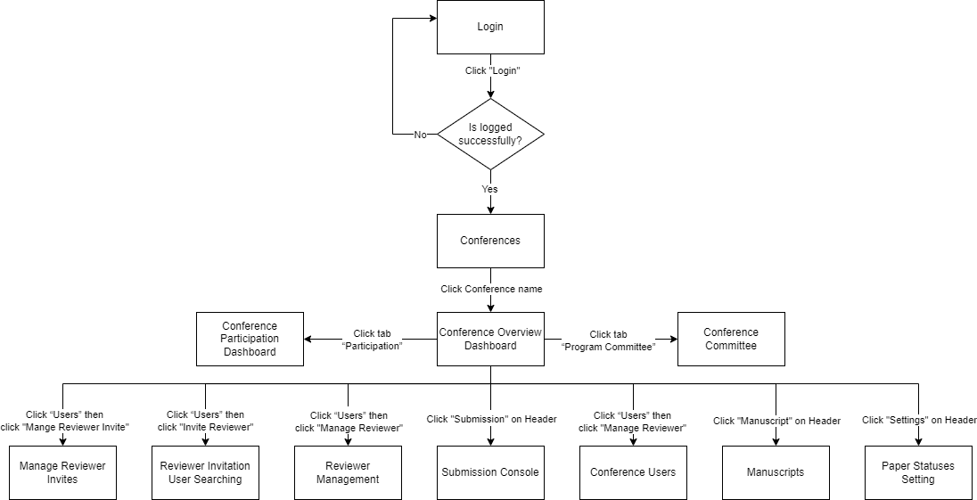

###### 3.1.1.1.1 Reviewer Invitation User Searching

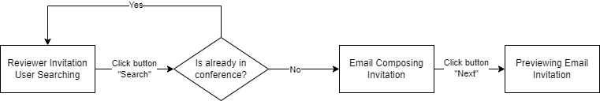

###### 3.1.1.1.2 Reviewer Management

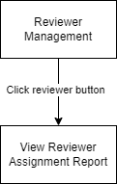

###### 3.1.1.1.3 Submission Console

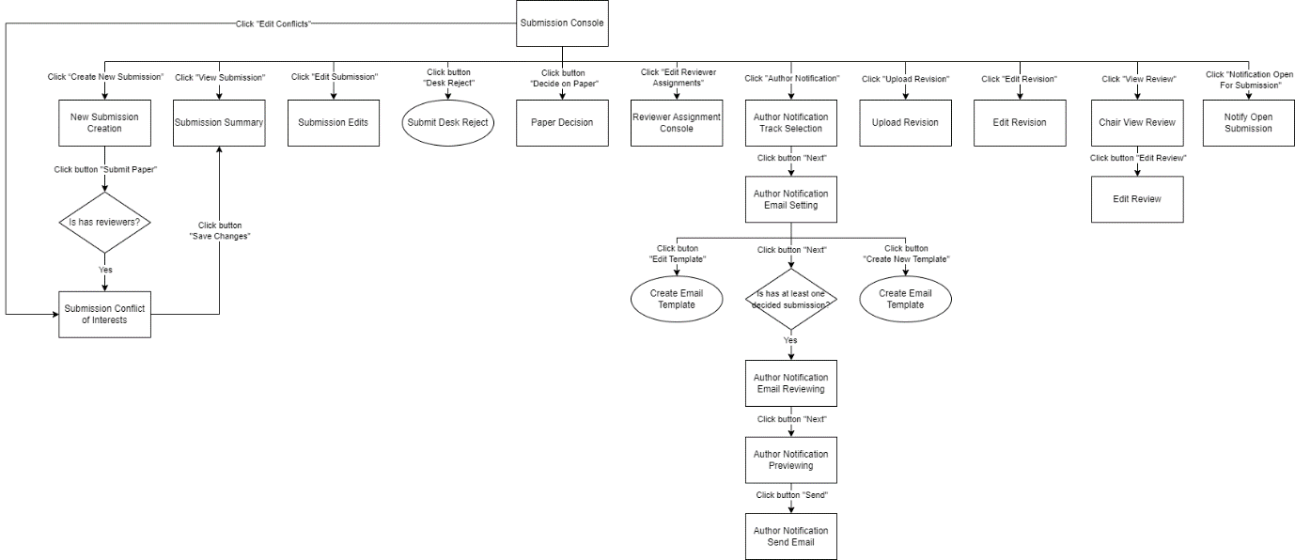

###### 3.1.1.1.4 Conference Users

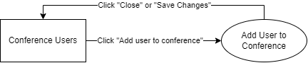

###### 3.1.1.1.5 Manuscripts

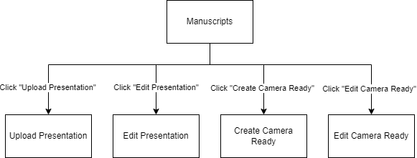

###### 3.1.1.1.6 Paper Statuses Setting

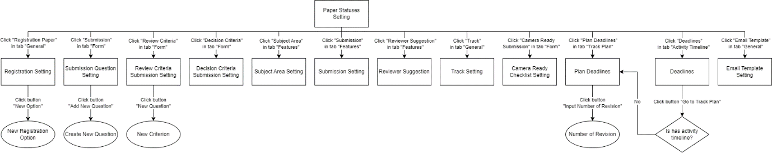

##### 3.1.1.2 Screens Flow – Author

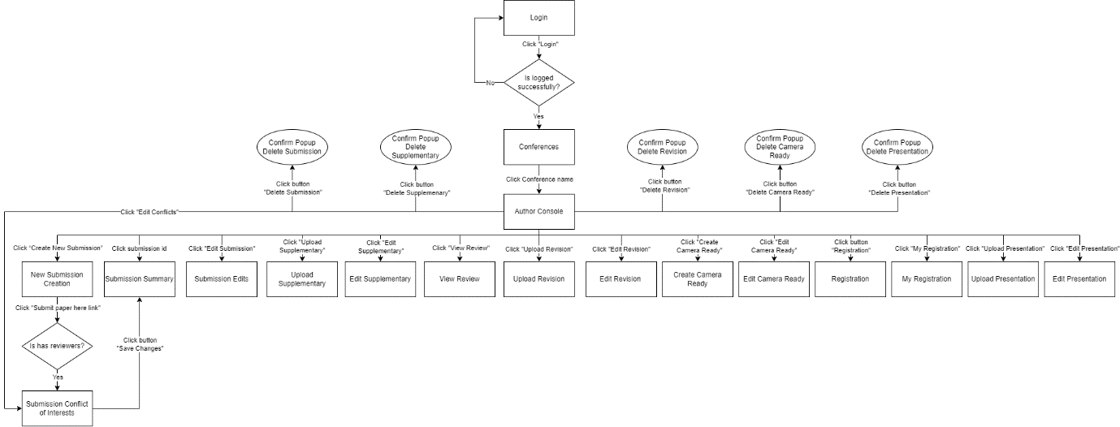

###### 3.1.1.2.1 Registration

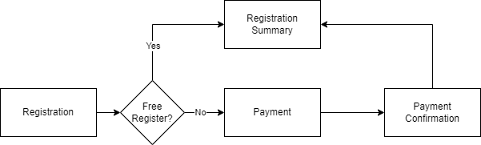

##### 3.1.1.3 Screens Flow – Reviewer

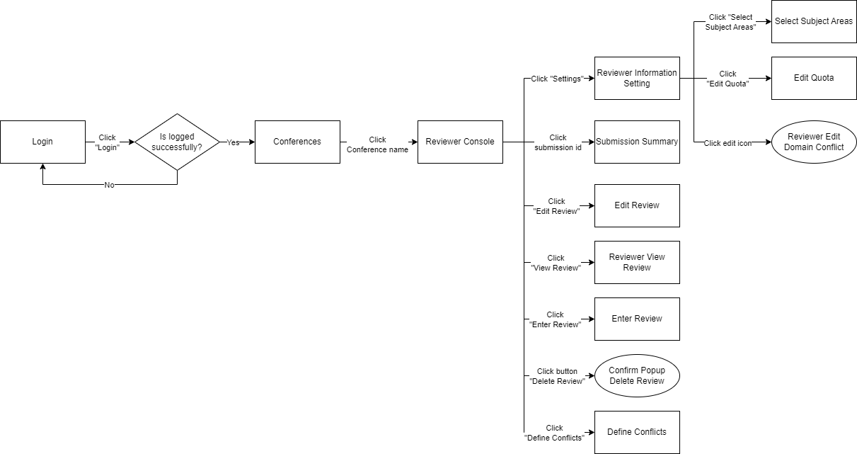

##### 3.1.1.4 Screens Flow – Admin

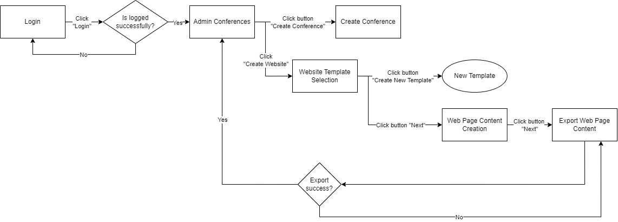

##### 3.1.1.5 Screens Flow – Lecturer

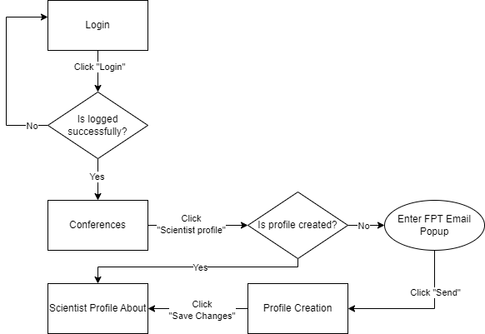

###### 3.1.1.5.1 Scientist Profile About

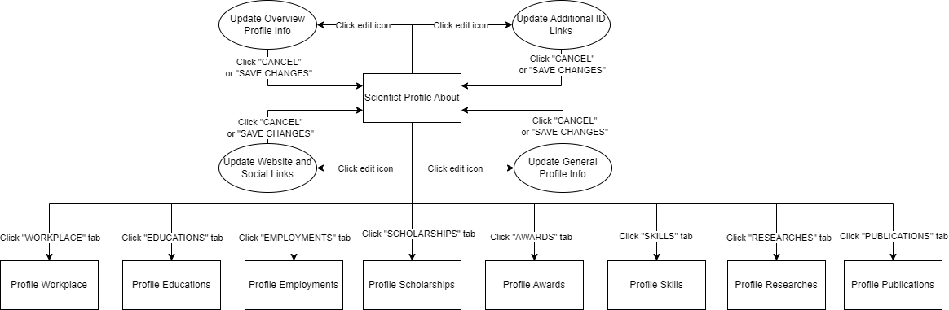

###### 3.1.1.5.2 Scientist Profile Workplace

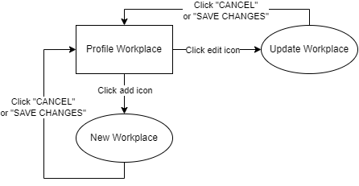

###### 3.1.1.5.3 Scientist Profile Educations

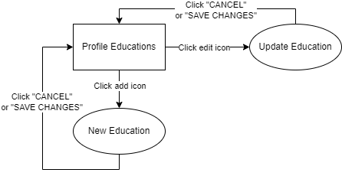

###### 3.1.1.5.4 Scientist Profile Employments

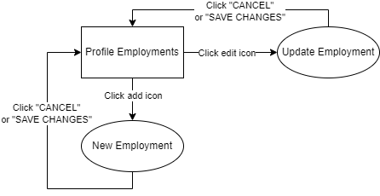

###### 3.1.1.5.5 Scientist Profile Scholarships

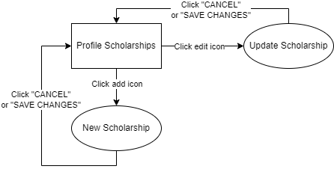

###### 3.1.1.5.6 Scientist Profile Awards

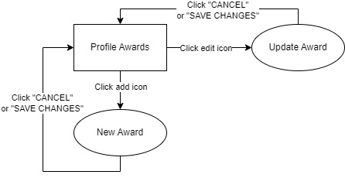

###### 3.1.1.5.7 Scientist Profile Skills

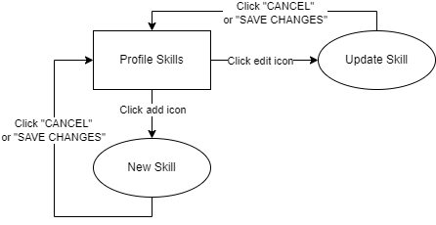

###### 3.1.1.5.8 Scientist Profile Researches

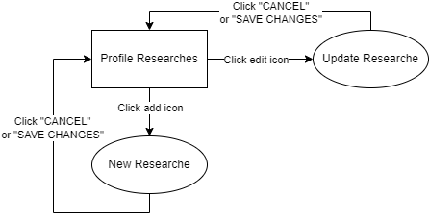

###### 3.1.1.5.9 Scientist Profile Publications

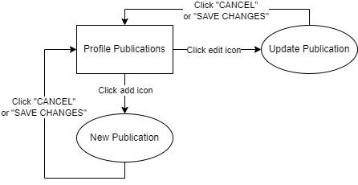

#### 3.1.2 Screen Descriptions

| **#** | **Feature** | **Screen** | **Description** |
| --- | --- | --- | --- |
| 1 | Login | Login | This screen is for unauthenticated users to login.  Login screen include:   * Email: Text * Password: Text |
| 2 | Register | Register | This screen allows users to register into the system with  the role “User”. Required fields are:   * Email: Text * Password: Text * Confirmed password: Text * First name: Text * Middle name: Text * Last name: Text * Organization: Text * Country: Text |
| 3 | Acquire conference summary | List Conference/ Conferences | List Conference or Conferences Page show list of conference  Each conference item includes:   * Name: Text * Start date: Datetime * End date: Datetime * Location: Text * Website link: Text * Submittable tracks * Status: Text   List Conference divided into three sections:   * My Conferences * All Conferences * Open For Submission |
| 4 | Acquire conference summary | Conference Overview Dashboard | This screen allows PC Chair view number of subject areas, conference website link, number of tracks and conference information. This screen includes:   * Conference logo: Image * Conference name: Text * Conference short name: Text * City: Text * Country: Text * Start date: Datetime * End date: Datetime * Current phase: Text * Website link: Text * Subject areas: List subject areas * Tracks: List Tracks |
| 5 | Acquire conference summary | Conference Committee | This screen allows PC Chair view list of committees within conference. Each item includes:   * Index: Number * Full name: Text * Email: Text * Organization: Text * Country: Text * Position: Text |
| 6 | Acquire conference summary | Conference Participation Dashboard | This screen shows an overview of the figures of conference, and statistics for each track within the conference.  - Overview Figures:   * Conference users: Number * Authors: Number * Submissions: Number * Reviewers: Number   - Track Statistic:   * Authors: Number * Submissions: Number * Reviewers: Number * Submission primary subject areas: List   + Subject area name: Text   + Percent: Number   + Number of submission: Number * Reviewer primary subject areas: List   + Subject area name: Text   + Percent: Number   + Number of submission: Number * Paper Statuses: List   + Status name: Text   + Percent: Number   + Number of submission: Number * Average reviewer assignment: Number * Average number of reviews: Number |
| 7 | Aggregate list of conference submissions | Submission Console | Submission Console Page show general conference information and list of submission  General conference information includes:   * Conference full name: Text * Conference short name: Text * Actions:   + Create New Submission: Button   + Camera Ready Bulk Enabled: Button   + Camera Ready Bulk Disabled: Button   + Notification Open for Submission: Button   + Author Notification: Button   At the top list submission includes submission statistic   * Number of submissions: Number * Paper with Revision Submitted: Number * Paper With Revision Not Submitted: Number * Camera Ready Requested: Number * Reviewed papers: Number * Reviewers assigned: Number * Papers Assigned Reviewers: Number * Papers not Assigned Reviewers: Number * Review Paper Complete: Number * Review Paper Incomplete: Number * Accepted Notified Papers: Number * Notified Statuses First Attempt: Number * Notified Statuses After Revision: Number * Rejected Notified Papers: Number * Revision Notified Papers: Number * Desk Rejected Notified Papers: Number * Awaiting decision: Number * Accepted submission: Number * Rejected submission: Number * Revision submission: Number * Desk reject submission: Number   Each Submission item includes:   * Paper: Text * Abstract: Text * Tract: Text * Authors: List Authors * PC Chair note: Button * Reviewer conflicts: List Reviewer Conflicts * Submission conflicts: List Submission Conflicts * Assigned: List Assigns * Progress: Percentage * Average score: Number * Status:   + Name: Text   + Decide on Paper: Button   + Desk Reject: Button * Notified Status: Text * Revision submitted: Boolean * Request for camera ready:   + Name: Text   + Request: Dropdown Menu * Camera ready submitted completely: Boolean * Actions:   + View Submission: Button   + Edit Submission: Button   + Edit Conflicts: Button   + Edit Reviewer Assignments: Button   + Upload Supplementary Material: Button   + Upload Revision Files: Button   + Edit Revision Files: Button   + Upload Presentation Files: Button   + Edit Presentation Files: Button   + Create Camera Ready Submission: Button   + Edit Camera Ready Submission: Button   + Delete Camera Ready Submission: Button |
| 8 | Get list of recommended reviewers for a submission | Reviewer Assignment Console | This screen shows general submission information of and list of reviewers.  General submission information includes:   * Track name: Text * Paper Id: Text * Paper title: Text   Domain Conflict Included: Boolean  List of reviewer show reviewers to be assigned to submission.   * Reviewer:   + Full name: Text   + Email: Text   + Organization: Text * Reviewer conflicts: List * Submission conflicts: List * Quota: Number * Number of assignments: Number * Relevance: Number * Assign: Checkbox Button   At The end of Page has two actions:   * Go Back: Button * Assign: Button |
| 9 | Decide on paper | Paper Decision | This screen shows two types of criteria for PC Chairs to decide based on these criteria. But before deciding on paper, PC Chair must tick all checkbox to make a commitment before deciding.  General submission information includes:   * Track name: Text * Paper Id: Text * Paper title: Text   There are two sections:   * Reviews:   + List of reviewers’ reviews: List   + Go Back: button   + Go to Decision: button * Decision * Factors Affection Selection: Text * Factors Disqualifying A Research Paper: Text * Checklist: List Checklist * Paper statuses: List Paper Statuses * Go Back: Button * Submit Decision: Button |
| 10 | Submit a conference paper | Submission Edits | This screen allows PC Chair or Author to edit submission. This screen includes:   * Track name: Text * Title: Text * Abstract: Text * Authors: List authors   + First author: Boolean   + Corresponding: Boolean   + Primary contact: Boolean   + Email: Text   + First name: Text   + Middle name: Text   + Last name: Text   + Organization: Text   + Country * Domain conflict: Text * Subject areas: List subject areas * Submission files: Files * Additional questions: List question   At the end of page, there are two actions:   * Go Back: Button * Save Changes: Button |
| 11 | Submit a conference paper | New Submission Creation | This screen allows PC Chair or Author to create new submission. This screen includes:   * Track name: Text * Title: Text * Abstract: Text * Authors: List authors   + First author: Boolean   + Corresponding: Boolean   + Primary contact: Boolean   + Email: Text   + First name: Text   + Middle name: Text   + Last name: Text   + Organization: Text   + Country * Domain conflict: Text * Subject areas: List subject areas * Submission files: Files * Additional questions: List question   At the end of page, there are two actions:   * Go Back: Button * Save Changes: Button |
| 12 | View a submission summary | Submission Summary | This screen includes information about submission:   * Conference full name: Text * Conference short name: Text * Track name: Text * Paper id: Text * Paper title: Text * Abstract: Text * Created on: Datetime * Last modified: Datetime * Authors: List Authors * Primary subject area: Text * Secondary subject area: List subject areas * Domain conflicts: Text * Conflicts of interest: List Conflicts of interest * Submission files: Files * Supplementary materials: Files * Revision files: Files * Camera ready files: Files * Copyright file: File * Presentation files: Files * Submission questions response: List submission questions   At The end of Page has action:   * Go Back: Button |
| 13 | Get submission conflict of interest | Submission Conflict of Interests | This screen allows PC Chair to edit submission conflict of interest with Reviewers. This screen includes:  Conference general information:   * Paper id: Text * Paper title: Text * Track name: Text   List reviewers:   * Full name: Text * Email: Text * Organization: Text * Selected conflicts: Boolean * Conflicts: List conflicts * Actions: List checkbox   At the end of page, there are two actions:   * Go Back: Button * Save Changes: Button |
| 14 | Select track to get the information of submissions status | Author Notification Track Selection | This screen allows PC Chair to choose track to base on the number of submissions to notify paper status to authors. This screen contains list of tracks. Each item includes:   * Select: Boolean * Track: Text * Number of Submissions: Number   At the end of page, there are three actions:   * Cancel: Button * Previous: Button * Next: Button |
| 15 | Select paper status | Author Notification Email Setting | This screen allows PC Chair to select the option that should notify the decision to only primary author or all authors belong to each submission. PC Chair also has to select the status corresponding with proper email template to notify decision and send email to author.  There are two options for char to Choose:   * Primary Contact Authors Only * All Authors with Registered Account   Template with two actions:   * Create New Template: Button * Edit Template: Button   There is a list of paper statuses. PC Chair has to choose status to notify. Each item includes   * Selection: Checkbox button * Paper Status: Text * Email Template: Dropdown Menu   PC Chair can create a new template or edit the existed At the end of page, there are three actions:   * Cancel: Button * Previous: Button * Next: Button |
| 16 | Make statistical information about conference submissions | Author Notification Email Reviewing | This screen allows PC Chair review statistic of submission after selecting paper status step. This screen contains a list of information. Each item includes:   * Paper Status: Text * Number Of Submissions: Number * Number Of Emails to Send: Number   At the end of page, there are three actions:   * Cancel: Button * Previous: Button * Next: Button |
| 17 | Get list of authors to send email corresponding selected paper status | Author Notification Previewing | This screen allows PC Chair to preview list of authors to send emails corresponding with specific paper status. Each item includes:   * From Name: Text * From Email: Text * To Name: Text * To Email: Text * Subject: Text * Body: Text * Actions:   + View Email Details: Button   At the end of page, there are three actions:   * Cancel: Button * Previous: Button * Next: Button |
| 18 | Send emails to authors | Author Notification Send Email | This screen allows PC Chair to view which selected paper statuses has been sent to authors. |
| 19 | Upload revision | Upload Revision | This screen allows PC Chair or Author to upload revision for submission. This screen includes:   * Paper Id: Text * Paper title: Text * Track name: Text * Revision files: Files   At the end of page, there are two actions:   * Go Back: Button * Upload Revision: Button |
| 20 | Upload revision | Edit Revision | This screen allows PC Chair or Author to edit revision for submission. This screen includes:   * Paper Id: Text * Paper title: Text * Track name: Text * Revision files: Files   At the end of page, there are two actions:   * Go Back: Button * Edit Revision: Button |
| 21 | Upload presentation | Upload Presentation | This screen allows PC Chair or Author to upload presentation for submission. This screen includes:   * Paper Id: Text * Paper title: Text * Track name: Text * Check presenters: List presenters * Presentation files: Files   At the end of page, there are two actions:   * Go Back: Button * Upload Presentation: Button |
| 22 | Upload presentation | Edit Presentation | This screen allows PC Chair or Author to edit presentation for submission. This screen includes:   * Paper Id: Text * Paper title: Text * Track name: Text * Check presenters: List presenters * Presentation files: Files   At the end of page, there are two actions:   * Go Back: Button * Edit Presentation: Button |
| 23 | Upload camera ready | Create Camera Ready | This screen allows PC Chair or Author to create camera ready for submission. This screen includes:   * Paper title: Text * Abstract: Text * Authors: List Authors * Checklist: List Checklist * Camera ready files: Files * Copyright files: Files   At the end of page, there are two actions:   * Go Back: Button * Submit Camera Ready: Button |
| 24 | Upload camera ready | Edit Camera Ready | This screen allows PC Chair or Author to edit camera ready for submission. This screen includes:   * Paper title: Text * Abstract: Text * Authors: List Authors * Checklist: List Checklist * Camera ready files: Files * Copyright files: Files   At the end of page, there are two actions:   * Go Back: Button * Edit Camera Ready: Button |
| 25 | View aggregation reviews of a submission | PC Chair View Review | This screen allows PC Chair to view list reviewers review. This screen includes:  General information:   * Paper Id: Text * Paper title: Text * Track name: Text   List reviewers review:   * Reviewer full name: Text * Research paper review criteria: List criteria * Average evaluation score: Number * Suggestion for PC Chair: Text * Comments for authors: Text   At The end of Page has action:   * Go Back: Button |
| 26 | Edit review | Edit Review | This screen allows PC Chair or Reviewer to edit submission review. This screen includes:  General information:   * Paper Id: Text * Paper title: Text   List reviewers review:   * Reviewer full name: Text * Research paper review criteria: List criteria * Average evaluation score: Number * Suggestion for PC Chair: Text * Comments for authors: Text   At the end of page, there is two actions:   * Go Back: Button * Save Changes: Button |
| 27 | Get conference user aggregation list | Conference Users | Conference Users page allows PC Chair to manage users. This screen shows general conference information and list of users  General conference information includes:   * Conference full name: Text * Conference short name: Text * Current phase: Text * Next phase: Text * Actions:   + Add user to conference   + Invite reviewer * Statistic of number users belong to the conference.   At the top of list of users, it shows the total of users. Each user includes:   * Full Name: Text * Email: Text * Organization: Text * Country: Text * Roles: List of roles * Actions:   + Mange Roles |
| 28 | Get list reviewers | Reviewer Management | This screen allows PC Chair view reviewers in conference. General conference information:   * Conference full name: Text * Conference short name: text * Actions:   + Invite Reviewer   List statics by track:   * Track name: Text * Number of reviewers: Number * Number of reviewers assigned: Number * Number of reviewers not assigned: Number * Number of reviewers reviewed all: Number * Number of reviewers not review any: Number * Number of reviewers reviewed partly: Number   Each reviewer item includes:   * Index: Number * ID: Text * Reviewer:   + Full name: Text   + Email: Text   + Organization: Text * Quota: Number * Primary subject area: Text * Secondary subject area: List subject areas * Domain conflict: Text * Assigned: Number * Progress: Percentage * Actions:   + View Reviewer Assignment Report |
| 29 | Get list submission assign to reviewer | View Reviewer Assignment Report | This screen allows PC Chair to view the submissions to which the reviewer is assigned. This screen shows reviewer general information and list of submissions  Reviewer general information:   * Reviewer:   + Full name: Text   + Email: Text * Assigned review: Number * Quota: Number   Each submission item includes:   * Index: Number * Paper Id: Text * Paper title: Text * Track name: Text * Authors: List authors * Primary subject area: Text * Secondary subject area: List subject areas * Submission files: Files * Supplementary materials: Files * Revision files: Files * Score: Number * Deadline time: Datetime * Reviewed: Boolean   At The end of Page has action:   * Go Back: Button |
| 30 | View the reviewer invitation list | Manage Reviewer Invites | This screen allows PC Chair to view list of reviewer's invitation in conference.  List statics by track:   * Number of invitations: Text * Number of accepted invitations: Number * Number of rejected invitations: Number * Number of not response invitations: Number   Each reviewer item includes:   * First name: Text * Last name: Text * Email: Text * Organization: Text * Sent time: Datetime * Expires time: Datetime * Track: Text * Status: Text |
| 31 | Invite a reviewer | Reviewer Invitation User Searching | This screen allows PC Chair to search users and invite to the conference.  If the user exists, the user includes:   * Email: Text * First name: Text * Middle name: Text * Last name: Text * Organization: Text   If the user is not existing PC Chair will create user as outsider, the outsider includes:   * Email: Text * First name: Text * Middle name: Text * Last name: Text * Organization: Text * Country: Text * Actions:   + Create Invite   At The end of Page has three actions:   * Cancel Invite: Button * Previous: Button * Next: Button |
| 32 | Compose email for invite reviewer | Email Composing Invitation | This screen allows PC Chair to compose email to send to the reviewer. This screen includes:   * Subject: Text * Body: Text   At The end of Page has three actions:   * Cancel: Button * Previous: Button * Next: Button |
| 33 | Get previewing email | Previewing Email Invitation | This screen allows PC Chair to preview email before sending it to the reviewer. This screen includes:   * Sender full name: Text * Sender email: Text * Recipient full name: Text * Recipient email: Text * Subject: Text * Body: Text   At The end of Page has three actions:   * Cancel: Button * Previous: Button * Send: Button |
| 34 | Aggregate list of conference manuscripts | Manuscripts | This screen allows PC Chair tracking final camera-ready submission, registration and presentation submission. This screen shows general conference information and list submissions:  General conference information includes:   * Conference full name: Text * Conference short name: Text * Current phase: Text * Next phase: Text * Request Presentation:   + Presentation Bulk Enabled: Button   + Presentation Bulk Disabled: Button   Based on the tab of the submission list, extra field includes:   * All manuscripts:   + Download: Button * All registered manuscripts:   + Download: Button * All presentation:   + Download: Button * Presentation-submitted manuscripts:   + Download: Button   Each submission item includes:   * Index: Number * Paper title: Text * Track name: Text * Primary subject area: Text * Secondary subject area: List subject areas * Authors: List authors * Registered: Boolean * Register option: Text * Order:   + Charge type: Text   + Price: Number   + Option: Text   + Amount: Number   + Subtotal: Number   + Order total: Number * Registrant:   + Name prefix: Text   + Full name: Text   + Email: Text   + Organization: Text   + Country: Text * Request for presentation:   + Name: Text   + Request: Dropdown Menu * Presentation completely: Boolean * Presenters: List presenters |
| 35 | Get paper statuses | Paper Statuses Setting | This screen shows all paper statuses of conference. The paper statuses include:   * Awaiting decision * Desk Reject * Accept * Revision * Reject |
| 36 | Define a track's subject area list | Subject Area Setting | This screen allows PC Chair to manage the subject areas. Subject Areas include:   * Subject Areas: List Subject Areas * Add Subject Area: Button * Edit Subject Area: Button * Delete Subject Area: Button |
| 37 | Adjust track settings | Submission Setting | This screen allows PC Chair to manage the configuration of submission. The configuration includes:   * Abstract   + Maximum number of characters for abstract: Dropdown Menu   + Abstract Required: Boolean * Submission File:   + Maximum number of file/s allowed: Dropdown Menu   + Minimum number of file/s required: Dropdown Menu   + File formats (comma separated): Dropdown Menu   + Maximum file size does not exceed (MB): Dropdown Menu * Supplementary Material:   + Allow submission of supplementary material: Boolean   + Maximum number of file/s allowed: Dropdown Menu   + Minimum number of file/s required: Dropdown Menu   + File formats (comma separated): Dropdown Menu   + Maximum file size does not exceed (MB): Dropdown Menu * Revision File:   + Allow submission of revision files for Revision paper: Boolean   + Maximum number of file/s allowed: Dropdown Menu   + Minimum number of file/s required: Dropdown Menu   + File formats (comma separated): Dropdown Menu   + Maximum file size does not exceed (MB): Dropdown Menu * Other:   + Allow only primary contact author to delete paper: Boolean |
| 38 | Get relevance score | Reviewer Suggestion | This screen allows PC Chair to modify subject relevance scores. PC Chair can choose the default option or custom option. This screen includes:  There are two options for PC Chair to choose:   * Default * Custom   If PC Chair choose custom option, field includes:   * Pp: Text * Ps: Text * Sp: Text * Ss: Text   At The end of Page has action:   * Save Changes: Button |
| 39 | Get list tracks of conference | Track Setting | This screen allows PC Chair to manage tracks of conference. The Tracks include:   * Tracks: List Tracks * Add Tracks: Button * Edit Tracks: Button * Delete Tracks: Button |
| 40 | Adjust conference general settings | Registration Setting | This screen allows PC Chair to manage the configuration registration paper. The configuration includes:   * Free Charge: Switch * Registration Configuration:   + Early Registration: Boolean   + Early Registration Deadline: Datetime   + Number of Pages: Number   + Number of Extra Papers: Number * Charge Option, each option include:   + Option: Text   + Early Registration: Number   + Regular Registration: Number   + Enabled: Boolean * Customization Option:   + New Option: Button   + Options: List Options, Each Option includes:     - Option: Text     - Early Registration     - Early Registration: Number     - Regular Registration: Number     - Delete: Button   At The end of Page has action:   * Save Changes: Button |
| 41 | Adjust track settings | Submission Question Setting | This screen allows PC Chair to manage the configuration submission questions. The configuration includes:   * Add New Question: Button * Preview: Button * Questions. Each question includes:   + Title: Text   + Text: Text   + Required: Boolean   + Visible to user: Boolean   + Type: Dropdown Menu   + Edit: Button   + Delete: Button   At The end of Page has action:   * Save Changes: Button |
| 42 | Adjust track settings | Camera Ready Checklist Setting | This screen allows PC Chair to manage camera ready checklist of conference. The checklist include:   * Checklist: checklists * Add checklist: Button * Edit checklist: Button * Delete checklist: Button   At The end of Page has action:   * Save Changes: Button |
| 43 | Adjust track settings | Review Criteria Submission Setting | This screen allows PC Chair to manage the configuration of review criteria submission. The review criteria include:   * Criteria List, each item include:   + Criteria Title: Text   + Evaluation Criteria: Text   + Grade Level: Number   + Weight: Number   + Actions:     - Edit: Button     - Delete: Button   At The end of page has action:   * Save Changes: Button |
| 44 | Adjust track settings | Decision Criteria Submission Setting | This screen allows PC Chair to manage the configuration of decision criteria. The configuration include:   * Decision checklist, each item includes:   + Title: Text   + Edit: Button   + Delete: Button * Factors Affecting Selection: Text * Factors Disqualifying Research Paper Abstract: Text   At The end of page has action:   * Save Changes: Button |
| 45 | Update a track's activity timeline | Deadlines | This screen allows PC Chair to manage activity timelines by completing conference phases or extending phases deadline. This screen shows list phase that includes:   * Phase name: Text * Deadline name: Text * Status: Dropdown * Deadline: Datetime |
| 46 | Create a track plan | Plan Deadlines | This screen allows PC Chair to create a track plan for the conference.  At the top list phase includes two button:   * Download Template: Button * Import Template: Button   List phase includes:   * Phase name: Text * Deadline name: Text * Status: Dropdown * Deadline: Datetime   At The end of Page has two actions:   * Reset Deadlines: Button * Save Changes: Button |
| 47 | Set up email templates | Email Template Setting | This screen allows PC Chair to update template setting for “Open For Submission” and ”Open For Camera Ready”.  There are two types of email template:   * CALLING FOR PAPER TEMPLATE, this includes:   + Subject   + Body * OPEN FOR SUBMISSION TEMPLATE, this includes:   + Subject   + Body   At The end of Page has one actions:   * Save Changes: Button |
| 48 | Get the list of author submissions | Author Console | This screen shows general conference information and allows Author to manage their submissions.  General conference information includes:   * Conference full name: Text * Conference short name: Text * Message: Text * Register paper: Button   There are three tabs in page:   * All Submissions * Requested for Camera Ready Submissions * Requested for Presentation Submissions   At the top list submission includes:   * Total of submission: Number   Each submission item includes:   * Paper id: Text * Title: Text * PC Chair note: Text * Abstract: Text * Track: Text * List files, each item includes:   + Submission files: List Submission files   + Download Submission: Button   + Supplementary files: List Supplementary files   + Download Supplementary: Button   + Revision files: List Revision files   + Download Revision: Button   + Camera ready files: List Camera ready files   + Download Camera ready: Button   + Copyright files: List Copyright files   + Download Copyright: Button   + Presentation files: List Presentation files   + Download Presentation: Button * Status: Text * Deadline time: Datetime * Actions:   + Edit Submission: Button   + Delete Submission: Button   + Edit Conflicts: Button   + Upload Supplementary: Button   + Delete Supplementary: Button   + Upload Revision: Button   + Edit Revision: Button   + Delete Revision: Button   + Create Camera ready: Button   + Edit Camera ready: Button   + Delete Camera ready: Button   + Upload Presentation: Button   + Edit Presentation: Button   + Delete Presentation: Button |
| 49 | Upload Supplementary  Materials | Upload Supplementary | This screen allows Author to upload supplementary for submission. This screen includes:   * Paper Id: Text * Paper title: Text * Track name: Text * Supplementary files: Files   At the end of page, there are two actions:   * Go Back: Button * Upload Supplementary Material: Button |
| 50 | Get an author's list of registered papers | My Registration | This screen shows general conference information and allows Author to view their registration submissions.  General conference information includes:   * Conference full name: Text * Conference short name: Text   Each submission item includes:   * Index: Number * Paper title: Text * Track name: Text * Primary subject area: Text * Secondary subject area: List subject areas * Authors: List authors * Registered: Boolean * Register option: Text * Order:   + Charge type: Text   + Price: Number   + Option: Text   + Amount: Number   + Subtotal: Number   + Order total: Number * Registrant:   + Name prefix: Text   + Full name: Text   + Email: Text   + Organization: Text   + Country: Text * Request for presentation: Boolean * Presentation completely: Boolean * Presenters: List presenters |
| 51 | Register an author's qualified papers r | Registration | This screen allows Author to register their paper into the conference. This screen include:  Price table, each item in table include:   * Option: Text * Early Registration: Number * Regular Registration: Number   Checklist registerable submission table, each item in table include:   * Title: Text * Check: Boolean   Paper Registration form, this form includes:   * Option: Dropdown menu * Add: Button * List Author registration from, each form include:   + Paper: Dropdown Menu   + Number of pages: Number   + Number of extra pages: Number * Checkout: button |
| 52 | Get payment order | Payment | This screen shows registration submission order and allows Author to make payment.  Registration submission order includes:   * Charge type: Text * Price: Number * Option: Text * Amount: Number * Subtotal: Number * Order total: Number   At The end of Page has action:   * PayPal: Button |
| 53 | Get payment success order | Payment Confirmation | This screen shows the message to Author that the payment was successful or failed, and registration submission order. This screen includes:   * Charge type: Text * Price: Number * Option: Text * Amount: Number * Subtotal: Number * Order total: Number * Functions:   + OK: Button |
| 54 | View payment summary | Registration Summary | This screen shows the registration summary to Author. This screen includes:   * Registrant full name: Text * Registrant email: Text * Registrant organization: Text * Conference full name: Text * Conference short name: Text * List of papers:   + Paper title: Text   + Paper Id: Text   + Authors: List authors   + Number of Pages: Number   + Number of Extra Pages: Number |
| 55 | Get reviewer review for author | Author View Review | This screen allows Author to view list reviewers review on submission. This screen includes:  Conference general information:   * Paper Id: Text * Paper title: Text * Track name: Text   List reviewers review:   * Average evaluation score: Number * Comments for authors: Text   At The end of Page has action:   * Go Back: Button |
| 56 | Get list submission assigned to reviewer | Reviewer Console | This screen shows general conference, reviewer information, and allows Reviewer to manage submissions assigned to them.  General information includes:   * Conference full name: Text * Conference short name: Text * Reviewer: Text * Assigned review: Number * Quota: Number   Each Submission includes:   * Paper Id: Text * Title: Text * Track: Text * Authors: List authors * Primary subject area: Text * Secondary subject area: List secondary subject areas * Files:   + Download submission: Button   + Download supplementary: Button   + Download revision: Button * Deadline time: Datetime * Actions:   + Enter review: Button   + Edit review: Button   + Delete review: Button   + Define conflicts: Button |
| 57 | Get review of reviewer | Reviewer View Review | This screen allows Reviewer to view his/her review on submission. This screen includes:  Conference general information:   * Paper Id: Text * Paper title: Text * Track name: Text   Review on submission includes:   * Research paper review criteria: List criteria * Average evaluation score: Number * Suggestion for PC Chair: Text * Comments for authors: Text   At the end of page, there is action:   * Go Back: Button |
| 58 | Enter review | Enter Review | This screen allows Reviewer to submit submission review. This screen includes:  General information:   * Paper Id: Text * Paper title: Text   List reviewers review:   * Reviewer full name: Text * Research paper review criteria: List criteria * Average evaluation score: Number * Suggestion for PC Chair: Text * Comments for authors: Text   At the end of page, there is two actions:   * Go Back: Button * Submit Review: Button |
| 59 | Declare reviewer conflicts of interest | Define Conflicts | This screen allows Reviewer to define conflicts of interest. This screen includes:  Conference general information:   * Paper id: Text * Paper title: Text * Track name: Text   List conflicts:   * Conflict case name: Text   At the end of page, there are two actions:   * Go Back: Button * Save Changes: Button |
| 60 | Get reviewer information and list conferences | Reviewer Information Setting | This screen allows Reviewer views all conference they attend. This screen includes:  Reviewer general information:   * Full name: Text * Account Id: Text * Email: Text * Country: Text * Domain conflicts: Text   List conferences:   * Index: Number * Conference name: Text * Conference short name: Text * Track name: Text * Primary subject area: Text * Secondary subject area: List subject areas * Quota: Number * Actions:   + Edit Quota: Button   + Select Subject Areas: Button |
| 61 | Specifying reviewing information | Edit Quota | This screen allows Reviewer change quota. This screen includes:   * Track name: Text * Conference name: Text * Quota: Number   At the end of page, there are two actions:   * Go Back: Button * Save Changes: Button |
| 62 | Select subject areas | Select Subject Areas | This screen allows Reviewer select primary and secondary subject areas. This screen includes:   * Track name: Text * Full name: Text * List subject areas: List subject areas   At the end of page, there are two actions:   * Go Back: Button * Save Changes: Button |
| 63 | Call for papers | Notification Open Submission | This screen allows PC Chair to download template and import a list of emails to send.  At the top, there are two buttons:   * Download Template: button * Import Template: button   There is a table show a list of emails after importing.  At the bottom, there are two buttons:   * Go back: button * Send: button |
| 64 | Get admin list conferences | Admin Conferences | This screen allows Admin to manage conferences in the system.  At the top list conferences includes:   * Create Conference: Button   List conferences includes:   * Conference full name: Text * Start date: Datetime * End date: Datetime * Location: Text * Website link:   + Link: text   + Edit Icon: Button * Status: Text * Actions:   + Create Website: Button   + Update Website: Button   + Delete Website: Button * Final Report:   + Export Final Report: Button |
| 65 | Create conference | Create Conference | This screen allows Admin to create new conference. This screen includes:   * Conference full name: Text * Conference short name: Text * Country: Text * City: Text * Website link: Text * PC Chairs: List PC Chairs * Tracks: List tracks * Conference logo: Image   At the end of page, there are two actions:   * Go Back: Button * Create Conference: Button |
| 66 | Create a conference's website content | Website Template Selection | This screen allows admin to choose template to create webpage content corresponding with selected web template and create navbars based on selected template. This screen includes:  Selecting template. A list of web template for admin to choose, each item includes:   * Choose: Radio Button * Name: Text * Description: Text * Conference has used: List of conference use the template * Preview: Button   Creating navbar based on selected template. This part is divided into two sections.   * The left site includes:   + Add nav   + parent naves: List of parent naves * The right site includes:   + Add sub nav   + Children nav: List of children naves corresponding with selected parent nav   At the end of page, there are three actions:   * Create New Template: Button * Back to Dashboard: Button * Next: Button |
| 67 | Create a conference's website content | Web Page Content Creation | This screen allows Admin to create webpage content with selected nav. This screen includes:  At the top at page, it has note for supporting admin to create the internal and external link page  At the left site is the list of parent naves and list of children naves corresponding with its parent nav  At the right site is the editor for admin to create webpage content corresponding with the selected nav. Below the editor has Preview button, helping admin to preview the webpage content on editor.  At the end of page, there are three actions:   * Back to Dashboard: Button * Previous: Button * Next: Button |
| 68 | Export a conference website's content | Export Web Page Content | This screen allows Admin to export the webpage content at step “Creating webpage content” into files html. This screen includes:   * Export webpage files: Button   At the end of page, there are three actions:  Previous: Button   * Next: Button |
| 69 | Input research profile information | Profile Creation | This screen allows Lecturer to create scientist profile. The Profile includes:   * Public name: Text * Date of birth: Datetime * Introduction: Text * Home address: Text * Phone number: Text * Mobile phone: Text * Gender: Radio Button * Primary email: Text * ORCID: Link * Scientist title: Text * Administration position function: Text * Academic rank: Text * Year of academic function achievement: Number * Current degree: Text * Year of current degree achievement: Number * Fax: Text |
| 70 | View the research profile | Scientist Profile About | This screen shows Lecturer scientist profile About information.  At the left page includes:   * Author Id: Text * Email: Text * Website & social links:   + Title: Text   + URL: Text   + Action:     - Edit: Button * Other Id:   + Title: Text   + URL: Text   + Action:     - Edit: Button * Country: Text   At the top page includes:   * Action:   + Edit: Button * Public name: Text * ORCID: Text * Scientist title: Text * Administration position function: Text * Academic rank: Text * Year of academic function achievement: Text * Current degree: Text * Year of current degree achievement: Text * Also known as: List name   Profile About includes:   * Action:   + Edit: Button * Home address: Text * Phone number: Text * Mobile phone: Text * Fax: Text * Introduction: Text * Date of birth: Datetime * Gender: Radio Button |
| 71 | View the research profile | Profile Workplace | This screen shows Lecturer scientist profile Workplace information.  At the left page includes:   * Author Id: Text * Email: Text * Website & social links:   + Title: Text   + URL: Text   + Action:     - Edit: Button * Other Id:   + Title: Text   + URL: Text   + Action:     - Edit: Button * Country: Text   At the top page includes:   * Action:   + Edit: Button * Public name: Text * ORCID: Text * Scientist title: Text * Administration position function: Text * Academic rank: Text * Year of academic function achievement: Text * Current degree: Text * Year of current degree achievement: Text * Also known as: List name   Profile Workplace includes:   * Edit: Button * Organization name: Text * Organization phone number: Text * Organization description: Text * Organization website: Text * GRID: Text |
| 72 | View the research profile | Profile Educations | This screen shows Lecturer scientist profile Educations information.  At the left page includes:   * Author Id: Text * Email: Text * Website & social links:   + Title: Text   + URL: Text   + Action:     - Edit: Button * Other Id:   + Title: Text   + URL: Text   + Action:     - Edit: Button * Country: Text   At the top page includes:   * Action:   + Edit: Button * Public name: Text * ORCID: Text * Scientist title: Text * Administration position function: Text * Academic rank: Text * Year of academic function achievement: Text * Current degree: Text * Year of current degree achievement: Text * Also known as: List name   Profile Educations include:   * Add: Button * List educations, each item includes:   + Full name of degree: Text   + Degree Abbreviation: Text   + Academic degree: Dropdown menu   + Start year: Datetime   + Year of education: Datetime   + Organization: Text   + Organization phone number: Text   + Organization description: Text   + Organization website: Text   + GRID: Text   + Edit: Button |
| 73 | View the research profile | Profile Employments | This screen shows Lecturer scientist profile Employments information.  At the left page includes:   * Author Id: Text * Email: Text * Website & social links:   + Title: Text   + URL: Text   + Action:     - Edit: Button * Other Id:   + Title: Text   + URL: Text   + Action:     - Edit: Button * Country: Text   At the top page includes:   * Action:   + Edit: Button * Public name: Text * ORCID: Text * Scientist title: Text * Administration position function: Text * Academic rank: Text * Year of academic function achievement: Text * Current degree: Text * Year of current degree achievement: Text * Also known as: List name   Profile Employments include:   * Add: Button * List Employments, each item includes:   + Role / Position: Text   + Start date: Datetime   + End date: Datetime   + Organization name: Text   + Organization phone number: Text   + Organization description: Text   + Organization website: Text   + GRID: Text   + Edit: Button |
| 74 | View the research profile | Profile Scholarships | This screen shows Lecturer scientist profile Scholarship information.  At the left page includes:   * Author Id: Text * Email: Text * Website & social links:   + Title: Text   + URL: Text   + Action:     - Edit: Button * Other Id:   + Title: Text   + URL: Text   + Action:     - Edit: Button * Country: Text   At the top page includes:   * Action:   + Edit: Button * Public name: Text * ORCID: Text * Scientist title: Text * Administration position function: Text * Academic rank: Text * Year of academic function achievement: Text * Current degree: Text * Year of current degree achievement: Text * Also known as: List name   Profile Scholarship include:   * Add: Button * A List Scholarships, each item includes:   + Name: Text   + Description: Text   + Issuer: Text   + Issue Year: Text   + Edit: Button |
| 75 | View the research profile | Profile Awards | This screen shows Lecturer scientist profile Awards information.  At the left page includes:   * Author Id: Text * Email: Text * Website & social links:   + Title: Text   + URL: Text   + Action:     - Edit: Button * Other Id:   + Title: Text   + URL: Text   + Action:     - Edit: Button * Country: Text   At the top page includes:   * Action:   + Edit: Button * Public name: Text * ORCID: Text * Scientist title: Text * Administration position function: Text * Academic rank: Text * Year of academic function achievement: Text * Current degree: Text * Year of current degree achievement: Text * Also known as: List name   Profile Awards include:   * Add: Button * A List Awards, each item includes:   + Name: Text   + Description: Text   + Issuer: Text   + Issue Year: Text   + Edit: Button |
| 76 | View the research profile | Profile Skills | This screen shows Lecturer scientist profile Skills information.  At the left page includes:   * Author Id: Text * Email: Text * Website & social links:   + Title: Text   + URL: Text   + Action:     - Edit: Button * Other Id:   + Title: Text   + URL: Text   + Action:     - Edit: Button * Country: Text   At the top page includes:   * Action:   + Edit: Button * Public name: Text * ORCID: Text * Scientist title: Text * Administration position function: Text * Academic rank: Text * Year of academic function achievement: Text * Current degree: Text * Year of current degree achievement: Text * Also known as: List name   Profile Skills include:   * Add: Button * A List Skills, each item includes:   + Name: Text   + Description: Text   + Issuer: Text   + Score / Result: Text   + Issue Year: Text   + Edit: Button |
| 77 | View the research profile | Profile Researches | This screen shows Lecturer scientist profile Skills information.  At the left page includes:   * Author Id: Text * Email: Text * Website & social links:   + Title: Text   + URL: Text   + Action:     - Edit: Button * Other Id:   + Title: Text   + URL: Text   + Action:     - Edit: Button * Country: Text   At the top page includes:   * Action:   + Edit: Button * Public name: Text * ORCID: Text * Scientist title: Text * Administration position function: Text * Academic rank: Text * Year of academic function achievement: Text * Current degree: Text * Year of current degree achievement: Text * Also known as: List name   Profile Researches include:   * Add: Button * A List Researches, each item includes:   + Name: Text   + Edit: Button |
| 78 | View the research profile | Profile Publications | This screen shows Lecturer scientist profile Publications information  At the left page includes:   * Author Id: Text * Email: Text * Website & social links:   + Title: Text   + URL: Text   + Action:     - Edit: Button * Other Id:   + Title: Text   + URL: Text   + Action:     - Edit: Button * Country: Text   At the top page includes:   * Action:   + Edit: Button * Public name: Text * ORCID: Text * Scientist title: Text * Administration position function: Text * Academic rank: Text * Year of academic function achievement: Text * Current degree: Text * Year of current degree achievement: Text * Also known as: List name   Profile Publications include:   * Add: Button * List Publications, each item includes:   + Publication name: Text   + Publisher: Text   + DOI title: Text   + DOI link: Text   + Work Type: Dropdown menu   + Publication date: Datetime   + Is author lead: Radio Button   + Other publication links: list of links   + Contributor names: list of contributors   + Edit: Button |

#### 3.1.3 Screen Authorization

| **Screen** | **Authenticated User** | | | | | **Unauthenticated User** |
| --- | --- | --- | --- | --- | --- | --- |
| **PC Chair** | **Author** | **Reviewer** | **Lecturer** | **Admin** |
| Login |  |  |  |  |  | X |
| Register |  |  |  |  |  | X |
| Conferences | X | X | X | X |  |  |
| Conference Overview Dashboard | X |  |  |  |  |  |
| Conference Committee | X |  |  |  |  |  |
| Conference Participation Dashboard | X |  |  |  |  |  |
| Reports | X |  |  |  |  |  |
| Submission Console | X |  |  |  |  |  |
| Reviewer Assignment Console | X |  |  |  |  |  |
| Paper Decision | X |  |  |  |  |  |
| Submission Edits | X | X |  |  |  |  |
| New Submission Creation | X | X |  |  |  |  |
| Submission Summary | X | X | X |  |  |  |
| Submission Conflict of Interests | X | X |  |  |  |  |
| Author Notification Track Selection | X |  |  |  |  |  |
| Author Notification Email Setting | X |  |  |  |  |  |
| Author Notification Email Reviewing | X |  |  |  |  |  |
| Author Notification Previewing | X |  |  |  |  |  |
| Author Notification Send Email | X |  |  |  |  |  |
| Upload Revision | X | X |  |  |  |  |
| Edit Revision | X | X |  |  |  |  |
| Upload Presentation | X | X |  |  |  |  |
| Edit Presentation | X | X |  |  |  |  |
| Create Camera Ready | X | X |  |  |  |  |
| Edit Camera Ready | X | X |  |  |  |  |
| PC Chair View Review | X |  |  |  |  |  |
| Edit Review | X |  | X |  |  |  |
| Conference Users | X |  |  |  |  |  |
| Reviewer Management | X |  |  |  |  |  |
| View Reviewer Assignment Report | X |  |  |  |  |  |
| Manage Reviewer Invites | X |  |  |  |  |  |
| Reviewer Invitation User Searching | X |  |  |  |  |  |
| Email Composing Invitation | X |  |  |  |  |  |
| Previewing Email Invitation | X |  |  |  |  |  |
| Manuscripts | X |  |  |  |  |  |
| Paper Statuses Setting | X |  |  |  |  |  |
| Subject Area Setting | X |  |  |  |  |  |
| Submission Setting | X |  |  |  |  |  |
| Reviewer Suggestion | X |  |  |  |  |  |
| Track Setting | X |  |  |  |  |  |
| Registration Setting | X |  |  |  |  |  |
| Submission Question Setting | X |  |  |  |  |  |
| Camera Ready Checklist Setting | X |  |  |  |  |  |
| Review Criteria Submission Setting | X |  |  |  |  |  |
| Decision Criteria Submission Setting | X |  |  |  |  |  |
| Deadlines | X |  |  |  |  |  |
| Plan Deadlines | X |  |  |  |  |  |
| Author Console |  | X |  |  |  |  |
| Upload Supplementary |  | X |  |  |  |  |
| My Registration |  | X |  |  |  |  |
| Registration |  | X |  |  |  |  |
| Payment |  | X |  |  |  |  |
| Payment Confirmation |  | X |  |  |  |  |
| Registration Summary |  | X |  |  |  |  |
| Author View Review |  | X |  |  |  |  |
| Reviewer Console |  |  | X |  |  |  |
| Reviewer View Review |  |  | X |  |  |  |
| Enter Review |  |  | X |  |  |  |
| Define Conflicts |  |  | X |  |  |  |
| Reviewer Information Setting |  |  | X |  |  |  |
| Edit Quota |  |  | X |  |  |  |
| Select Subject Areas |  |  | X |  |  |  |
| Admin Conferences |  |  |  |  | X |  |
| Create Conference |  |  |  |  | X |  |
| Website Template Selection |  |  |  |  | X |  |
| Web Page Content Creation |  |  |  |  | X |  |
| Export Web Page Content |  |  |  |  | X |  |
| Profile Creation | X | X | X | X |  |  |
| Scientist Profile About | X | X | X | X |  |  |
| Profile Workplace | X | X | X | X |  |  |
| Profile Educations | X | X | X | X |  |  |
| Profile Employments | X | X | X | X |  |  |
| Profile Scholarships | X | X | X | X |  |  |
| Profile Awards | X | X | X | X |  |  |
| Profile Skills | X | X | X | X |  |  |
| Profile Researches | X | X | X | X |  |  |
| Profile Publications | X | X | X | X |  |  |

#### 3.1.4 Non-Screen Functions

*[Provide the descriptions for the non-screen system functions, i.e batch/cron job, service, API, etc.]*

| **#** | **Feature** | **System Function** | **Description** |
| --- | --- | --- | --- |
| 1 | <<Feature Name>> | <<Function Name1>> | <<Function Name1 Description>> |
| 2 | … |  |  |

#### 3.1.5 Entity Relationship Diagram

*[Provide the entity relationship diagram and the entity descriptions in the table format as below]*



**Entities Description**

| **#** | **Entity** | **Description** |
| --- | --- | --- |
| 1 | AbpUsers | An entity that represents the personal and authentication information of users within the system. This encompasses details such as username, email, password, and affiliated organization, as well as the user's confirmation status and domain conflicts. |
| 2 | ActivityDeadline | An entity representing crucial deadlines for various activities within a conference management system. It contains details like the name of the activity, its current status, and the exact deadline, all linked to specific tracks. |
| 3 | Authors | This entity captures information about authors who have submitted content to the system. Details like participant ID, submission information, and author roles like primary contact or presenter are included. |
| 4 | CameraReadies | Represents the finalized versions of the conference submissions. It contains paths to relevant files, ensuring that the conference presentations and proceedings are accessible. |
| 5 | ConferenceAccount | Links user accounts to specific conferences, detailing their roles within the conference and any potential domain conflicts they might have. |
| 6 | ConferenceRole | Details the various roles individuals can assume within a conference. It specifies if a role belongs to the Program Committee and other related attributes. |
| 7 | Conferences | Provides comprehensive information about different conferences, capturing details such as their locations, dates, and other relevant settings. |
| 8 | ConflictCases | An entity that lists potential conflict scenarios for various submissions, ensuring transparent and unbiased review processes. |
| 9 | Conflict | Highlights specific conflicts associated with particular submissions, allowing the system to address them appropriately. |
| 10 | Emails | Chronicles the emails dispatched by the system, capturing details like the email status and associated templates. |
| 11 | EmailTemplate | Contains templates for emails, allowing standardised communication processes within the system. |
| 12 | Guidelines | Represents a set of guidelines, which could be related to submission processes, reviews, or any other conference-related aspect. |
| 13 | Incumbent | Holds information about specific roles or titles conferred to users within the conference context, recognizing their contributions or authority. |
| 14 | InvitationClones | Captures clones or duplicates of invitations, ensuring the system has backups or versions of original invitations. |
| 15 | Invitations | Houses details about invitations sent out, including their current status and any comments associated with them. |
| 16 | Orders | This entity captures purchase or transaction records associated with the conference. This could include ticket sales, merchandise purchases, or any other financial transactions. |
| 17 | Outsiders | Holds data about individuals who aren't registered within the conference system but have some form of involvement, perhaps as guest speakers or special attendees. |
| 18 | PaperStatuses | Enumerates the possible statuses that a paper or submission might hold, such as "Under Review," "Accepted," or "Rejected." |
| 19 | Participant | Chronicles the participants of the conference, mapping them to either their user accounts or outsider profiles. This ensures every attendee is accounted for, regardless of their registration status. |
| 20 | Payments | Contains records of all payment transactions for the conference, linked to specific orders. This ensures financial transparency and accurate bookkeeping. |
| 21 | PlaceholderGroups | An entity grouping specific placeholders used within email or web templates. This aids in streamlining and standardizing communication processes. |
| 22 | QuestionGroups | Represents clusters of related questions, possibly used for surveys, feedback forms, or review criteria. |
| 23 | Question | Contains individual questions that are associated with specific groups or tracks, facilitating structured data collection. |
| 24 | RegistrationPapers | Associates papers or submissions with particular registrations, helping track which papers are part of which sessions or slots. |
| 25 | Registration | Details all registration data, linking it to when the registration was created, ensuring timely and accurate attendee management. |
| 26 | ResearcherProfiles | A detailed profile repository for researchers, capturing various fields about their background, academic achievements, publications, and other accolades. |
| 27 | ReviewAssignments | Details assignments designated for reviews, ensuring every submission is reviewed appropriately and fairly. |
| 28 | Reviewers | Contains specifics about reviewers, such as their quota of papers to review, ensuring a balanced workload. |
| 29 | ReviewerSubjectAreas | Links reviewers to specific subject areas or domains, ensuring that they are assigned papers aligned with their expertise. |
| 30 | Revisions | Chronicles paths for submission revisions, ensuring that all versions of a paper are easily accessible and trackable. |
| 31 | SubjectAreas | Enumerates various areas or domains of expertise for submissions, helping to categorize and streamline the review process. |
| 32 | SubmissionAttachments | Holds supplementary materials or files associated with primary submissions, ensuring all related documents are consolidated. |
| 33 | SubmissionClones | Captures versioned or cloned data for submissions, maintaining a historical record of changes or updates. |
| 34 | Submissions | The central table for submissions with detailed information about the content, its current status, associated files, and other pertinent details. |
| 35 | SupportedPlaceholders | Lists placeholder values supported within email or web templates, ensuring dynamic and customizable communications. |
| 36 | Tracks | Chronicles conference tracks with their associated settings and details, providing structure to the event's proceedings. |
| 37 | Website | Holds details about the conference's official website or portal, ensuring attendees have access to relevant information. |
| 38 | WebTemplate | Contains templates used for the website or specific web pages, ensuring a consistent and branded appearance. |
| 39 | QuestionGroupTrack | Bridges question groups to specific tracks, ensuring relevant questions are posed for each session or domain. |

### 3.2 Web Application

#### 3.2.1 <Unauthenticated User> Authentication / Authorization

1. **Log in**

* **Function trigger:** Unauthenticated User request login into the system by clicking on the “Login” button.
* **Function description:** Unauthenticated User login to the system to verify role, give them access to more features in the system.
* **Screen layout:**

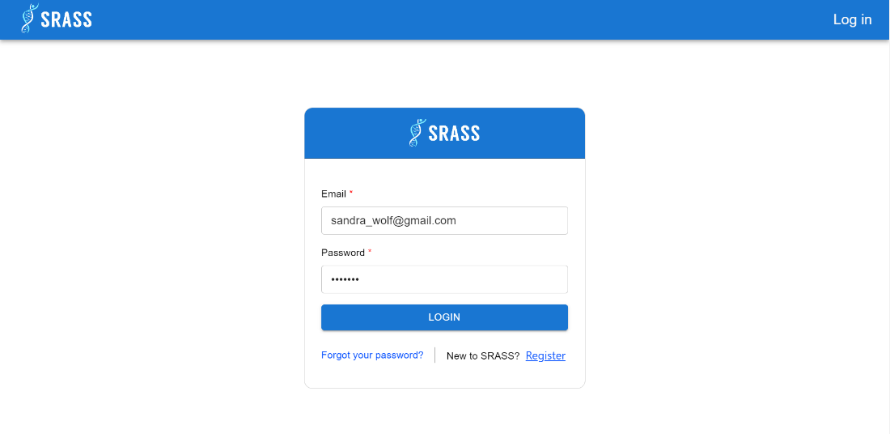

* + Unauthenticated User input email, password and clicks on “Login” button.
  + System queries the email and password in the database to verify the account exists.
  + System validates the resolving content:
    - Success: System generates a JWT and returns the JWT back to the browser.
    - Fail: System returns and shows error message.

1. **Register**
   * **Function trigger:** Unauthenticated User request to join into the system with the role “**Authenticated User**” by clicking on the “Register” button.
   * **Function description:** Unauthenticated User create an account for more access to the system.
   * **Screen layout:**

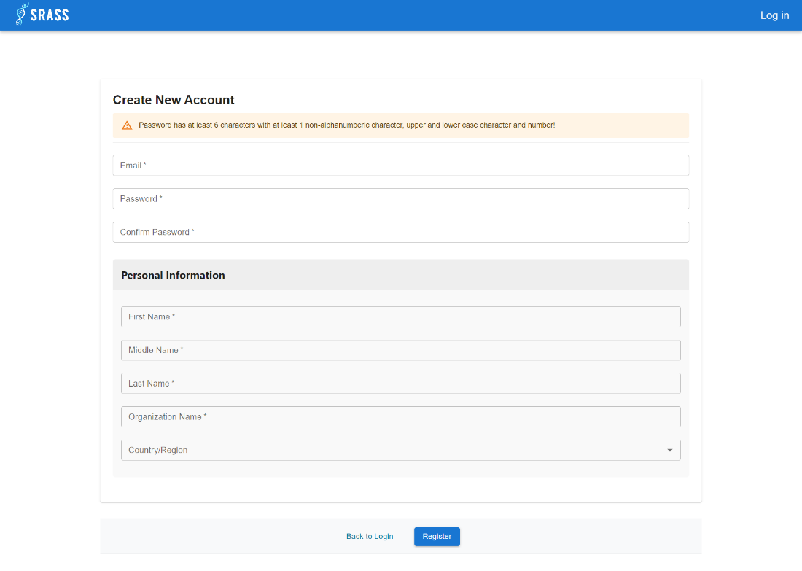

* + Unauthenticated User input email, password, confirm password, first name, middle name, last name, organization name, country and click on “Register” button.
  + System queries the email, password in the database to check if the email exists or password has corrected format already.
  + System validates the resolving content:
    - Success: System send email to Unauthenticated User to confirm email. After clicking the link in Unauthenticated User's email account, the system will redirect to “Log in” page.
    - Fail: System returns and shows error message.

#### 3.2.2 <Authenticated User> Conferences

1. **Get Joined Conferences**
   * **Function trigger:** Authenticated User after login into system will enter the “Conferences” screen with tab “My Conferences” as default.
   * **Function description:** Authenticated User can view and enter joined conferences
   * **Screen layout:**

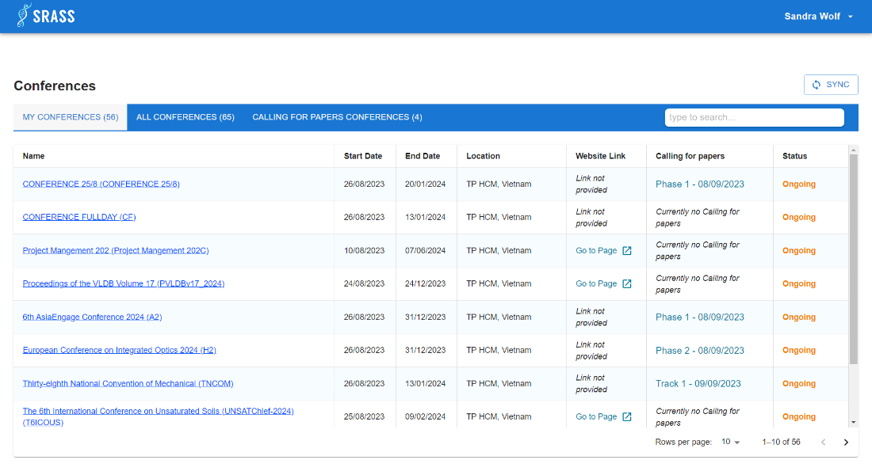

* + This function requires the user to login to the system with the role “**Authenticated User**”.
  + This function returns a list of joined conferences included: Name, StartDate, EndDate, Location, Website Link, Calling for papers link, Status.

1. **Get All Conferences**
   * **Function trigger:** Authenticated User click on tab “All Conferences”.
   * **Function description:** Authenticated User can view and enter conferences
   * **Screen layout:**

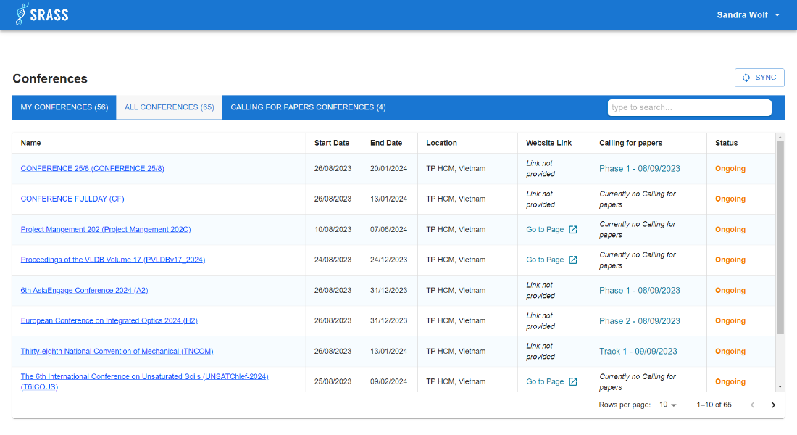

* + This function requires the user to login to the system with the role “**Authenticated User**”.
  + This function returns a list of all conferences included: Name, StartDate, EndDate, Location, Website Link, Calling for papers link, Status.

1. **Get Call for Papers Conference** 
   * **Function trigger:** Authenticated User click on tab “Calling for Papers Conferences”.
   * **Function description:** Authenticated User can view and enter conferences that are calling for paper submission.
   * **Screen layout:**

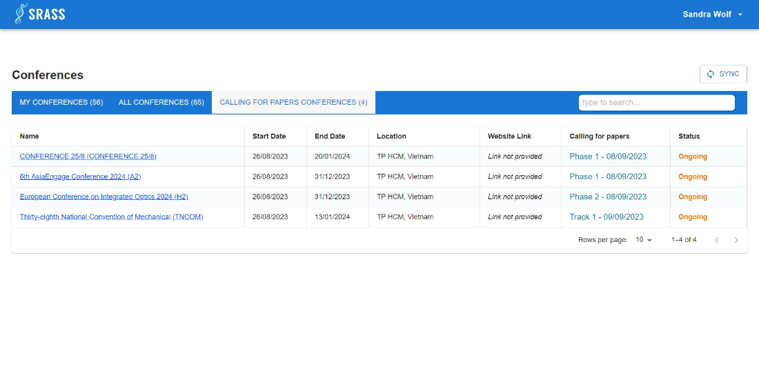

* + This function requires the user to login to the system with the role “**Authenticated User**”.
  + This function returns a list of conferences that are calling for paper submission included: Name, StartDate, EndDate, Location, Website Link, Calling for papers link, Status.

#### 3.2.3 <PC Chair> Conference Overview Dashboard

* + **Function trigger:** PC Chair click conference name on “Conferences”.
  + **Function description:** PC Chair can view conference details such as conference logo, conference name, conference short name, conference status, city, country, current phase of the conference, start date, end date. Below the tab Summary, PC Chair can view conference website link, list of subject areas, list of tracks in conference.
  + **Screen layout:**

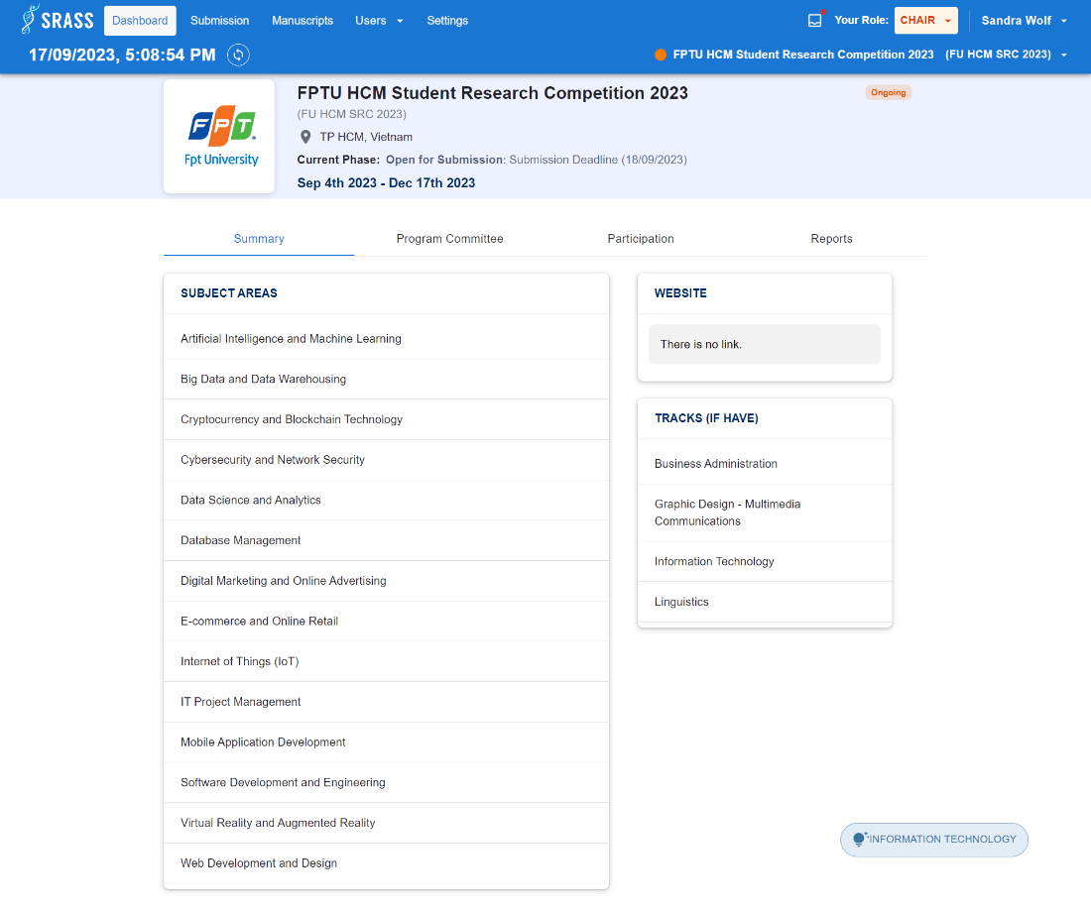

* + This function requires the user to login to the system with the role “**PC Chair**”.
  + The system returns with conference details included: logo, conferenceFullName, conferenceShortName, city, country, status, currentPhase, startDate, endDate.
  + If subject area has results, the system shows a list of subject areas. If not, system return a message “Subject Areas Empty”.
  + If website link has results, the system shows the web link. If not, the system returns a message “There is no link”.
  + If track has results, the system shows a list of tracks. If not, the system returns a message “Tracks Empty”.

#### 3.2.4 <PC Chair> Conference Committee

* + **Function trigger:** PC Chair click tab “Program Committee” in “Conference Overview Dashboard”.
  + **Function description:** PC Chair can view committees in conference.
  + **Screen layout:**

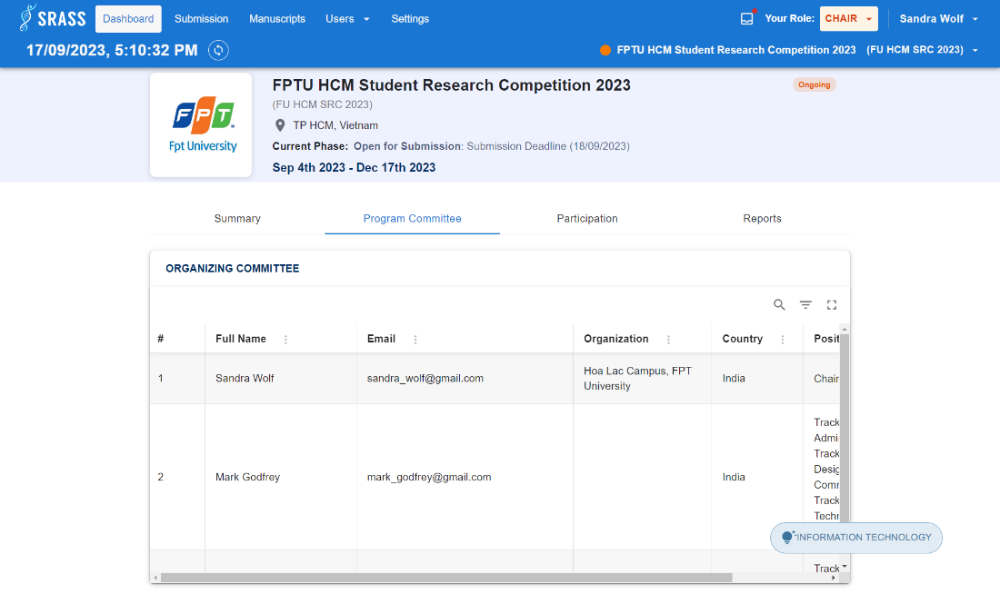

* + This function requires the user to login to the system with the role “**PC Chair**”.
  + If committee has results, the system shows a list of program committees in conference. If not, system return a message “No record to display”.

#### 3.2.5 <PC Chair> Conference Participation Dashboard

* + **Function trigger:** PC Chair click tab “Participation” in “Conference Overview Dashboard”.
  + **Function description:** PC Chair can view overall statistic of conference and each track.
  + **Screen layout:**

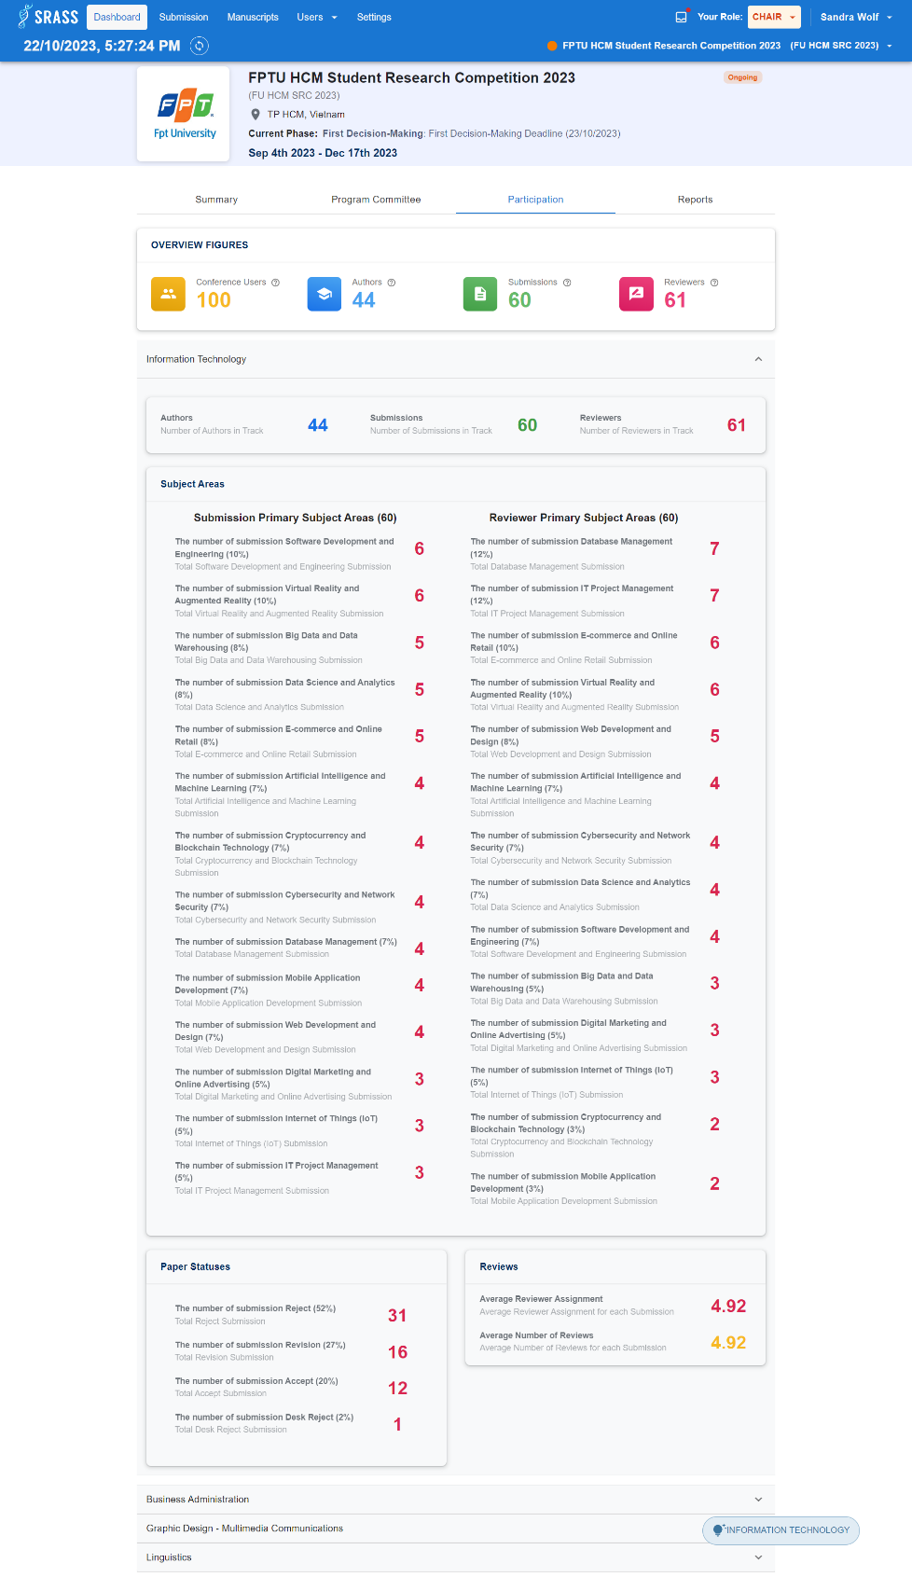

* + This function requires the user to login to the system with the role “**PC Chair**”.

#### 3.2.6 <PC Chair> Reports

* + **Function trigger:** PC Chair click tab “Reports” in “Conference Overview Dashboard”.
  + **Function description:** PC Chair
  + **Screen layout:**

#### 3.2.7 <PC Chair> Submission Console

* + **Function trigger:** PC Chair click on the “Submission” on header.
  + **Function description:** PC Chair can view list of submission and statistic related to submission in conference.
  + **Screen layout:**

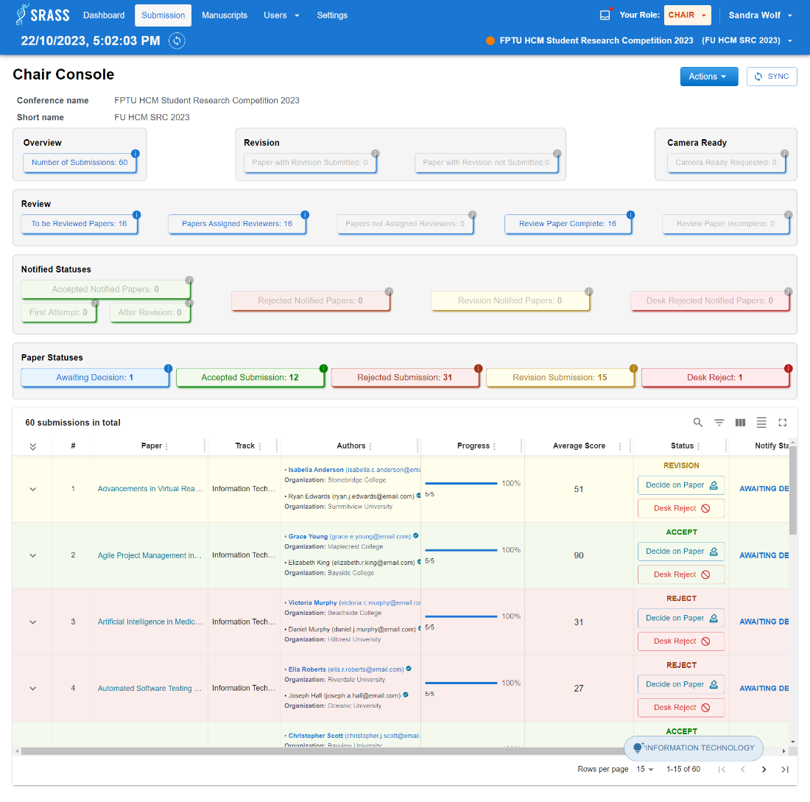

* + This function requires the user to login to the system with the role “**PC Chair**”.
  + If submission has results, the system shows a list of submission in conference included: title, track name, authors, PC ChairNoteId, reviewerConflicts, submissionConflicts, assigned, progress, averageScore, status, notifyStatus, revisionSubmitted, isRequestedForCameraReady, cameraReadySubmitted. If not, system return a message “No record to display”.
  + Table column visible based on that phase of the conference.
  + PC Chair can click on statistic buttons to filter submission data table.
    - Statistic button disabled when statistic value is 0.
    - The statistic button will be highlighted if that statistic needs attention based on that phase of the conference.

#### 3.2.8 <PC Chair> Reviewer Assignment Console

1. **All Reviewer**
   * **Function trigger:** PC Chair click “Edit Reviewer Assignments” in the “Submission Console” table action menu.
   * **Function description:** PC Chair can view list of reviewers and assign reviewers to review submission.
   * **Screen layout:**

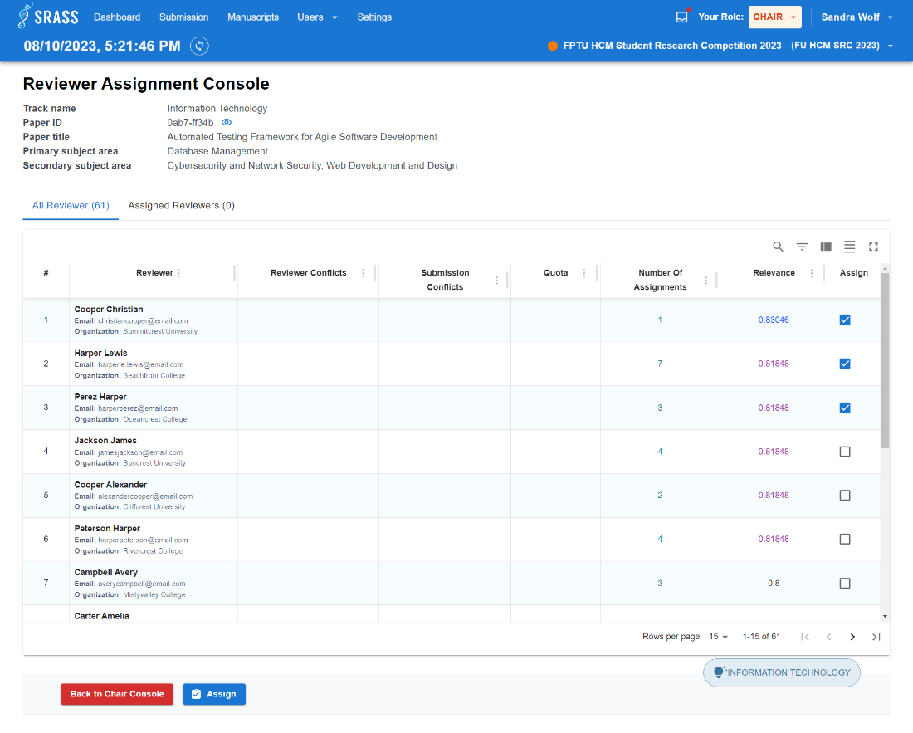

* + This function requires the user to login to the system with the role “**PC Chair**”.
  + The system returns the list of reviewer order by relevance score. The top highest relevance score is highlighted in blue, and the second highest score is highlighted in purple.

1. **Assigned Reviewers**
   * **Function trigger:** After assign reviewers or click on the “Assigned Reviewers” tab.
   * **Function description:** PC Chair can view reviewers who were assigned to the submission or can also unassign to the reviewer.
   * **Screen layout:**

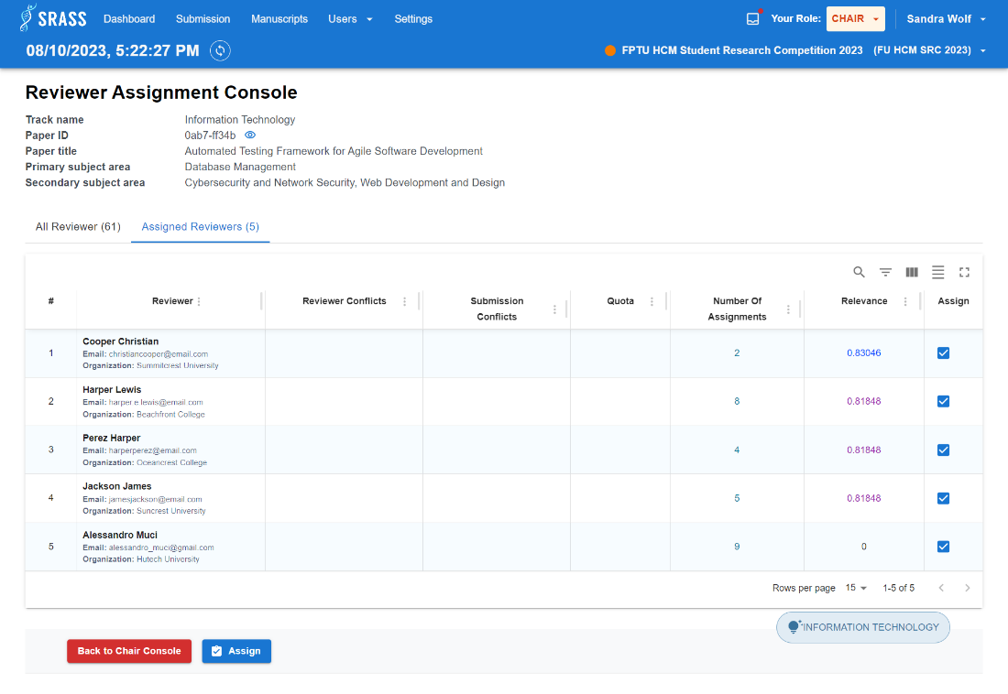

* + This function requires the user to login to the system with the role “**PC Chair**”.
  + The system returns the list of reviewers assigned to submission.

#### 3.2.9 <PC Chair> Paper Decision

1. **View Review**
   * **Function trigger:** PC Chair click on “Decide on Paper” button in the “Submission Console” table status column.
   * **Function description:** PC Chair can view reviews of submission before giving decision on submission.
   * **Screen layout:**

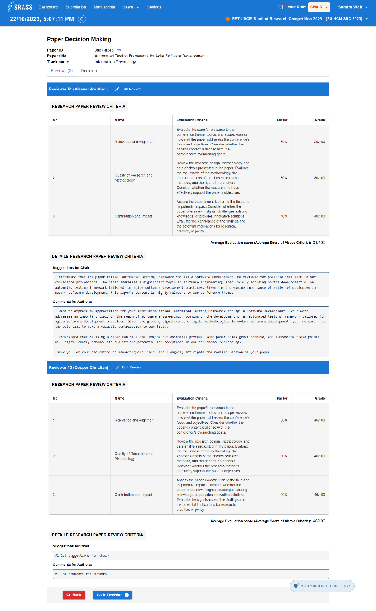

* + This function requires the user to login to the system with the role “**PC Chair**”.
  + If has reviews, the system shows a list of reviews of submission. If not, system navigate to “Decision” tab.

1. **Decision**
   * **Function trigger:** PC Chair click on “Go to Decision” button in “Reviews” tab or click on the “Decision” tab.
   * **Function description:** PC Chair decide status on submission after reading reviews.
   * **Screen layout:**

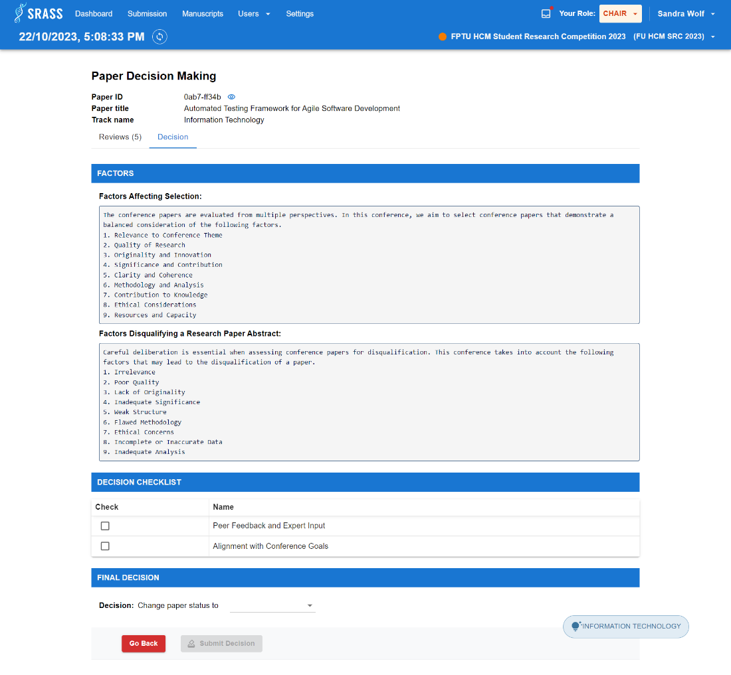

* + This function requires the user to login to the system with the role “**PC Chair**”.
  + This function requires: decision checklist must be checked, and final decision must be selected.

#### 3.2.10 <PC Chair and Author> Submission Edits

* + **Function trigger:** If selected role is:
    - * **PC Chair:** 
        + Click “Edit Submission” in the “Submission Console” table action menu.
      * **Author:**
        + Click “Edit Submission” button in the “Author Console” table action column.
  + **Function description:** PC Chair or Author can edit information of submission before deadline.
  + **Screen layout:**

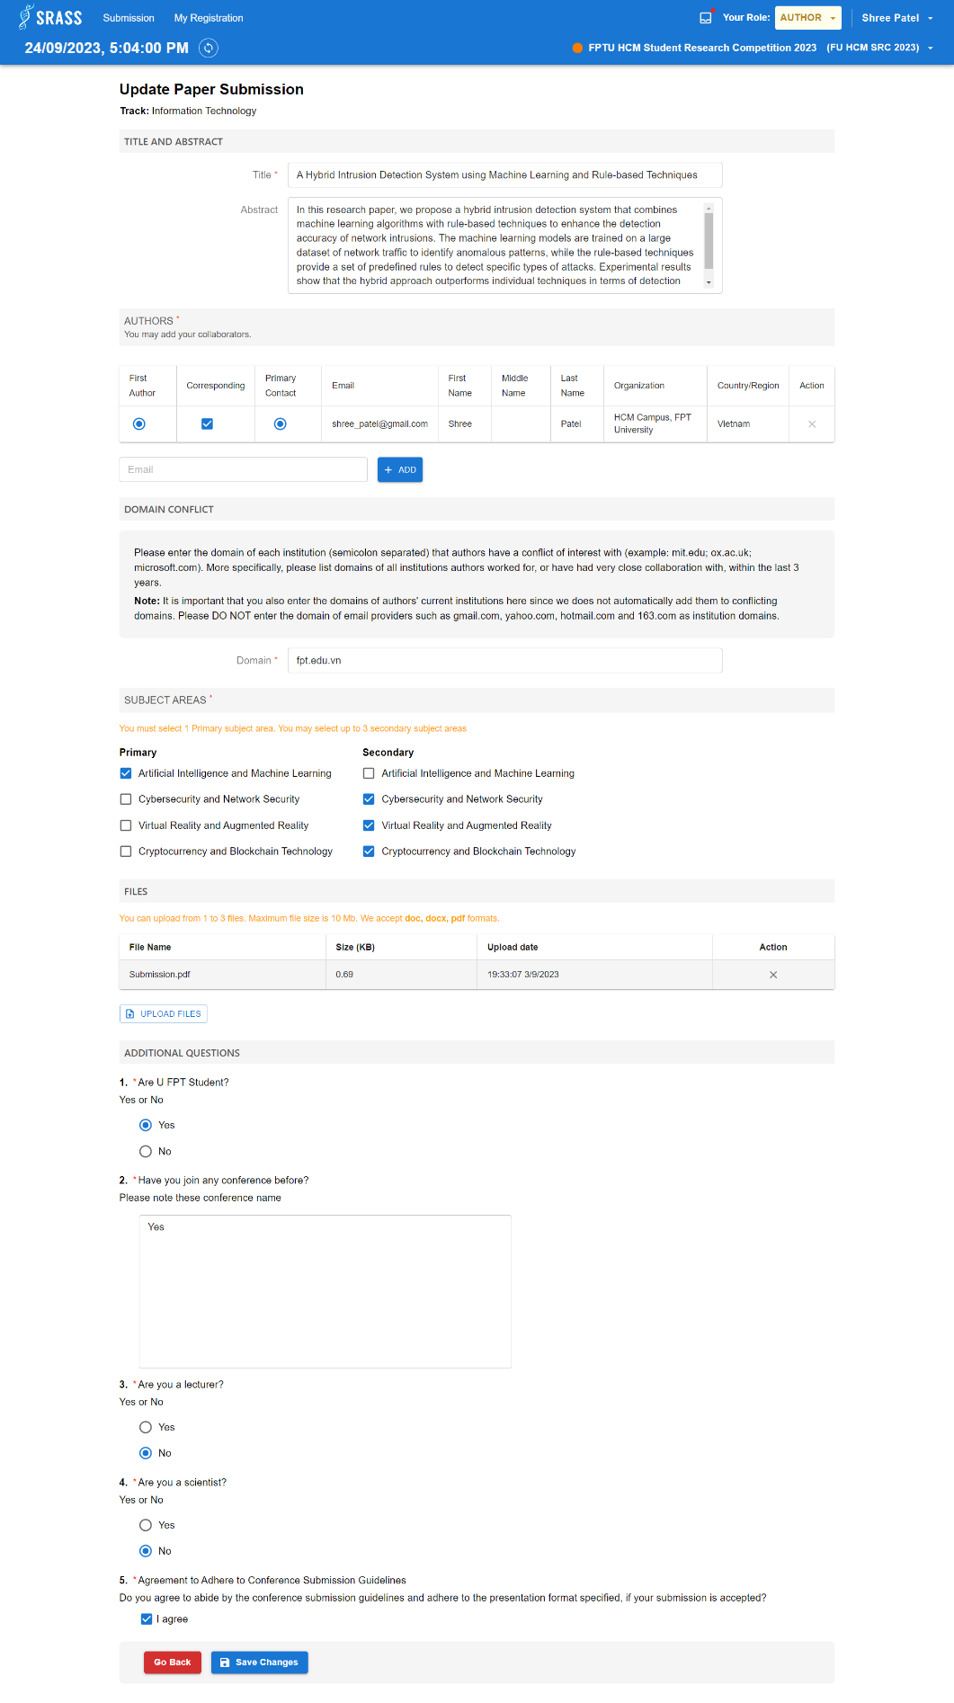

* + This function requires the user to login to the system with the role “**PC Chair**” or “**Author**”.
  + This function requires: Title, Abstract, Authors, Domain Conflict, Subject Areas, Submission Files, Additional Questions.

#### 3.2.11 <PC Chair and Author> New Submission Creation

* + **Function trigger:** If selected role is:
    - * **PC Chair:** 
        + Click “Create New Submission” in the “Action” dropdown button top right of the “Submission Console”.
      * **Author:**
        + Click “Submit paper here link” on top right of the “Author Console”.
  + **Function description:** PC Chair or Author can submit new submission in conference.
  + **Screen layout:**

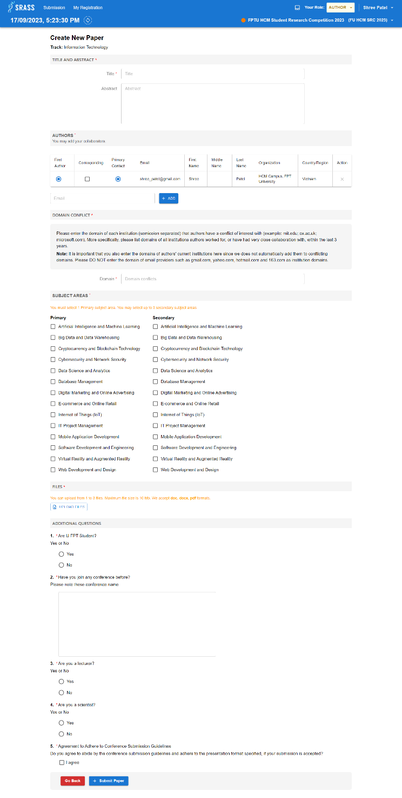

* + This function requires the user to login to the system with the role “**PC Chair**” or “**Author**”.
  + This function requires: Title, Abstract, Authors, Domain Conflict, Subject Areas, Submission Files, Additional Questions.

#### 3.2.12 <PC Chair, Author and Reviewer> Submission Summary

* + **Function trigger:** If selected role is:
    - * **PC Chair:** 
        + Click submission title or click “View Submission” in the “Submission Console” table action menu.
      * **Author:**
        + Click submission id in the “Author Console”.
      * **Reviewer:**
        + Click submission id in the “Reviewer Console”.
  + **Function description:** PC Chair, Author or Reviewer can view submission details.
  + **Screen layout:**

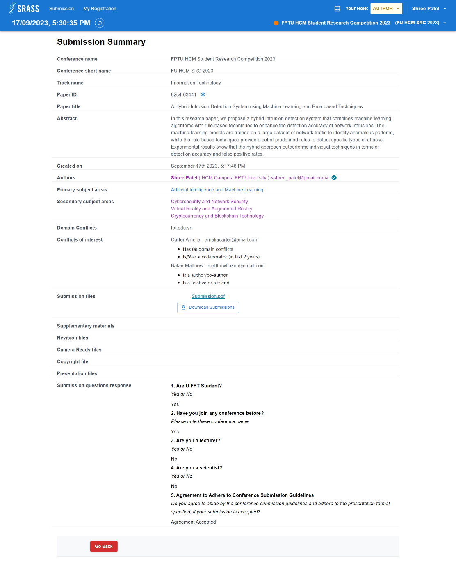

* + This function requires the user to login to the system with the role “**PC Chair**” or “**Author**” or “**Reviewer**”.
  + Submission question response is not visible for role Reviewer.

#### 3.2.13 <PC Chair and Author> Submission Conflict of Interests

* + **Function trigger:** If selected role is:
    - * **PC Chair:** 
        + Click “Edit Conflicts” in the “Submission Console” table action menu.
      * **Author:**
        + Click “Edit Conflicts” button in the “Author Console” table action column.
  + **Function description:** PC Chair or Author can choose conflict with reviewer for submission in conference.
  + **Screen layout:**

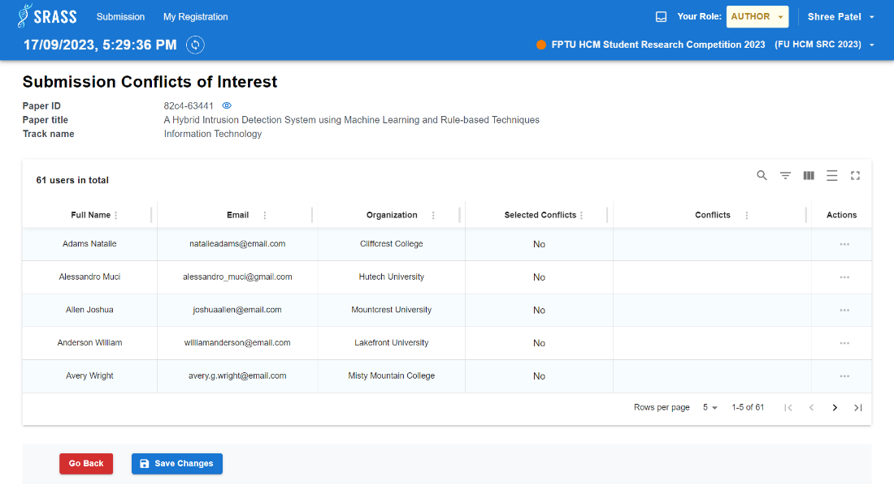

* + This function requires the user to login to the system with the role “**PC Chair**” or “**Author**”.
  + This function allows update list of conflicts for each reviewer. PC Chair or Author can click more menu in Actions column to choose conflicts for reviewer.

#### 3.2.14 <PC Chair> Author Notification Track Selection

* + **Function trigger:** PC Chair click “Author Notification” in the “Action” dropdown button top right of the “Submission Console”.
  + **Function description:** PC Chair choose track needs to send notification.
  + **Screen layout:**

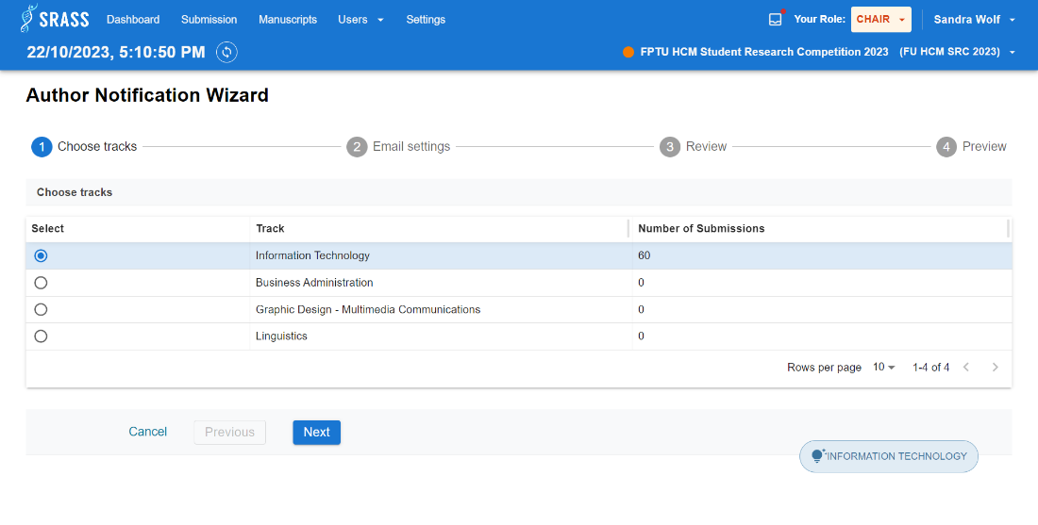

* + This function requires the user to login to the system with the role “**PC Chair**”.
  + This function requires PC Chair to choose 1 track to continue next step.

#### 3.2.15 <PC Chair> Author Notification Email Setting

1. **Email Setting**
   * **Function trigger:** PC Chair click “Next” button in “Author Notification Track Selection” page.
   * **Function description:** PC Chair can select recipient's option, create/edit email template and select the email template to send for submissions based on the decision status.
   * **Screen layout:**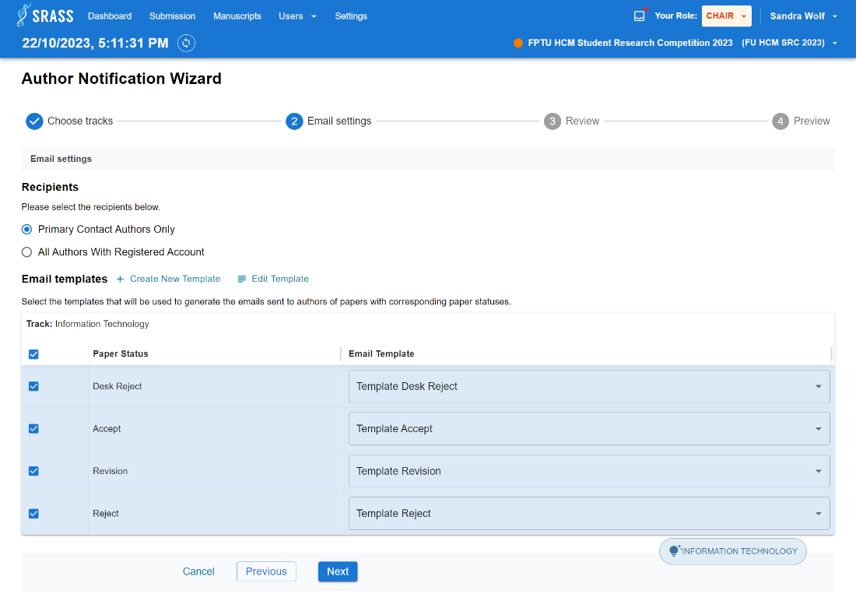
   * This function requires the user to login to the system with the role “**PC Chair**”.
   * This function requires PC Chair to choose at least 1 status to continue next step.
2. **Create Email Template**
   * **Function trigger:** Click “Create New Template” button in “Email Setting” page.
   * **Function description:** This function allows create new email template for conference. If selected role is:
     + - **PC Chair:** 
         * Email template created by PC Chair will appear for all tracks within conference.
   * **Screen layout:**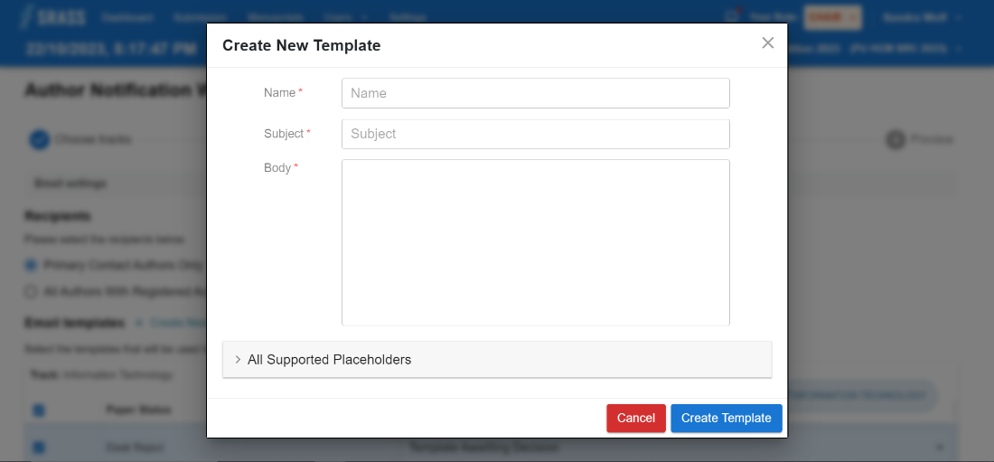
   * This function requires the user to login to the system with the role “**PC Chair**”.
   * PC Chair fill in all required fields and then click “Create Template” to create new or click “Cancel” to close modal.
   * PC Chair can use all supported placeholders to map information related to conference such as: Conference Name, Submission Title, Recipient Last Name, Recipient First Name, etc...
3. **Edit Email Template**
   * **Function trigger:** Click “Edit Template” button in “Email Setting” page.
   * **Function description:** This function allows edit email template in conference. If selected role is:
     + - **PC Chair:** 
         * Can edit email template in conference.
   * **Screen layout:** 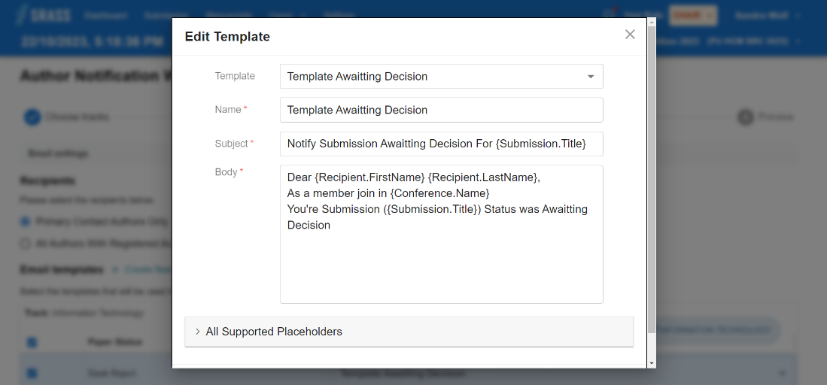
   * This function requires the user to login to the system with the role “**PC Chair**”.
   * PC Chair can select template name and edit fields. Then click “Update Template” to update new information or click “Cancel” to close modal.

#### 3.2.16 <PC Chair> Author Notification Email Reviewing

* + **Function trigger:** PC Chair click “Next” button in “Author Notification Email Setting” page.
  + **Function description:** PC Chair can view total emails and number of emails sent to submissions of each decision status.
  + **Screen layout:**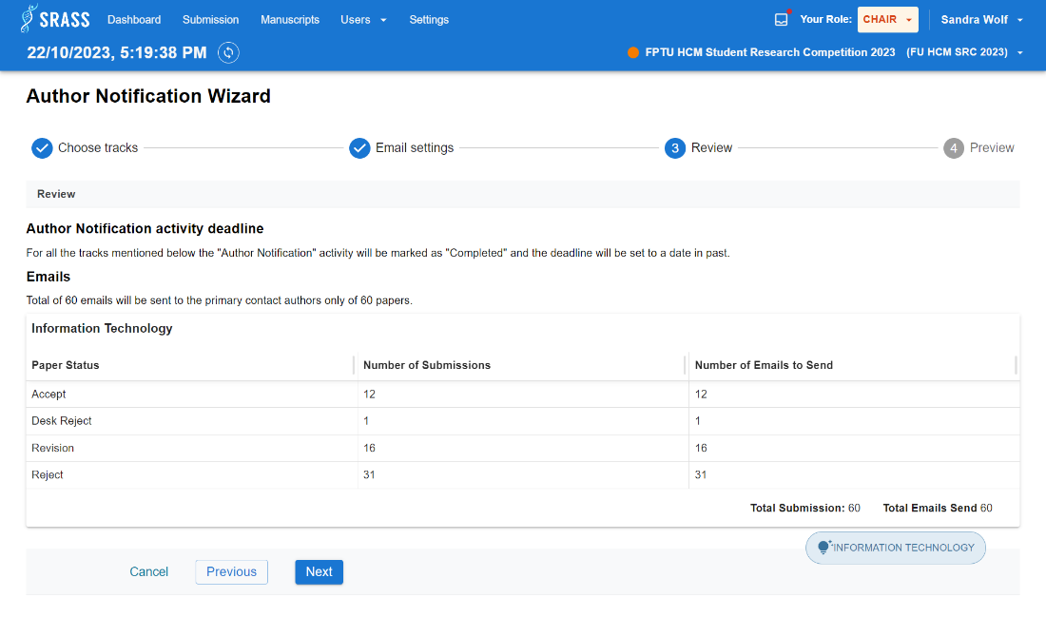
  + This function requires the user to login to the system with the role “**PC Chair**”.

#### 3.2.17 <PC Chair> Author Notification Previewing

* + **Function trigger:** PC Chair click “Next” button in “Author Notification Email Reviewing” page.
  + **Function description:** PC Chair can preview list of authors to send emails corresponding with specific paper status.
  + **Screen layout:**

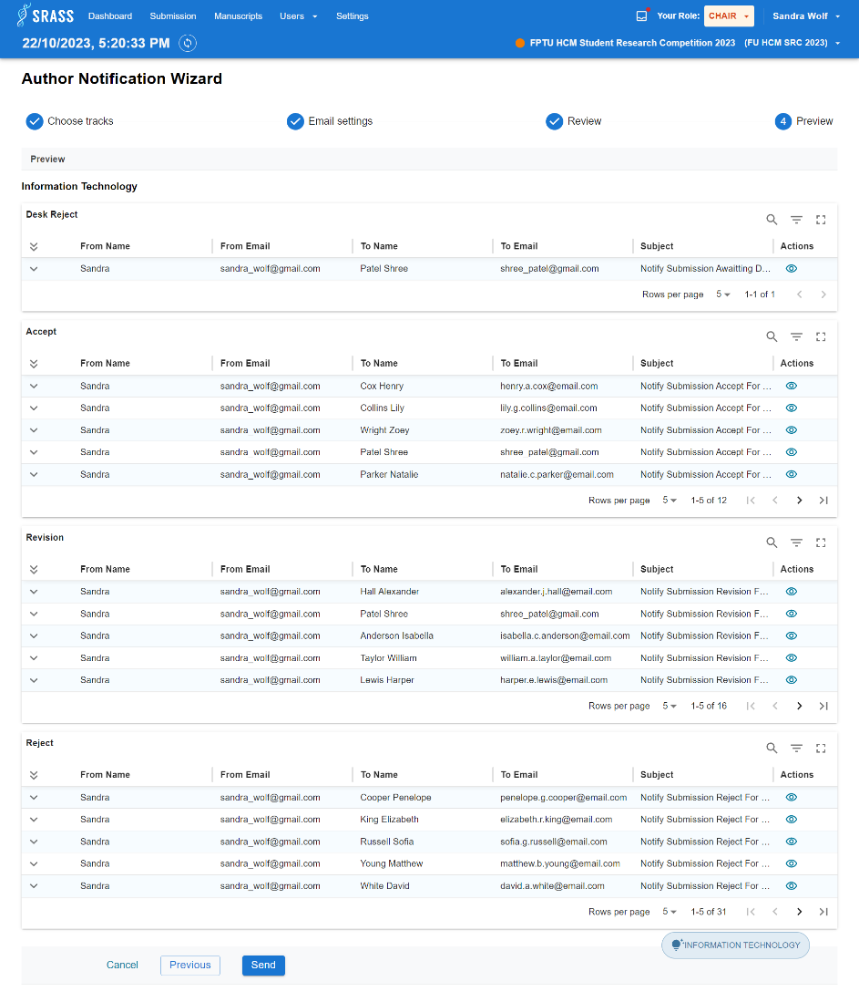

* + This function requires the user to login to the system with the role “**PC Chair**”.
  + The system returns tables with detailed information of each email sent with each decision status.

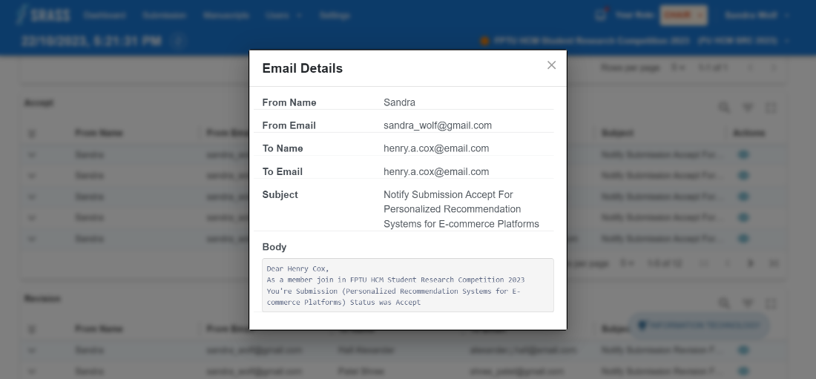

* + PC Chair can click on button  on each row to view popup of full detail email.
  + PC Chair click button “Send” to send emails.

#### 3.2.18 <PC Chair and Author> Author Notification Send Email

* + **Function trigger:** PC Chair click “Send” button in “Author Notification Previewing” page.
  + **Function description:** PC Chair can view which selected paper statuses has been sent to authors.
  + **Screen layout:**

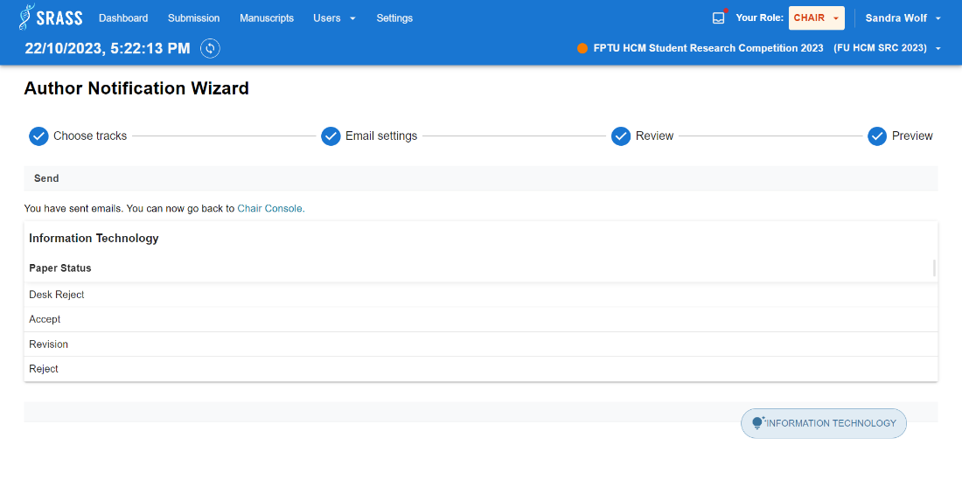

* + This function requires the user to login to the system with the role “**PC Chair**”.

#### 3.2.19 <PC Chair and Author> Upload Revision

* + **Function trigger:** If selected role is:
    - * **PC Chair:** 
        + Click “Upload Revision” in the “Submission Console” table action menu.
      * **Author:**
        + Click “Upload Revision” button in the “Author Console” table action column.
  + **Function description:** PC Chair and Author can upload revision file for submission paper.
  + **Screen layout:**

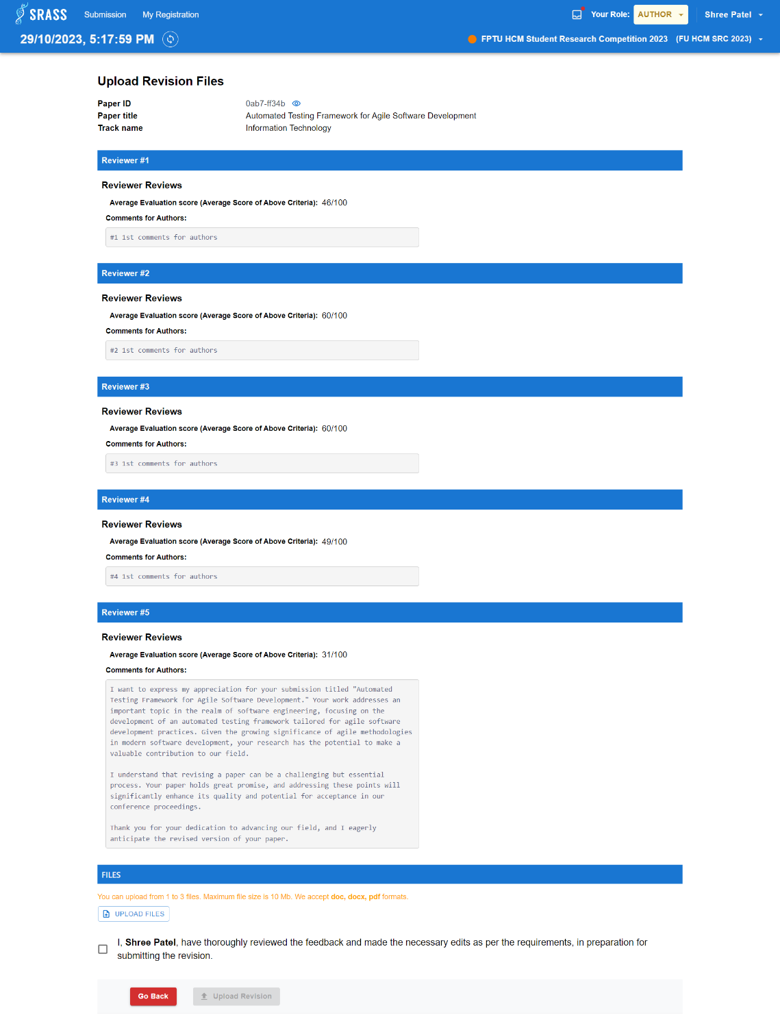

* + This function requires the user to login to the system with the role “**PC Chair**” or “**Author**”.
  + PC Chair or Author can view list of reviews included: average evaluation score, and comments for authors.
  + This function requires submitting a revision file and selecting checkbox to confirm that feedback has been read carefully. Then click button “Upload Revision” to submit revision.

#### 3.2.20 <PC Chair and Author> Edit Revision

* + **Function trigger:** If selected role is:
    - * **PC Chair:** 
        + Click “Edit Revision” in the “Submission Console” table action menu.
      * **Author:**
        + Click “Edit Revision” button in the “Author Console” table action column.
  + **Function description:** PC Chair and Author can edit revision of submission.
  + **Screen layout:**

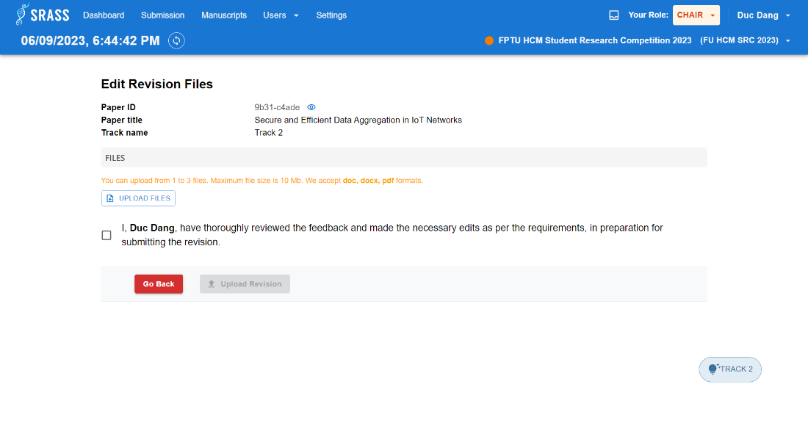

* + This function requires the user to login to the system with the role “**PC Chair**” or “**Author**”.

#### 3.2.21 <PC Chair and Author> Upload Presentation

* + **Function trigger:** After request for presentation is enabled by PC Chair for submission. If selected role is:
    - * **PC Chair:** 
        + Click “Upload Presentation” in the “Manuscripts” table action menu.
      * **Author:**
        + Click “Upload Presentation” button in the “Author Console” table action column.
  + **Function description:** PC Chair and Author can upload presentation file when the submission has been requested for presentation, and the conference has reached the [Open for Presentation Submission] phase.
  + **Screen layout:**

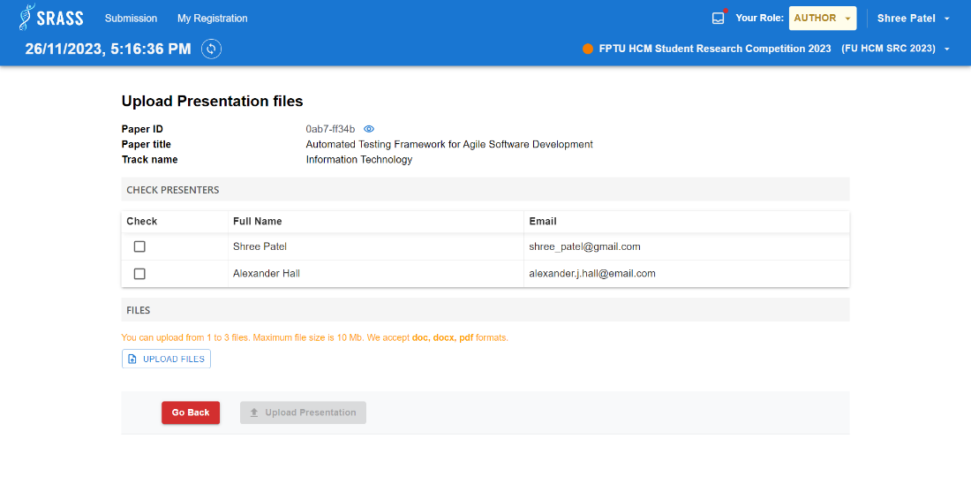

* + This function requires the user to login to the system with the role “**PC Chair**” or “**Author**”.
  + This function requires to select presenters and upload presentation file. Then click button “Upload Presentation” to submit.

#### 3.2.22 <PC Chair and Author> Edit Presentation

* + **Function trigger:** If selected role is:
    - * **PC Chair:** 
        + Click “Edit Presentation” in the “Manuscripts” table action menu.
      * **Author:**
        + Click “Edit Presentation” button in the “Author Console” table action column.
  + **Function description:** PC Chair and Author can edit presentation of submission.
  + **Screen layout:**

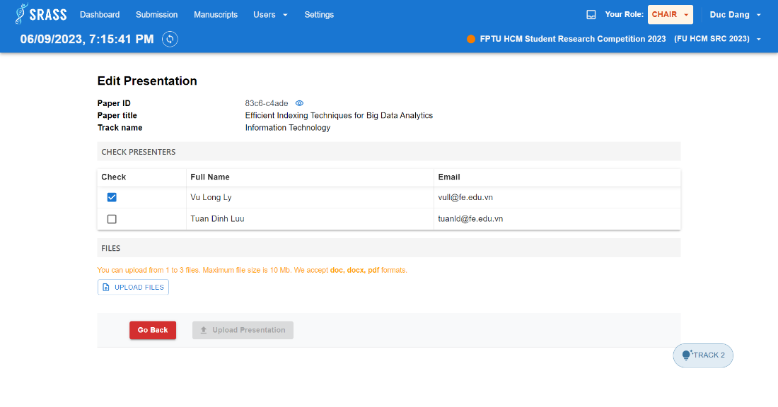

* + This function requires the user to login to the system with the role “**PC Chair**” or “**Author**”.

#### 3.2.23 <PC Chair and Author> Create Camera Ready

* + **Function trigger:** After request for camera ready is enabled by PC Chair for submission.If selected role is:
    - * **PC Chair:** 
        + Click “Create Camera Ready” in the “Manuscripts” table action menu.
      * **Author:**
        + Click “Create Camera Ready” button in the “Author Console” table action column.
  + **Function description:** PC Chair and Author can submit camera ready and copyright file when the submission has been requested for camera ready, and the conference has reached the [Open for Camera Ready Submission]phase.
  + **Screen layout:**

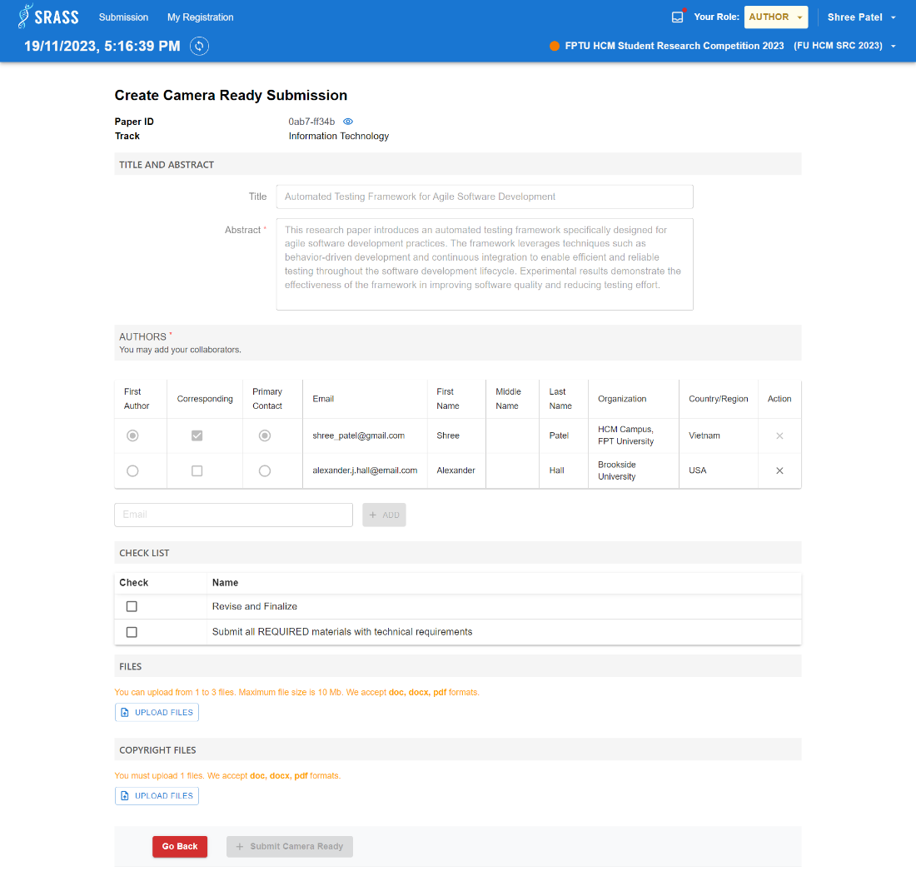

* + This function requires the user to login to the system with the role “**PC Chair**” or “**Author**”.
  + PC Chair and Author requires to submit presentation and copyright files. Then click button “Submit Camera Ready” to submit.

#### 3.2.24 <PC Chair and Author> Edit Camera Ready

* + **Function trigger:** If selected role is:
    - * **PC Chair:** 
        + Click “Edit Camera Ready” in the “Manuscripts” table action menu.
      * **Author:**
        + Click “Edit Camera Ready” button in the “Author Console” table action column.
  + **Function description:** PC Chair and Author can edit camera ready file or copyright file of submission.
  + **Screen layout:**

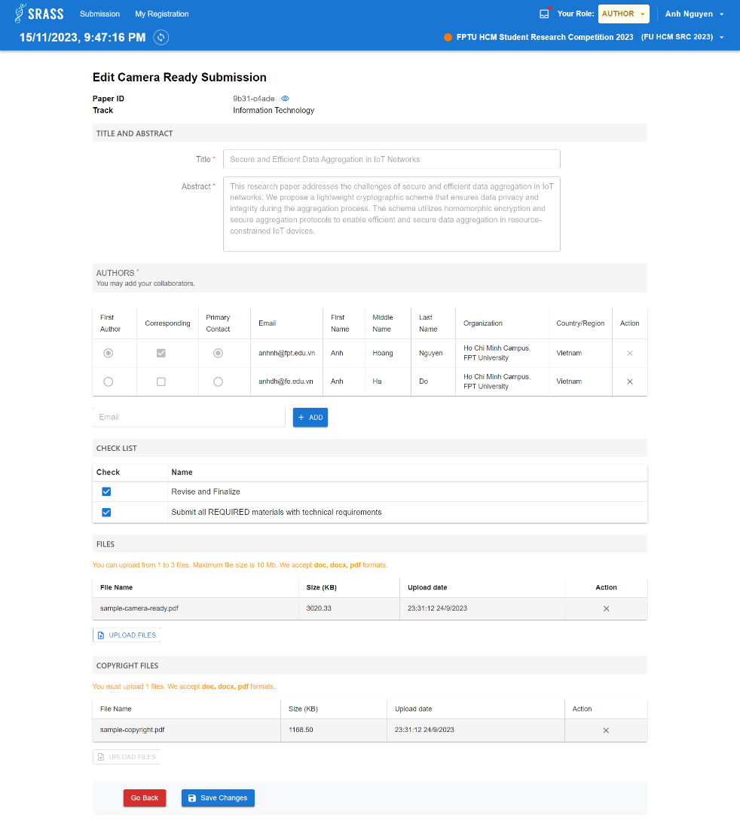

* + This function requires the user to login to the system with the role “**PC Chair**” or “**Author**”.

#### 3.2.25 <PC Chair> PC Chair View Review

* + **Function trigger:** PC Chair click “View Review” in the “Submission Console” table action menu.
  + **Function description:** PC Chair can view reviewers' reviews of submission with content such as scores, suggestions for the PC Chair, and comments for the author.
  + **Screen layout:**

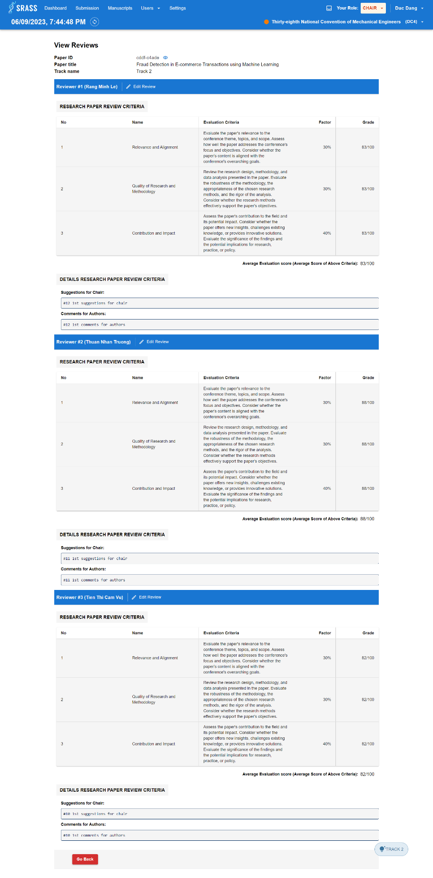

* + This function requires the user to login to the system with the role “**PC Chair**”.
  + PC Chair can view list of reviews included: list of review criteria, average evaluation score, suggestion for PC Chair, comments for authors.

#### 3.2.26 <PC Chair and Reviewer> Edit Review

* + **Function trigger:** If selected role is:
    - * **PC Chair:** 
        + Click “Edit Review” in the “Submission Console” table action menu.
      * **Author:**
        + Click “Edit Review” button in the “Reviewer Console” table action column.
  + **Function description:** PC Chair and Reviewer can edit review for submission.
  + **Screen layout:**

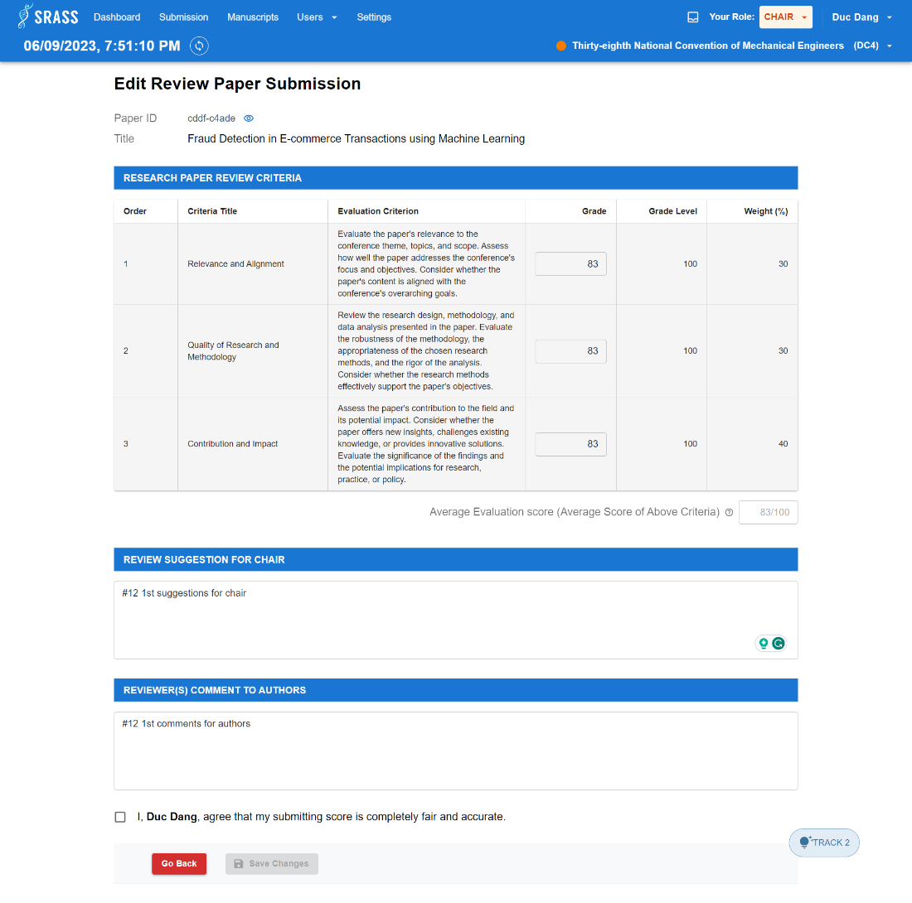

* + This function requires the user to login to the system with the role “**PC Chair**” or “**Reviewer**”.
  + PC Chair or Author can edit grades, suggestion for PC Chair, comment for authors.
  + This function requires selecting checkbox to confirm that score submitting is fair and accurate. Then click button “Save Changes” to submit review.

#### 3.2.27 <PC Chair> Conference Users

1. **Manage Conference Users**
   * **Function trigger:** PC Chair click on the “Users” dropdown and select “Conference User” on header.
   * **Function description:** PC Chair can manage conference user.
   * **Screen layout:**

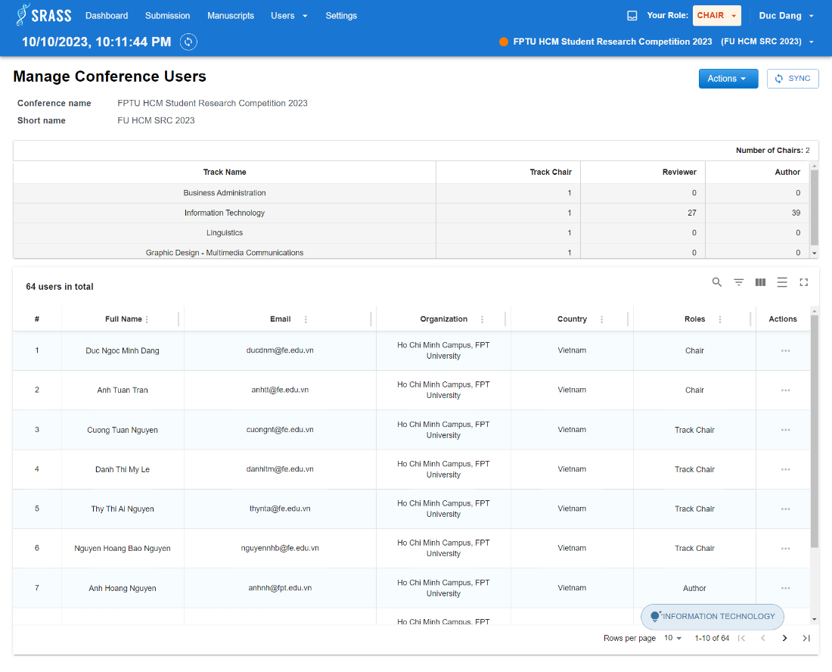

* + This function requires the user to login to the system with the role “**PC Chair**”.
  + This function returns a list of all users of the conference included: Full Name, Email, Organization, Country, Roles.

1. **Add user to conference**
   * **Function trigger:** 
     + PC Chair click “Add user to conference” in the “Action” dropdown button top right of the “Manage Conference Users” page to show pop-up to search user by email.
     + After searching the user needed to add by email, PC Chair will click on button “Add Role” to add roles such as **Reviewer**, **Author**, **PC Chair**.
     + After choosing role, the pop-up choose track will show up and PC Chair will add user with role to tracks. Then click button “Save Changes” to add user to conference.
   * **Function description:** PC Chair can add user to conference by email and select role for user in track of conference.
   * **Screen layout:**

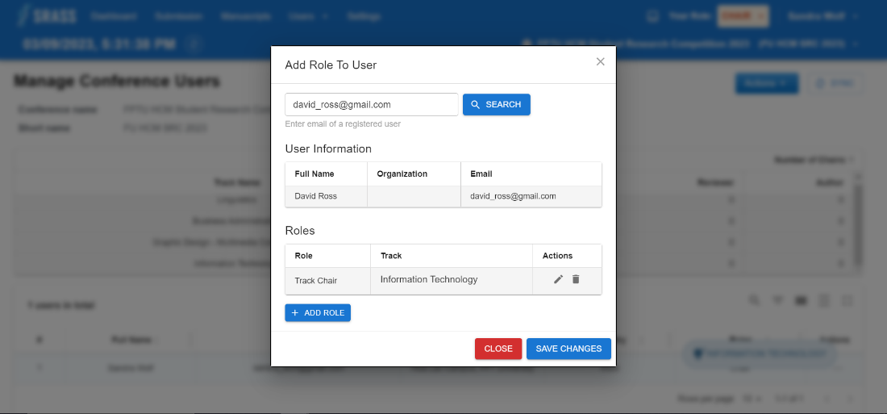

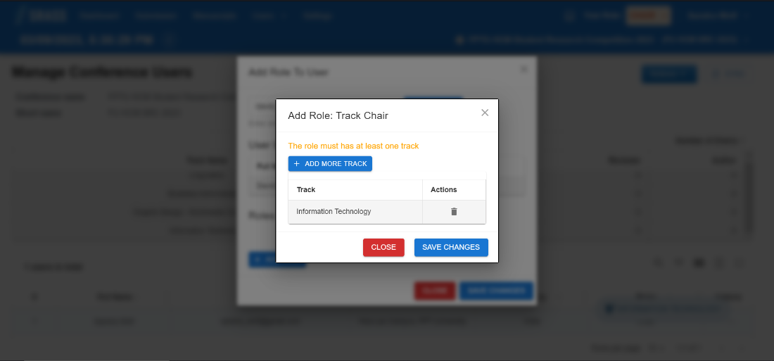

* + This function requires the user to login to the system with the role “**PC Chair**”.
  + PC Chair will search for user by email and select roles. If selected role is:
    - * **PC Chair:** 
        + There is no need to select a track for the user to proceed with adding.
      * **Reviewer/Author/PC Chair:**
        + Must select at least 1 track for user to proceed with adding.
  + When clicking “Save Changes”, if success, it will return to “Manage Conference Users” screen, else, error message will show.

#### 3.2.28 <PC Chair> Reviewer Management

* + **Function trigger:** PC Chair click on the “Users” dropdown and select “Manage Reviewer” on header.
  + **Function description:** PC Chair can view list of reviewers and statistic related reviewers in conference.
  + **Screen layout:**

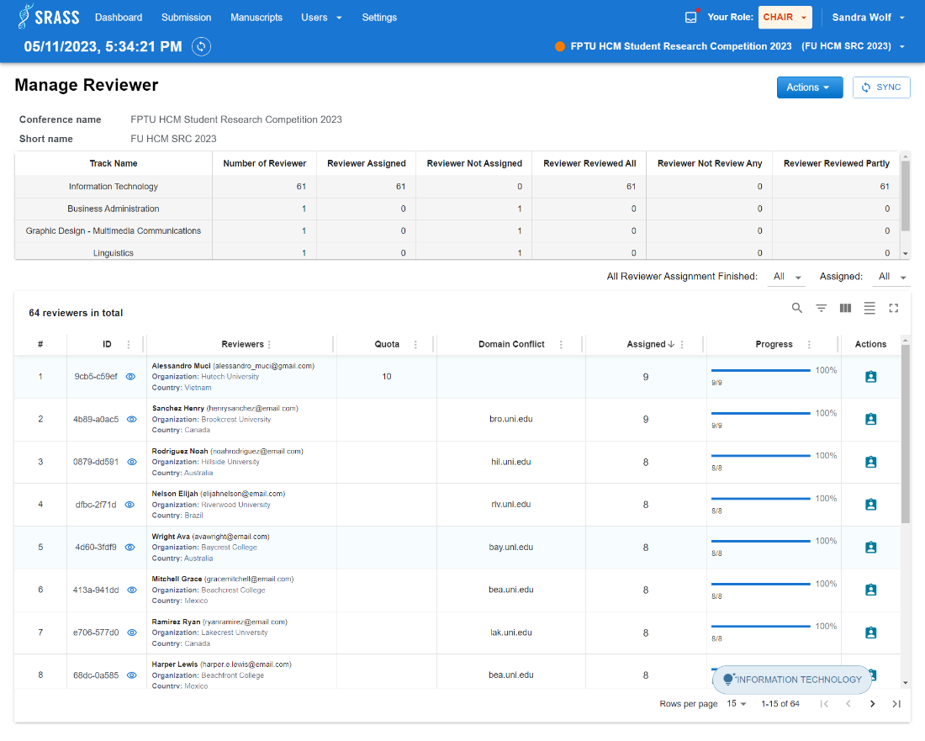

* + This function requires the user to login to the system with the role “**PC Chair**”.
  + PC Chair can view all tracks' statistic in system included: Track name, Number of reviewers, Number of reviewers assigned, Number of reviewers not assigned, Number of reviewers reviewed all, Number of reviewers not review any, Number of reviewers reviewed partly.
  + This function returns a list of all reviewers of the conference included: ID, Reviewer Full name, Reviewer email, Reviewer organization, Quota, Primary subject area, Secondary subject area, Domain conflict, Number of assigned, Review progress.

#### 3.2.29 <PC Chair> View Reviewer Assignment Report

* + **Function trigger:** PC Chair click on button  in the “Reviewer Management” table action column.
  + **Function description:** PC Chair can view detail of reviewer.
  + **Screen layout:**

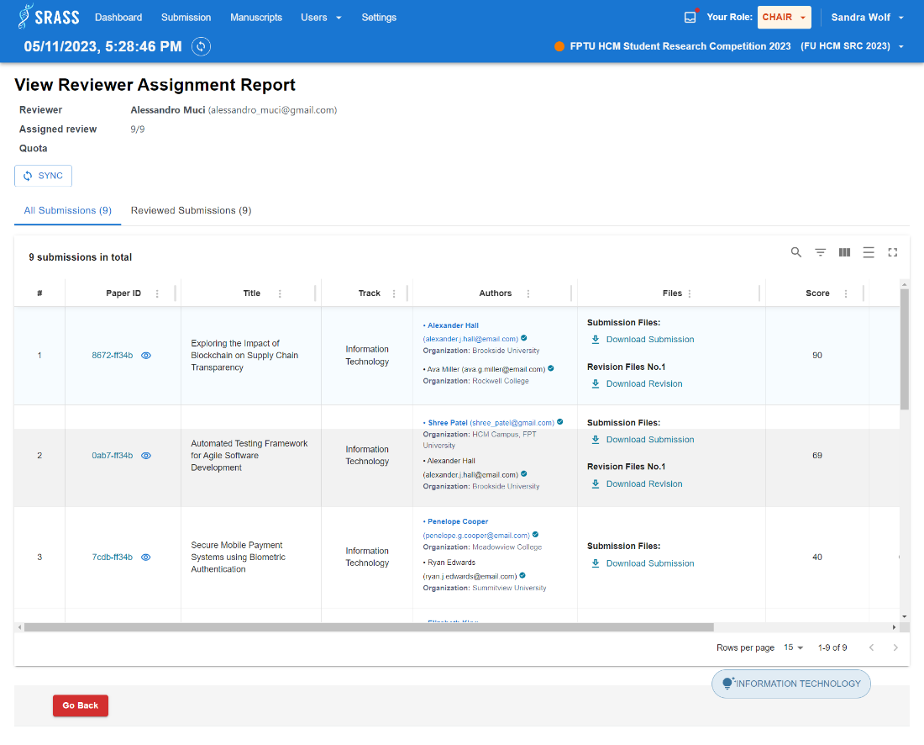

* + This function requires the user to login to the system with the role “**PC Chair**”.
  + PC Chair can view reviewer full name, reviewer email, assigned review, quota of reviewer.
  + PC Chair can click on “All Submissions” tab to view all submissions assigned to reviewer and click on “Reviewed Submissions” tab to view list of submissions that the reviewer has reviewed among the assigned submissions.
  + This function returns a list of submissions assigned to reviewer included: Paper Id, Paper title, Track name, Authors, Primary subject area, Secondary subject area, Submission files, Supplementary materials, Revision files, Score, Deadline Time, Reviewed.

#### 3.2.30 <PC Chair> Manage Reviewer Invites

* + **Function trigger:** PC Chair click on the “Users” dropdown and select “Mange Reviewer Invite” on header.
  + **Function description:** PC Chair can view list of reviewer's invitation in conference.
  + **Screen layout:**

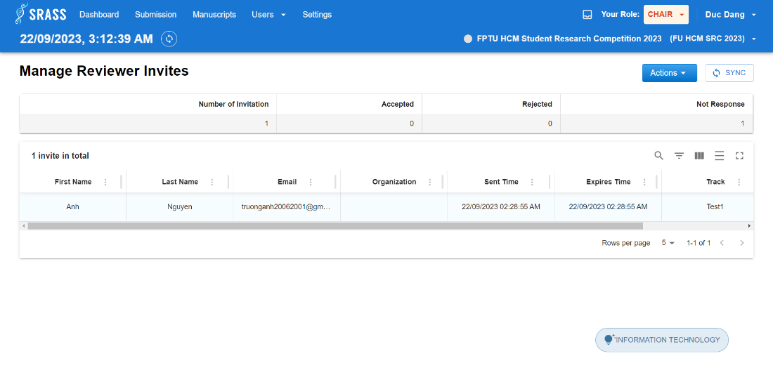

* + This function requires the user to login to the system with the role “**PC Chair**”.
  + PC Chair can view invitation statistic in conference included: Number of invitations, Number of accepted invitations, Number of rejected invitations, Number of not response invitations.
  + This function returns a list of invitation to reviewers included: First name, Last name, Email, Organization, Sent time, Expires time, Track, Status.

#### 3.2.31 <PC Chair> Reviewer Invitation User Searching

* + **Function trigger:** PC Chair click on the “Users” dropdown and select “Invite Reviewer” on header.
  + **Function description:** PC Chair can search for user in the system to invite to conference.
  + **Screen layout:**

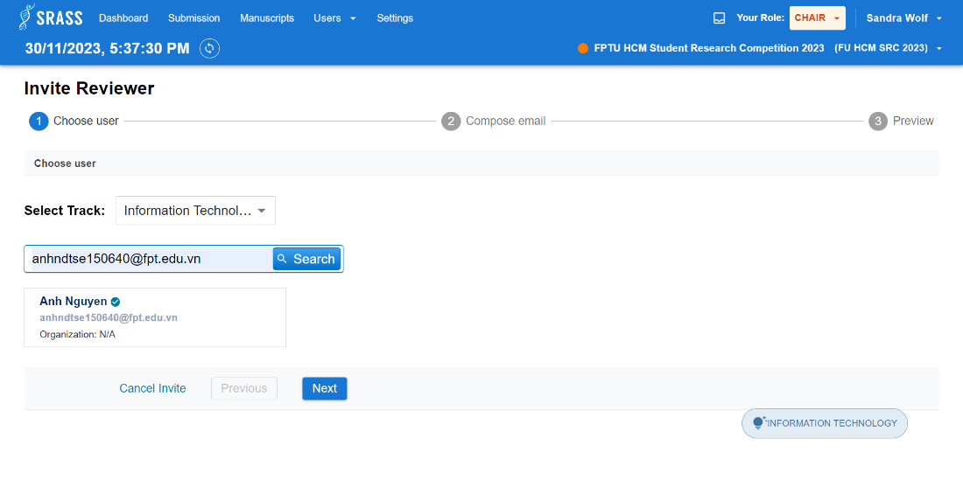

* + This function requires the user to login to the system with the role “**PC Chair**”.
  + PC Chair can search user by email. There will be the following cases:
    - If user already a reviewer in conference, the system shows message "Reviewer already in {TrackName}".
    - If user does not have account in the system, then system will show fields to create user as outsider.
    - If user has account and has not in the conference, then PC Chair can continue next step.
  + PC Chair after search user then click “Next” to continue next step or click “Cancel” to go back previous screen.

#### 3.2.32 <PC Chair> Email Composing Invitation

* + **Function trigger:** PC Chair click “Next” button in “Reviewer Invitation User Searching”.
  + **Function description:** PC Chair can compose email subject and body.
  + **Screen layout:**

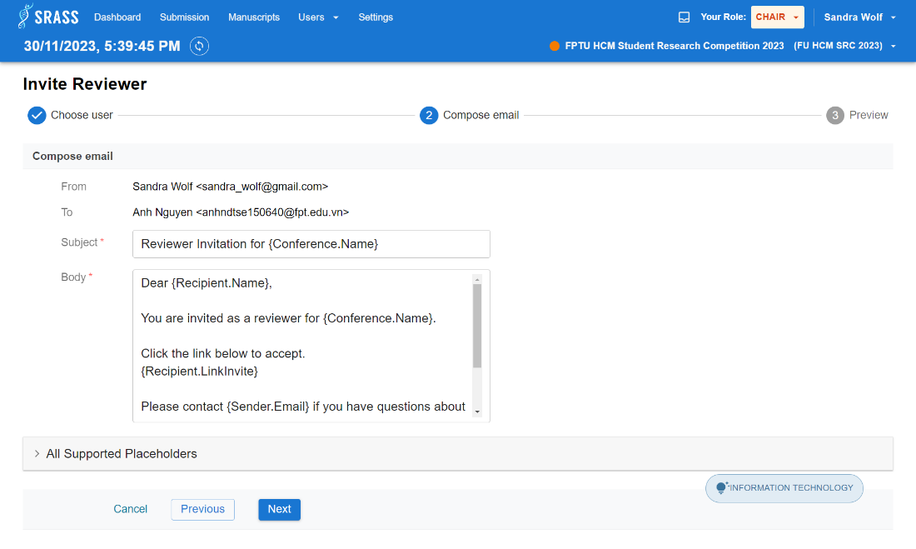

* + This function requires the user to login to the system with the role “**PC Chair**”.
  + PC Chair fill in all required fields and then click “Next” to continue next step or click “Previous” to return previous step or click “Cancel” to go back previous screen.
  + PC Chair can use all supported placeholders to map information related to conference such as: Conference Name, Submission Title, Recipient Last Name, Recipient First Name, etc...

#### 3.2.33 <PC Chair> Previewing Email Invitation

* + **Function trigger:** PC Chair click “Next” button in “Email Composing Invitation”.
  + **Function description:** PC Chair can preview sender information, email subject, and email body before sending invite.
  + **Screen layout:**

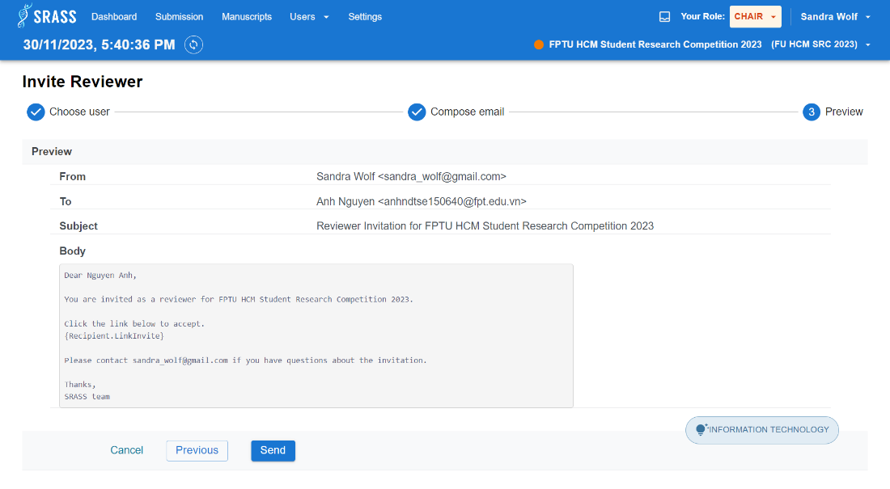

* + This function requires the user to login to the system with the role “**PC Chair**”.
  + PC Chair can view sender full name, sender email, recipient full name, recipient email, subject, body.
  + After PC Chair preview then click “Send” to send email or click “Previous” to return previous step or click “Cancel” to go back previous screen.
    - If successful, the email will be sent to reviewer email.

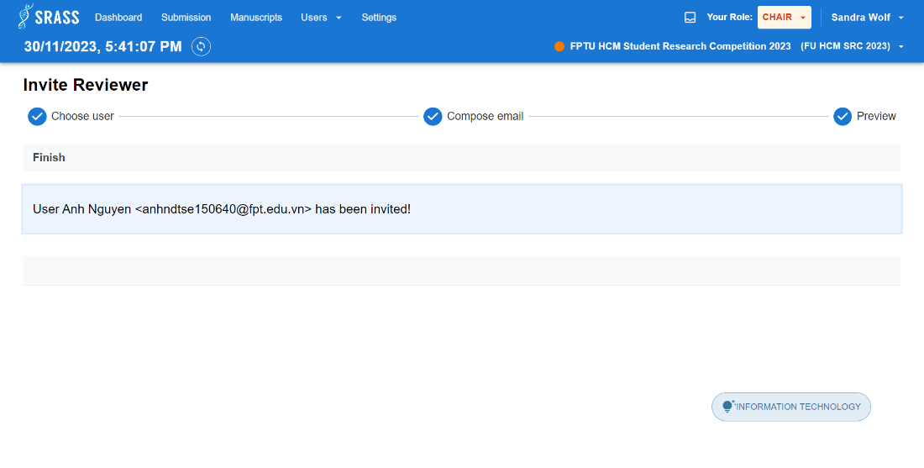

#### 3.2.34 <(Un) Authenticated User> Invite Confirmation

* + **Function trigger:** (Un)authenticated User click the link in email.
  + **Function description:** (Un)authenticated User can confirm invitation by accept or decline.
  + **Screen layout:**

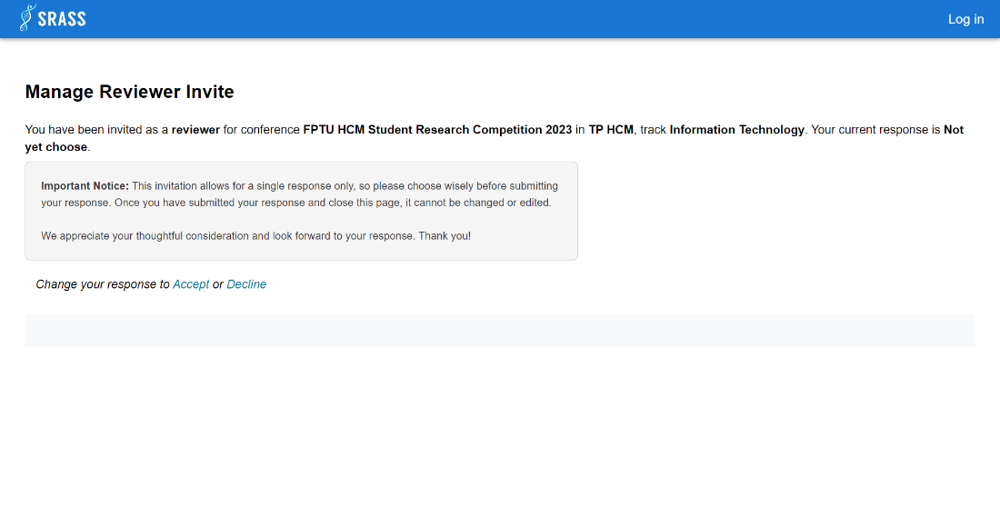

* + If the email does not exist in the system, the system will show message “Please register account in the system.” and navigate to “Register” page.
  + If the invitation has been confirmed, the system will show message “This invitation has already responded.”. If selected role is:
    - Authenticated User:
      * The system will navigate user to “Conference” screen or click “Cancel” to close pop-up.
    - Unauthenticated User:
      * The system will navigate user to “Log in” screen or click “Cancel” to close pop-up.
  + (Un)authenticated User can view conference name, track and conference location then click “Accept” or “Decline” to confirm invitation. 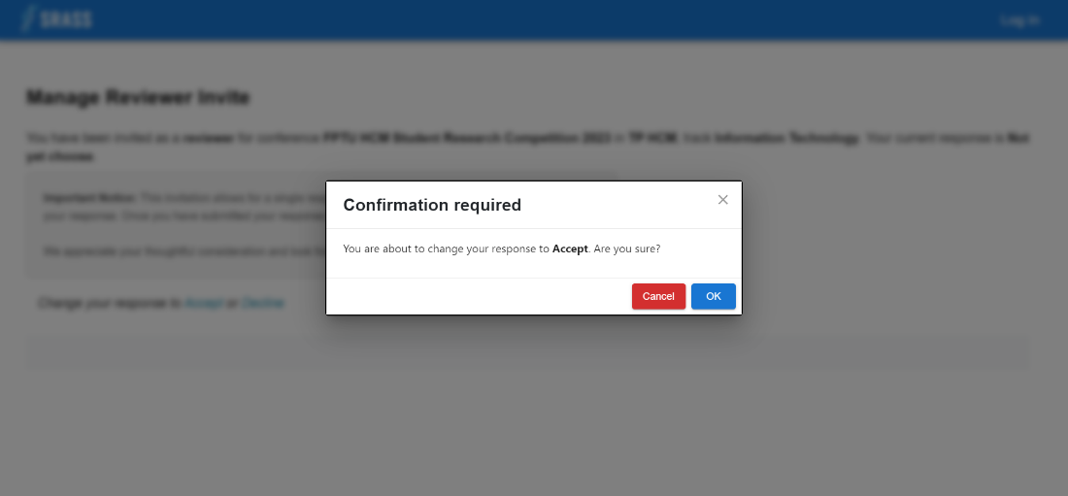
  + If selected role is:
    - Authenticated User:
      * Click “OK” to confirm response, the system will navigate user to “Conference” screen or click “Cancel” to close pop-up.
    - Unauthenticated User:
      * Click “OK” to confirm response, the system will navigate user to “Log in” screen or click “Cancel” to close pop-up.

#### 3.2.35 <PC Chair> Manuscripts

* + **Function trigger:** PC Chair click on the “Manuscript” on header.
  + **Function description:** PC Chair can track final camera-ready submissions, registration and presentation submissions.
  + **Screen layout:**

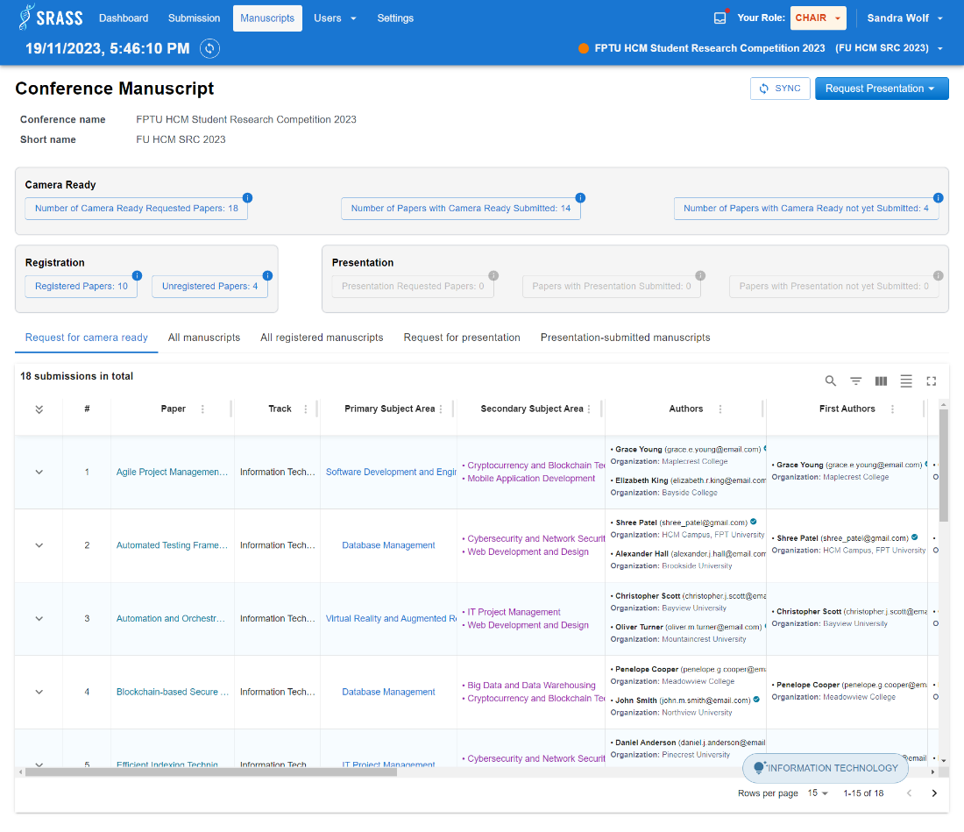 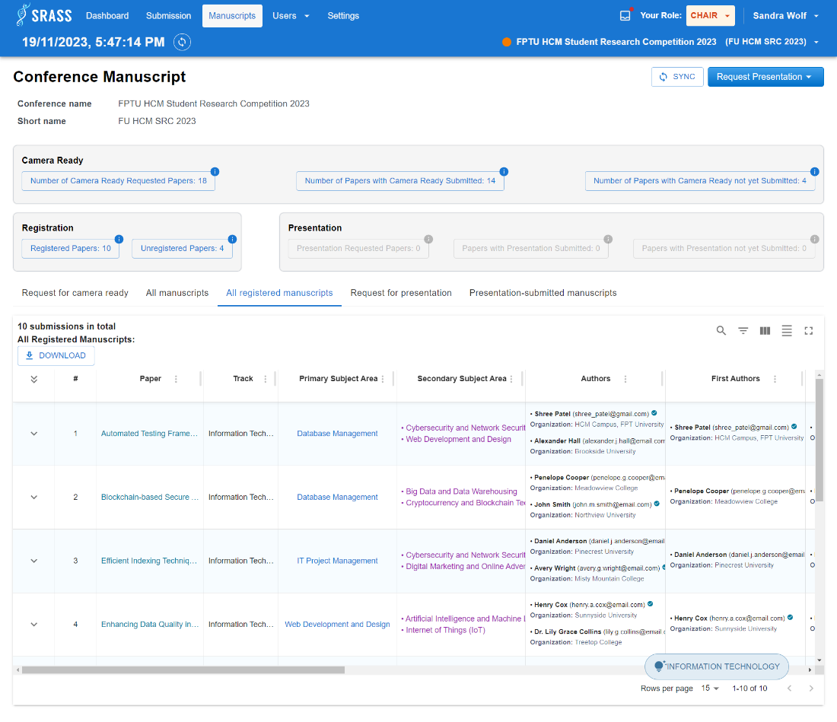

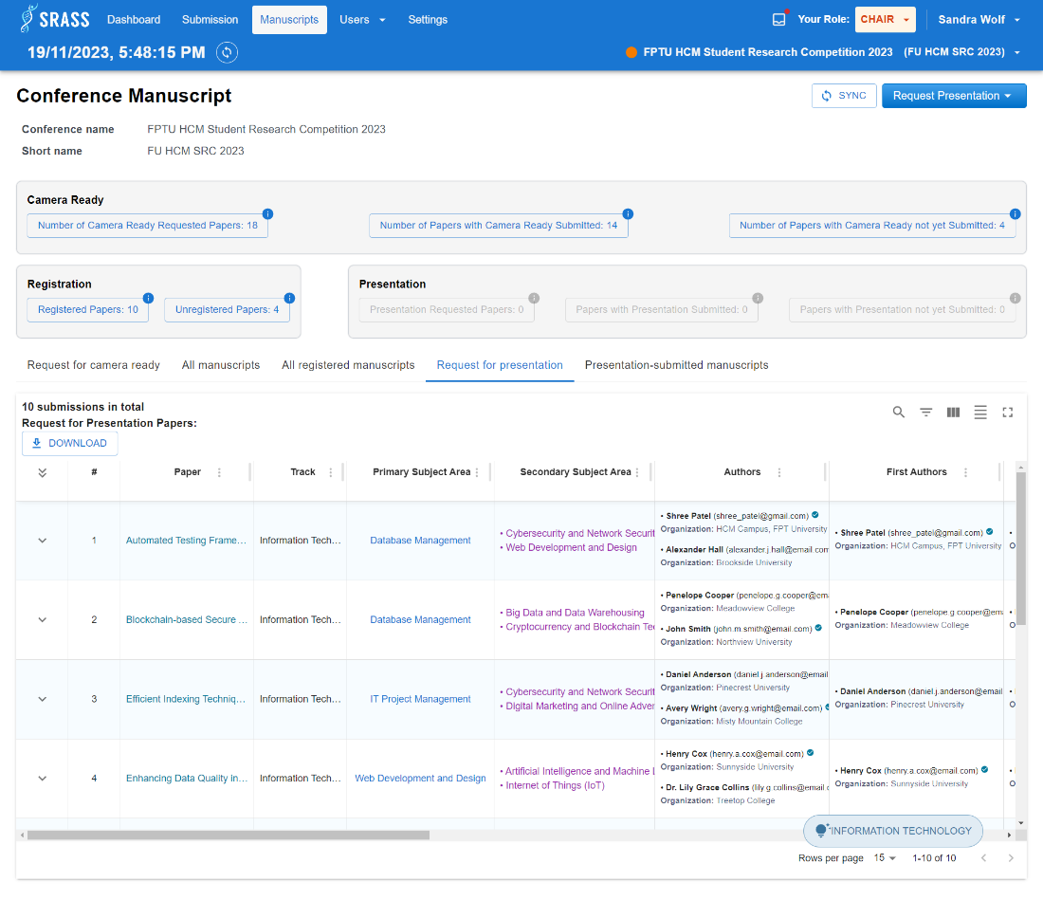

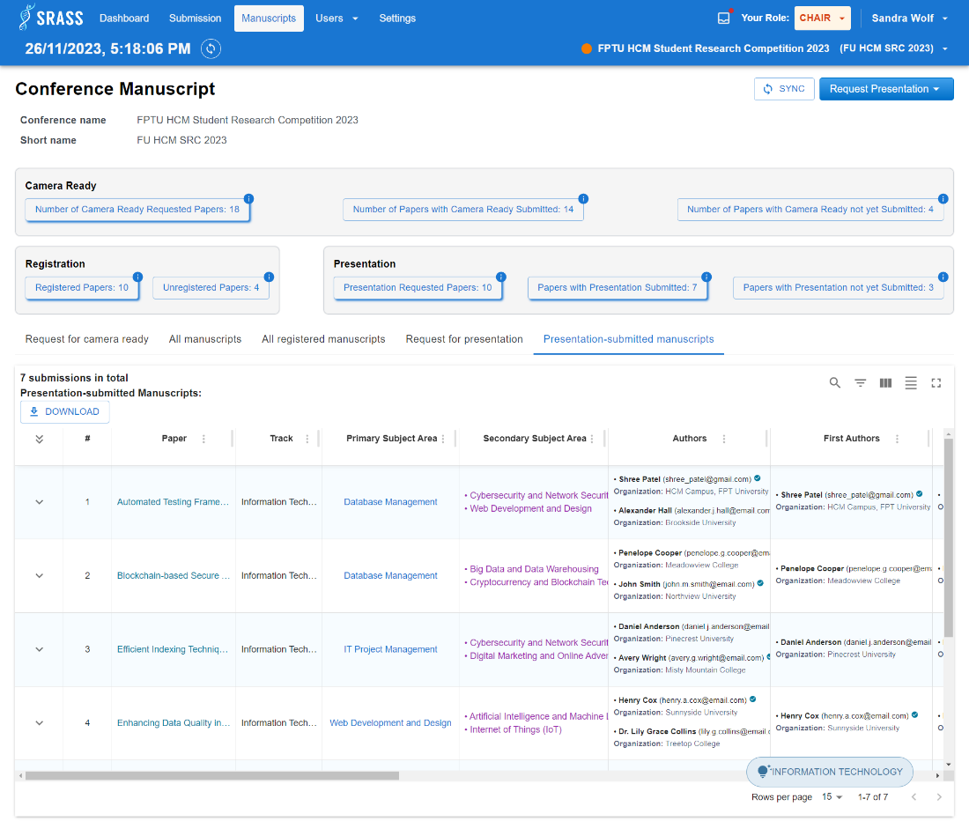

* + This function requires the user to login to the system with the role “**PC Chair**”.
  + PC Chair can view conference statistic in system included: Number of camera-ready requested papers, Number of papers with camera ready submitted, Number of papers with camera ready not yet submitted, Registered papers, Unregistered papers, Presentation requested papers, Papers with presentation submitted, Papers with presentation not yet submitted.
  + PC Chair can click on tabs:
    - “All Manuscript”:
      * To view all submissions manuscript.
      * Click “Download” button to download all manuscript.
    - “All registered manuscripts”:
      * To view all registered submissions.
      * Click “Download” button to download zip file included all registered submissions and excel file summarizing information report.
    - “Request for presentation”:
      * To view all submissions that request for presentation.
      * Click “Download” button to download zip file included request for presentation submissions and excel file summarizing information report.
    - “Presentation-submitted manuscripts”:
      * To view all submissions manuscript.
      * Click “Download” button to download zip file included presentation submitted submissions and excel file summarizing information report.
  + If manuscripts have results, the system shows a list of submission in conference included: Paper title, Track name, Primary subject area, Secondary subject area, Authors, Registered, Register option, Order, Registrant, Request for presentation, Presentation completely, Presenters. If not, system return a message “No record to display”.
  + Table column visible based on that phase of the conference.
  + PC Chair can click on statistic buttons to filter manuscript data table.
    - Statistic button disabled when statistic value is 0.
    - If PC Chair click statistic button “Number of Camera Ready Requested Papers” or “Number of Papers with Camera Ready not yet Submitted” or “Unregistered papers” or “Papers with Presentation not yet Submitted”, the system will move to the first tab and the tab's text will become the same name as the statistic button just clicked, along with the data table related to the data.
    - If PC Chair click statistic button “Number of Papers with Camera Ready Submitted” the system will move to the “All Manuscript” tab.
    - If PC Chair click statistic button “Registered Papers” the system will move to the “All registered manuscripts” tab.
    - If PC Chair click statistic button “Presentation Requested Papers” the system will move to the “Request for presentation” tab.
    - If PC Chair click statistic button “Papers with Presentation Submitted” the system will move to the “Presentation-submitted manuscripts” tab.

#### 3.2.36 <PC Chair> Paper Statuses Setting

* + **Function trigger:** PC Chair click on the “Settings” on header. Then the default tab will be the “Paper Status” tab.
  + **Function description:** PC Chair view the statuses that the submission may have.
  + **Screen layout:**

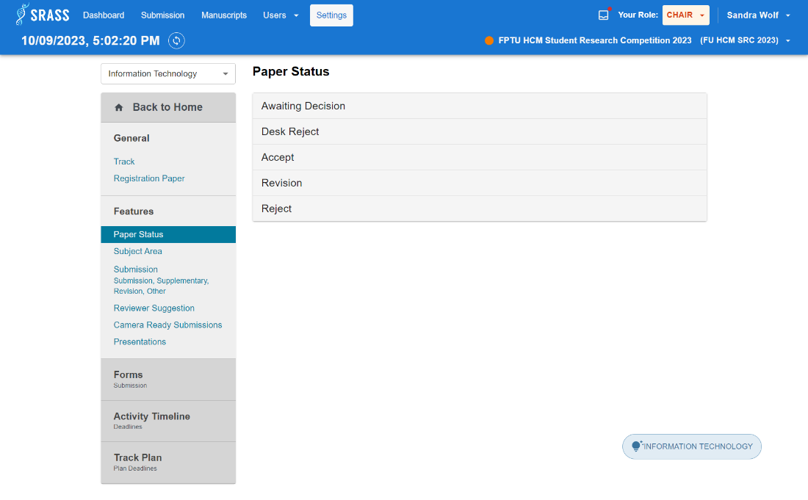

* + This function requires the user to login to the system with the role “**PC Chair**”.
  + PC Chair can only view the status of paper.

#### 3.2.37 <PC Chair> Subject Area Setting

* + **Function trigger:** PC Chair click on the “Settings” on header. Then choose the “Subject Area” tab in “Features” section.
  + **Function description:** PC Chair can set up the subject area to for “Open For Submission” phase.
  + **Screen layout:**

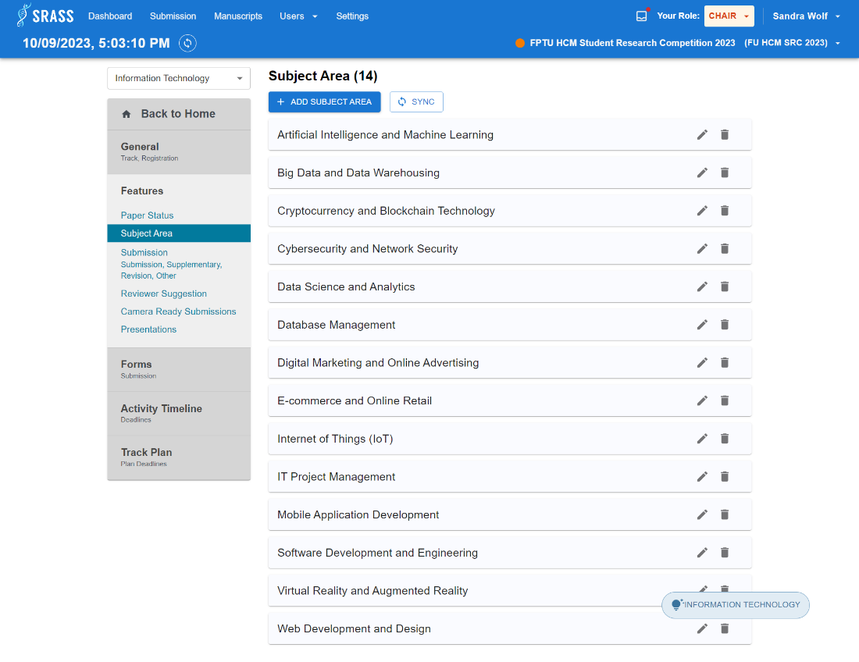

* + This function requires the user to login to the system with the role “**PC Chair**”.
  + PC Chair can view all subject areas of a selected track.
  + PC Chair need to create subject area in “Calling For Papers” phase to be ready for next phase. To create new subject area, PC Chair click on the “ADD SUBJECT AREA” button then type the name of subject area.
  + After creating new subject area. PC Chair can edit subject area by clicking on “edit” icon or delete subject area by clicking on “trash can” icon.
  + The system will throw error if PC Chair create new subject area or edit subject area having the same name with existing one.
  + The system will show a pop-up for PC Chair to confirm before deleting a subject area.

#### 3.2.38 <PC Chair> Submission Setting

* + **Function trigger:** PC Chair click on the “Settings” on header. Then choose the “Submission” tab in “Features” section.
  + **Function description:** PC Chair can set up configuration of welcome message, files and abstract to prepare for different phases when conference is occurring.
  + **Screen layout:**

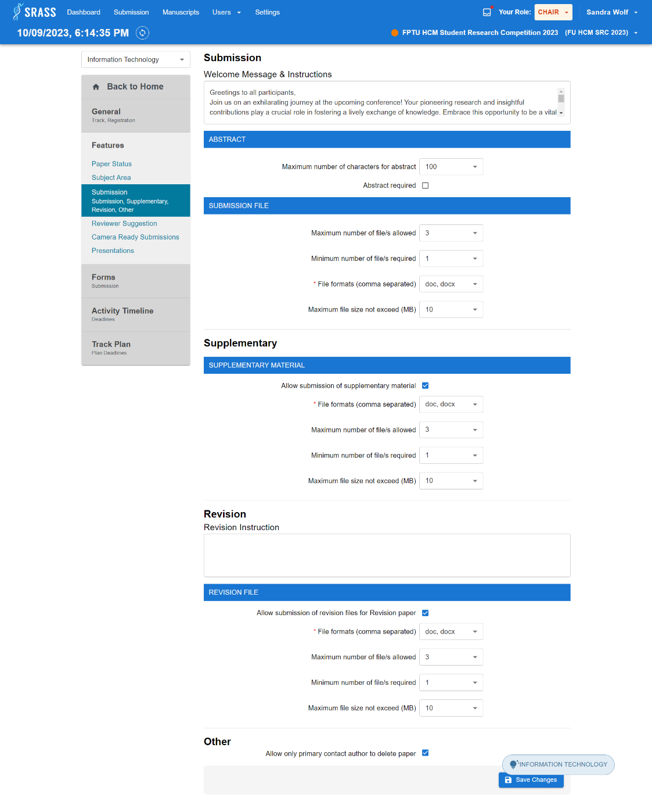

* + This function requires the user to login to the system with the role “**PC Chair**”.
  + PC Chair can view all setting of welcome messages, files, abstract and other of a selected track.
  + PC Chair can config the file or welcome message or abstract to prepare for different phases such as “Open For Submission”, “Open For Supplementary Material”, “Open For Revision” phase.
  + PC Chair click on “Save Changes” button to save the settings.

#### 3.2.39 <PC Chair> Reviewer Suggestion

* + **Function trigger:** PC Chair click on the “Settings” on header. Then choose the “Reviewer Suggestion” tab in “Features” section.
  + **Function description:** PC Chair can setup relevance scores as default or with custom option.
  + **Screen layout:**

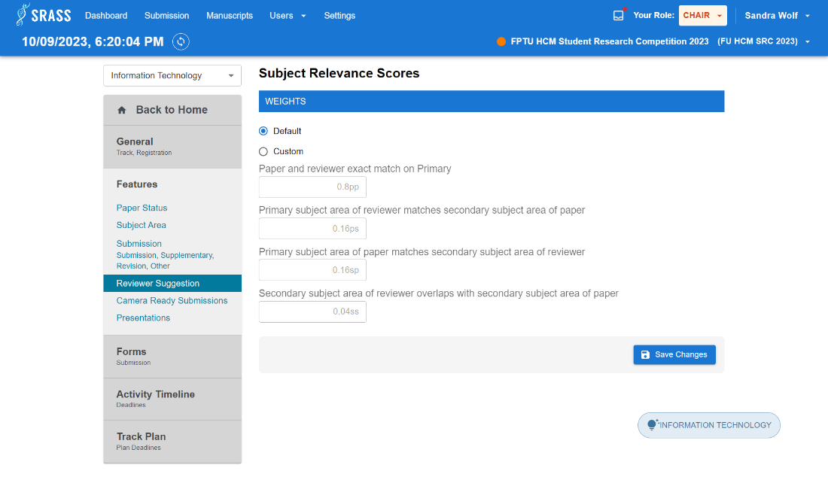

* + This function requires the user to login to the system with the role “**PC Chair**”.
  + PC Chair can config relevance scores such as Paper and reviewer exact match on Primary (pp), Primary subject area of reviewer matches secondary subject area of paper (ps), Primary subject area of paper matches secondary subject area of reviewer (sp), Secondary subject area of reviewer overlaps with secondary subject area of paper (ps).
  + PC Chair click on “Save Changes” button to save the settings.

#### 3.2.40 <PC Chair> Track Setting

* + **Function trigger:** PC Chair click on the “Settings” on header. Then choose the “Track” tab in “General” section.
  + **Function description:** PC Chair can manage tracks in conference.
  + **Screen layout:**

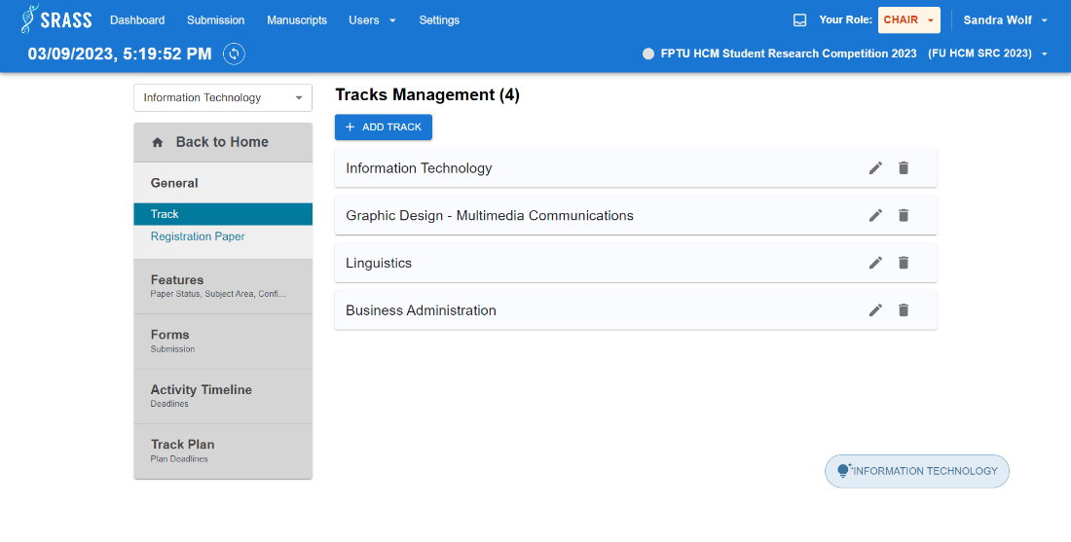

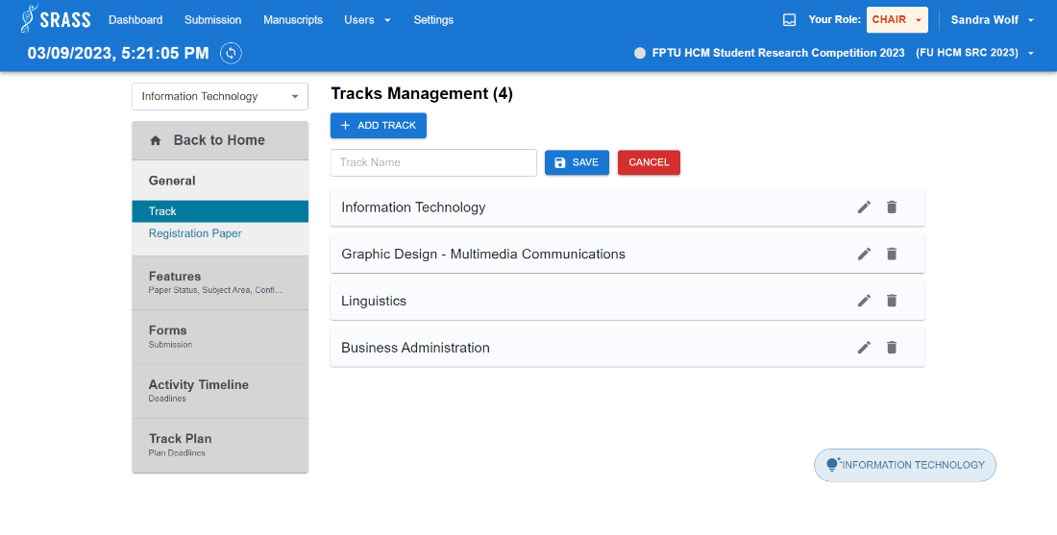

* + This function requires the user to login to the system with the role “**PC Chair**”.
  + PC Chair can view all tracks of the conference.
  + PC Chair click on the “ADD TRACK” button then type the name of track.
  + After creating new track. PC Chair can edit track by clicking on “edit” icon or delete track by clicking on “trash can” icon.
  + The system will throw error if PC Chair create new track or edit track having the same name with existing one.
  + The system will show a pop-up for PC Chair to confirm before deleting a track.

#### 3.2.41 <PC Chair> Registration Setting

* + **Function trigger:** PC Chair click on the “Setting” on header. Then choose the “Registration Paper” tab in “General” section.
  + **Function description:** PC Chair can configure the price list for each submission including free or paid when the author decides to register the submission.
  + **Screen layout:**

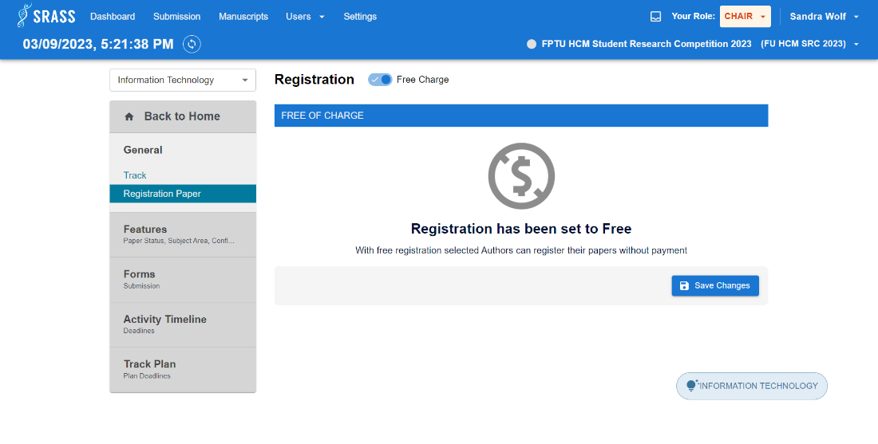

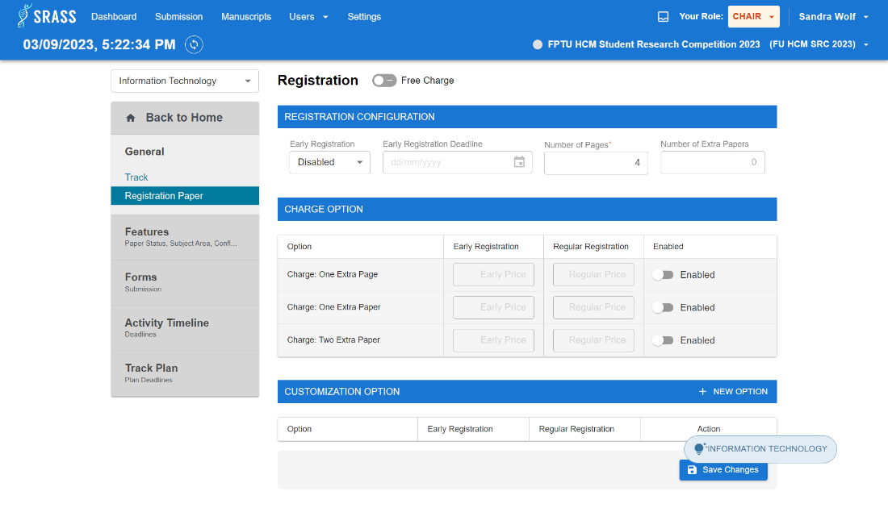

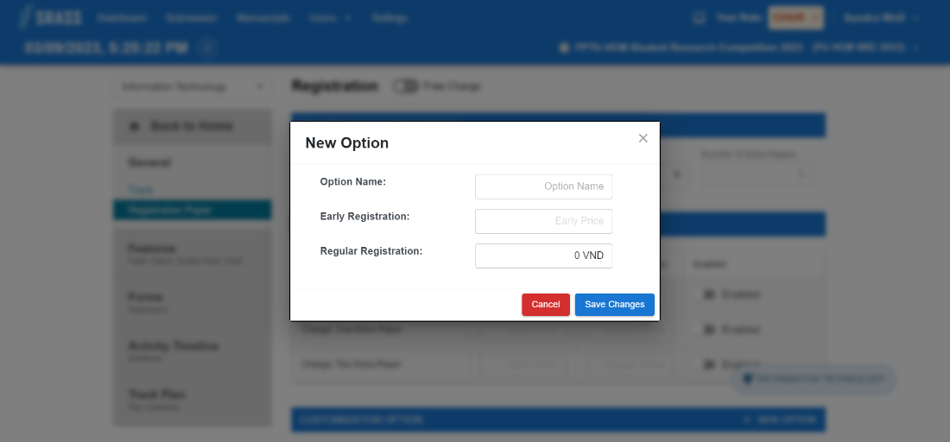

* + This function requires the user to login to the system with the role “**PC Chair**”.
  + PC Chair can config the price cling on “Free Charge” switch button to toggle the status: free or paid.
  + If “Free Charge” is enabled. Then click on “Save Changes” button to save the settings.
  + If “Free Charge” is disabled. Then PC Chair have to config three things
    - REGISTRATION CONFIGURATION:
      * Toggle enabled or disabled “Early Registration”.
      * Choose deadline date for “Early Registration Deadline” if “Early Registration” is enabled. If not, then PC Chair can not choose date.
      * Enter “Number of Pages”.
      * “Number of Extra Papers” will be automatically inputted when PC Chair config “PC Chair Option”.
    - CHARGE OPTION:
      * There are three options to enable:
        + PC Chair can input “Early Registration” in “CHARGE OPTION” when “Early Registration” in REGISTRATION. CONFIGURATION“ is enabled or “Enabled” column is enabled.
        + PC Chair can input “Regular Registration” when “Enabled” column is enabled.
    - CUSTOMIZATION OPTION:
      * PC Chair can create new option by clicking on “+ NEW OPTION” button. Then the pop-up will appear. PC Chair input the information of each field then click “Save Changes” button on pop-up to add new option.
  + PC Chair click on “Save Changes” button of page to save the settings.

#### 3.2.42 <PC Chair> Submission Question Setting

* + **Function trigger:** PC Chair click on the “Settings” on header. Then choose the “Submission” tab in “Form” section.
  + **Function description:** PC Chair can set up the submission question for “Open For Submission” phase.
  + **Screen layout:**

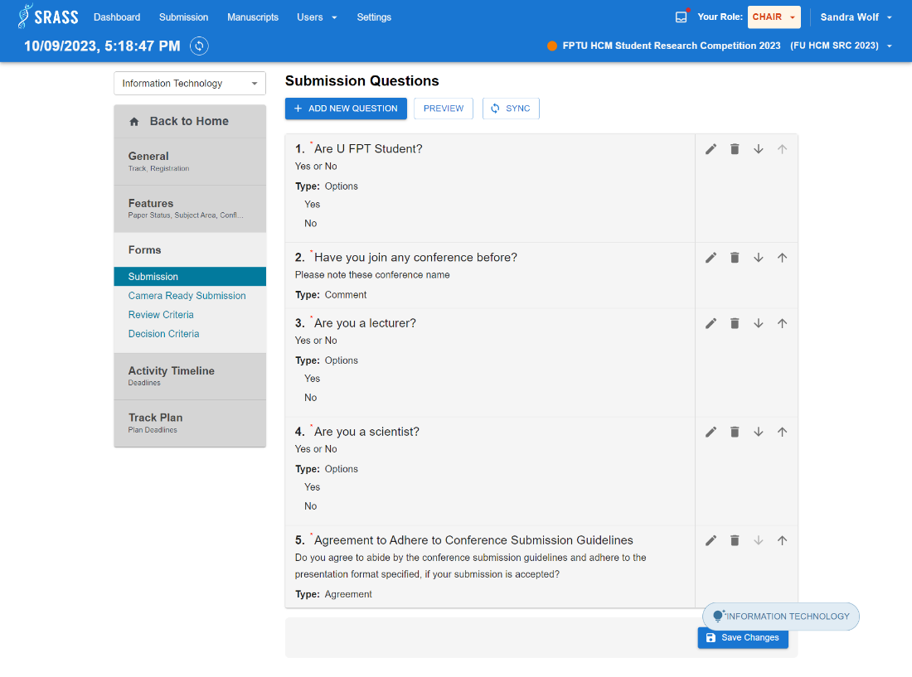

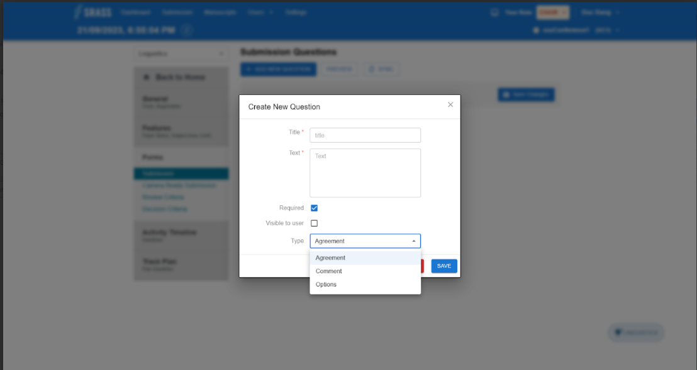

* + This function requires the user to login to the system with the role “**PC Chair**”.
  + PC Chair can view all submission questions of selected track in the conference.
  + PC Chair click on the “+ ADD NEW QUESTION” button then the pop-up will appear.
  + The have to fulfil all required field on the pop-up:
    - Title.
    - Text.
    - Check or not check “Required” or “Visible to user” checkbox.
    - Choose type of question. Default is ”Agreement” option.
  + Click on “Save” button on pop up to add new question.
  + After creating new question. PC Chair can edit question by clicking on “edit” icon or delete question by clicking on “trash can” icon. PC Chair can also change the order of question by clicking on “Down Arrow” icon or “Forward Arrow” icon.
  + Clicking on “Save Changes” button to save all questions.

#### 3.2.43 <PC Chair> Camera Ready Checklist Setting

* + **Function trigger:** PC Chair click on the “Settings” on header. Then choose the “Camera Ready Submission” tab in “Form” section.
  + **Function description:** PC Chair can set up the camera ready checklist for “Open For Camera Ready Submission” phase.
  + **Screen layout:**

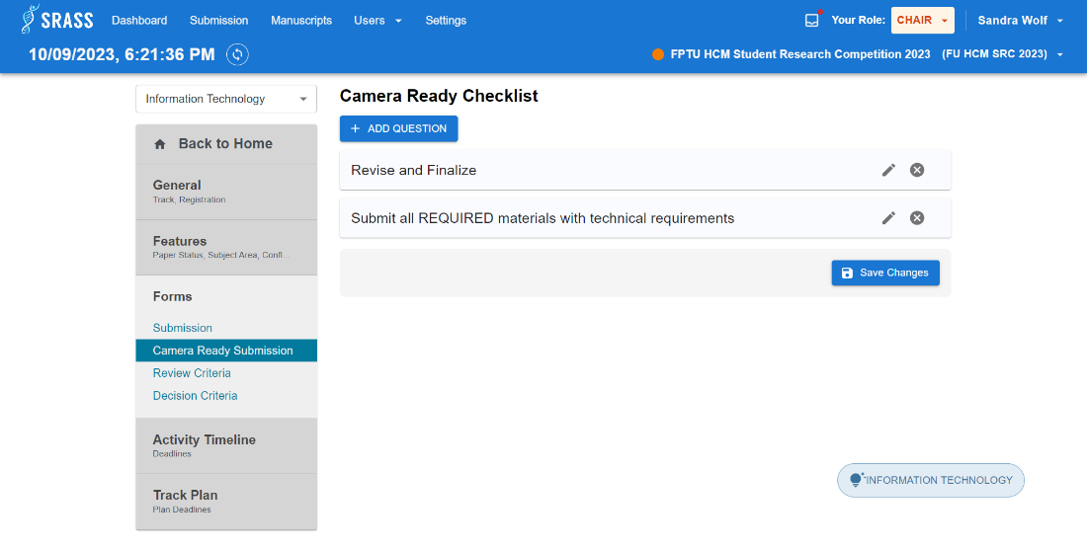

* + This function requires the user to login to the system with the role “**PC Chair**”.
  + PC Chair can view all camera ready checklist of a selected track.
  + To create new task, PC Chair click on the “+ADD CHECKLIST” button then type the name of task.
  + After creating new task. PC Chair can edit task by clicking on “edit” icon or delete task by clicking on “trash can” icon.
  + The system will show a pop-up for PC Chair to confirm before deleting a task.
  + Click on “Save Changes” button to save the checklist.

#### 3.2.44 <PC Chair> Review Criteria Submission Setting

* + **Function trigger:** PC Chair click on the “Settings” on header. Then choose the “Review Criteria” tab in “Form” section.
  + **Function description:** PC Chair can manage reviews criteria of selected track in conference.
  + **Screen layout:**

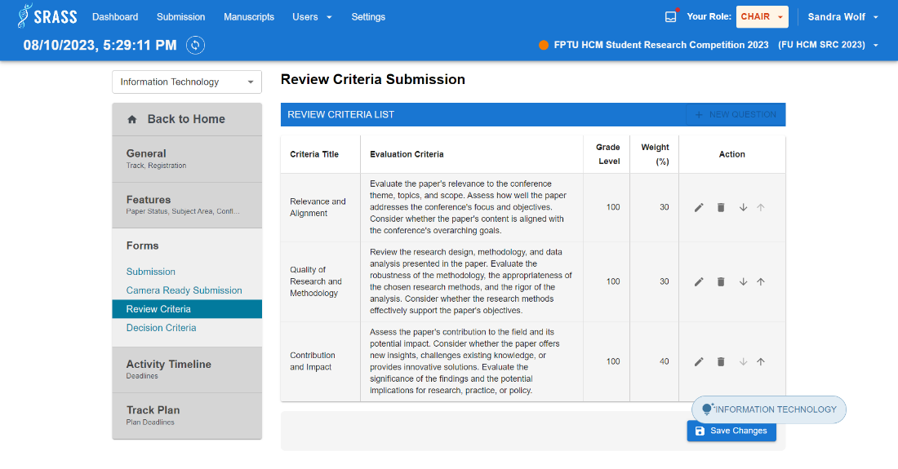

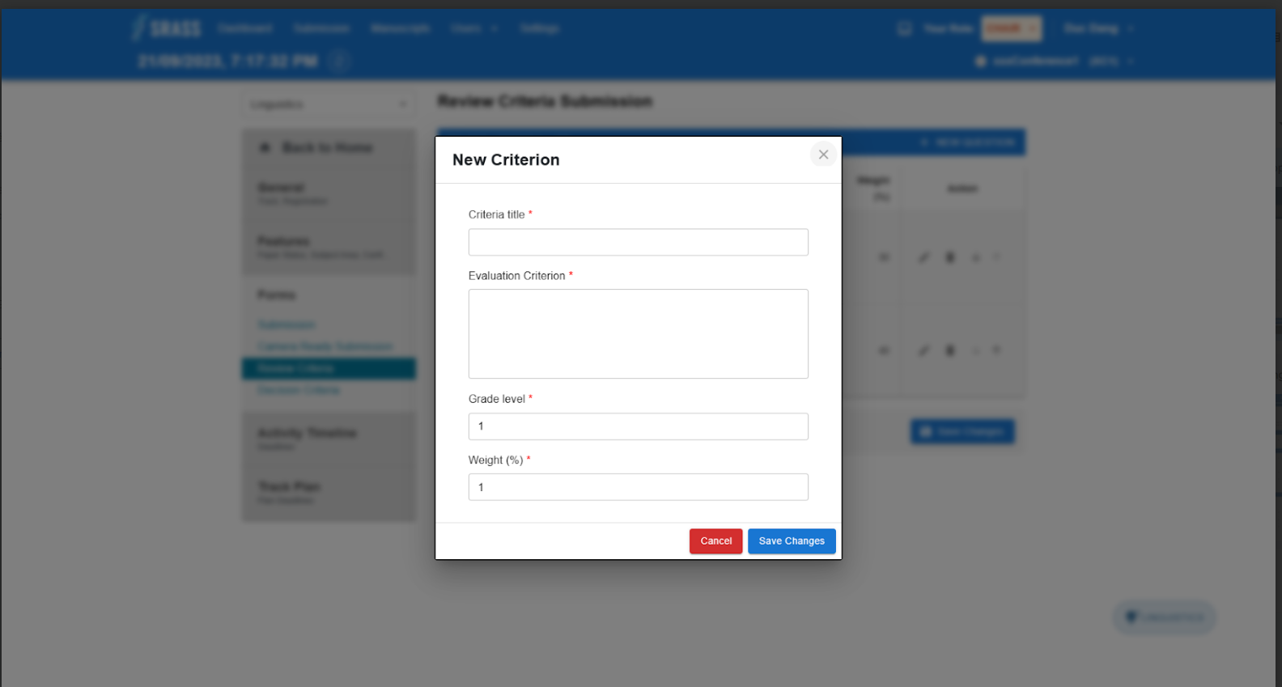

* + This function requires the user to login to the system with the role “**PC Chair**”.
  + PC Chair can view all review criterion checklist of a selected track.
  + To create new criterion, PC Chair click on the “+ADD NEW Criterion” button then the pop-up will appear.
  + The have to fulfil all required field on the pop-up:
    - Criteria title.
    - Evaluation Criterion.
    - Grade level. The default value is 1. Min value is 1 and Max value is 100.
    - Weight. The default value is 1. Min value is 1 and Max value is 100.
  + Click on “Save” button on pop up to add new criterion.
  + After creating new criterion. PC Chair can edit criterion by clicking on “edit” icon or delete criterion by clicking on “trash can” icon. PC Chair can also change the order of criterion by clicking on “Down Arrow” icon or “Forward Arrow” icon.
  + Clicking on “Save Changes” button to save criteria.

#### 3.2.45 <PC Chair> Decision Criteria Submission Setting

* + **Function trigger:** PC Chair click on the “Settings” on header. Then choose the “Decision Criteria” tab in “Form” section.
  + **Function description:** PC Chair can manage decision criteria of selected track in conference.
  + **Screen layout:**

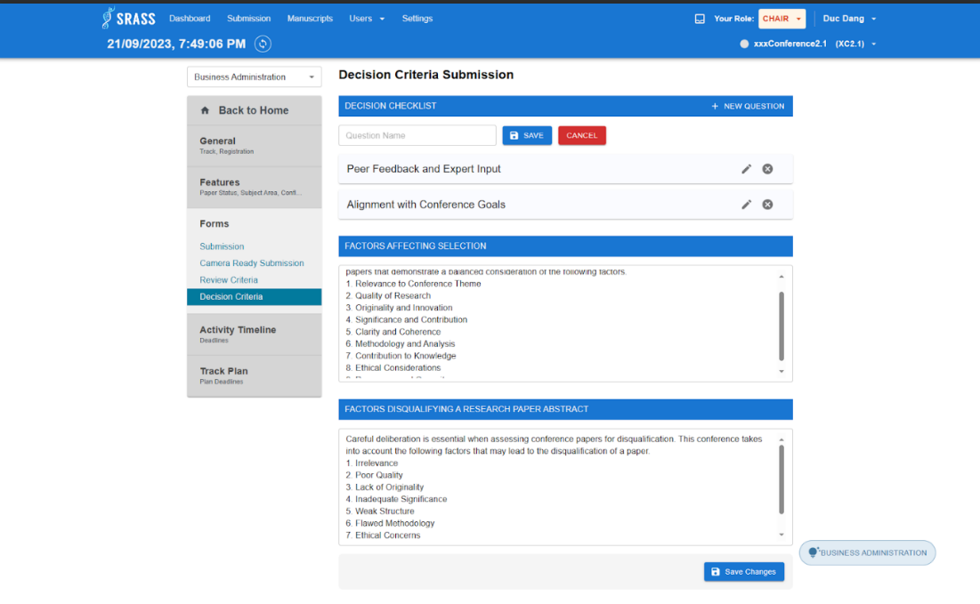

* + This function requires the user to login to the system with the role “**PC Chair**”.
  + PC Chair can view all decision criterion checklist of a selected track.
  + To create new criterion, PC Chair click on the “+NEW CRITERION” button then type the. name of criterion.
  + After creating new criterion. PC Chair can edit criterion by clicking on “edit” icon or. delete criterion by clicking on “trash can” icon.
  + The system will show a pop-up for PC Chair to confirm before deleting a criterion.
  + PC Chair also have to enter for “FACTORS AFFECTING SELECTION” and “FACTORS DISQUALIFYING A RESEARCH PAPER ABSTRACT”.
  + Click on “Save Changes” button to save all settings.

#### 3.2.46 <PC Chair> Deadlines

* + **Function trigger:** PC Chair click on the “Settings” on header. Then choose the “Deadlines” tab in “Activity Timeline” section.
  + **Function description:** PC Chair can view all activity deadlines of selected track in conference.
  + **Screen layout:**

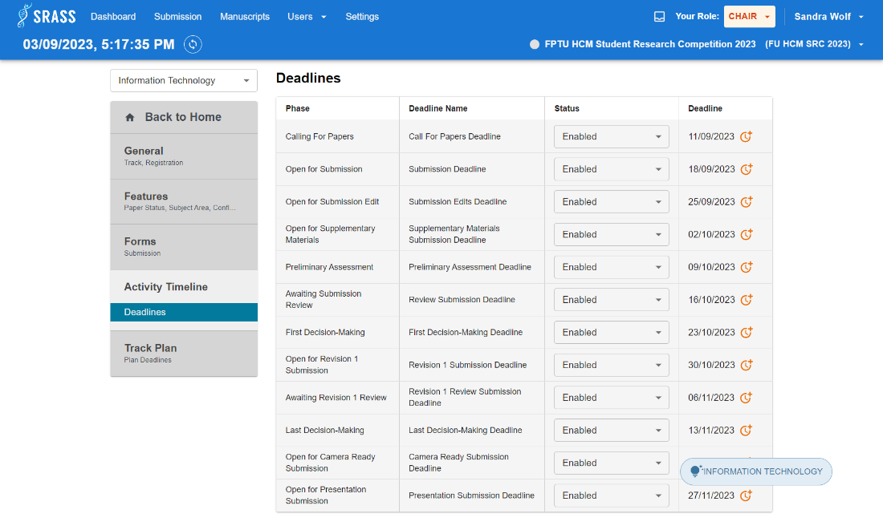

* + This function requires the user to login to the system with the role “**PC Chair**”.
  + PC Chair view all phases with its deadline. If necessary, PC Chair can also extend the deadline by click on “Clock” icon.

#### 3.2.47 <PC Chair> Plan Deadlines

* + **Function trigger:** PC Chair click on the “Settings” on header. Then choose the “Plan Deadlines” tab in “Track Plan” section.
  + **Function description:** PC Chair can create deadlines of selected track in conference.
  + **Screen layout:**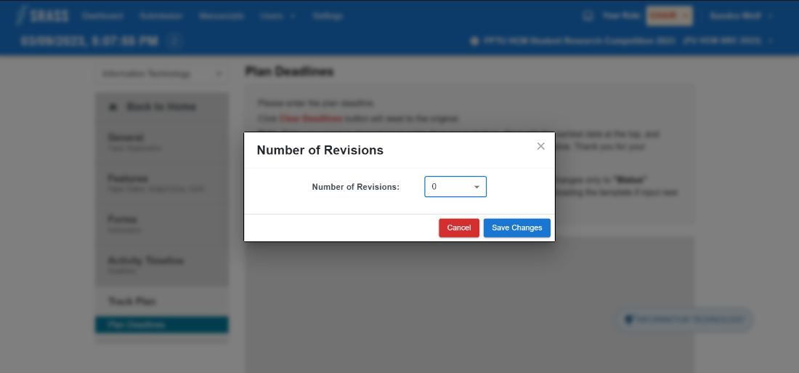 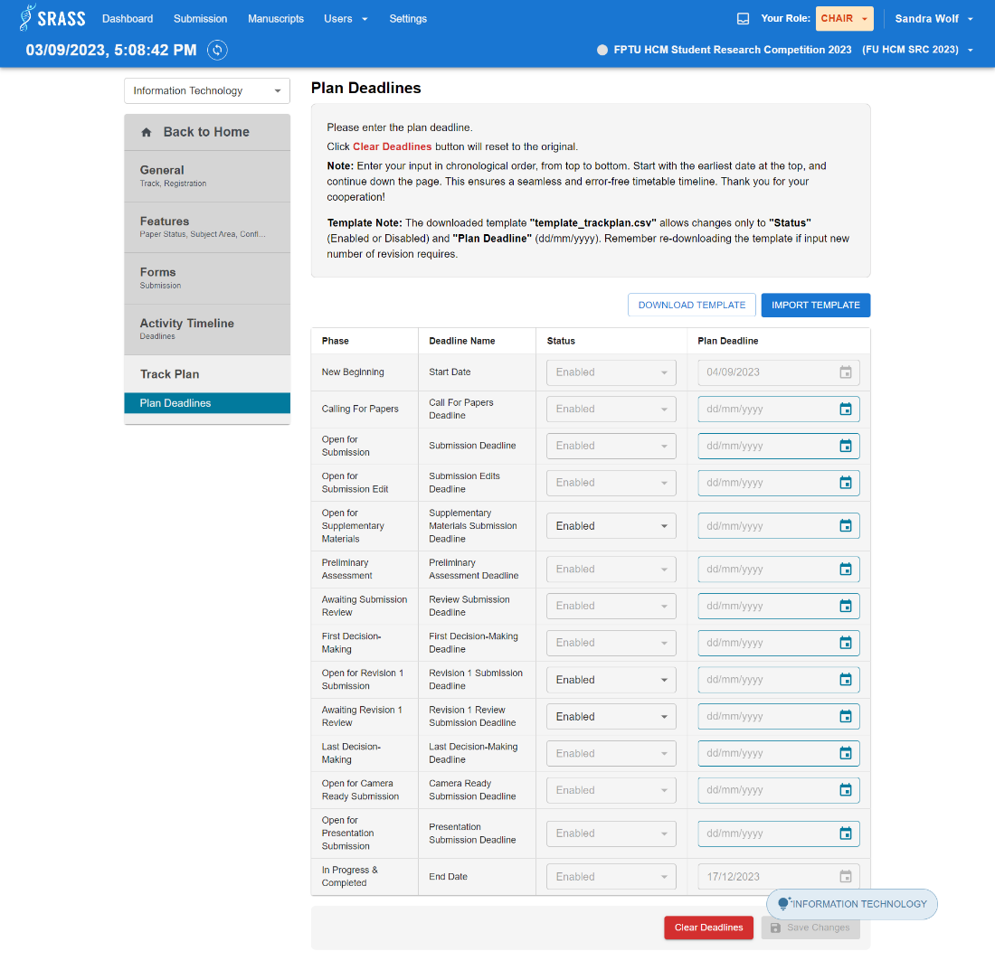

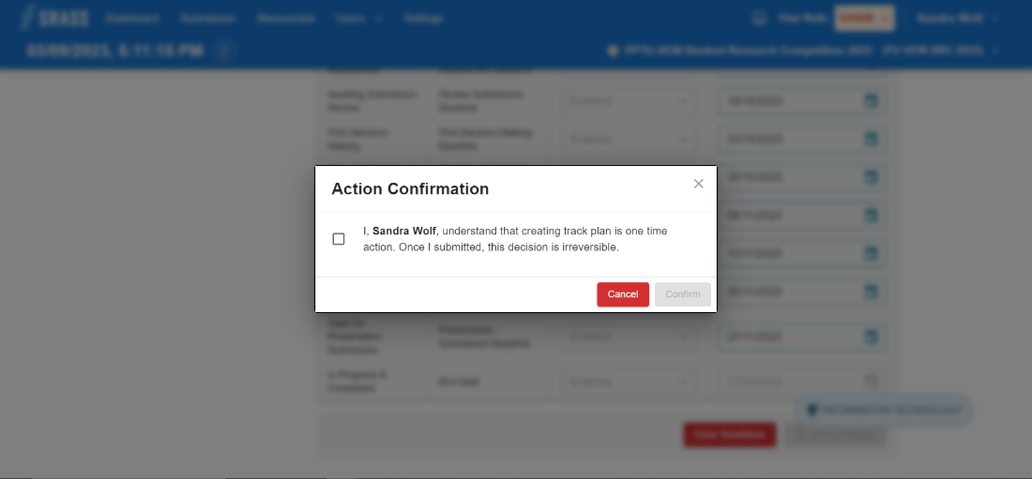 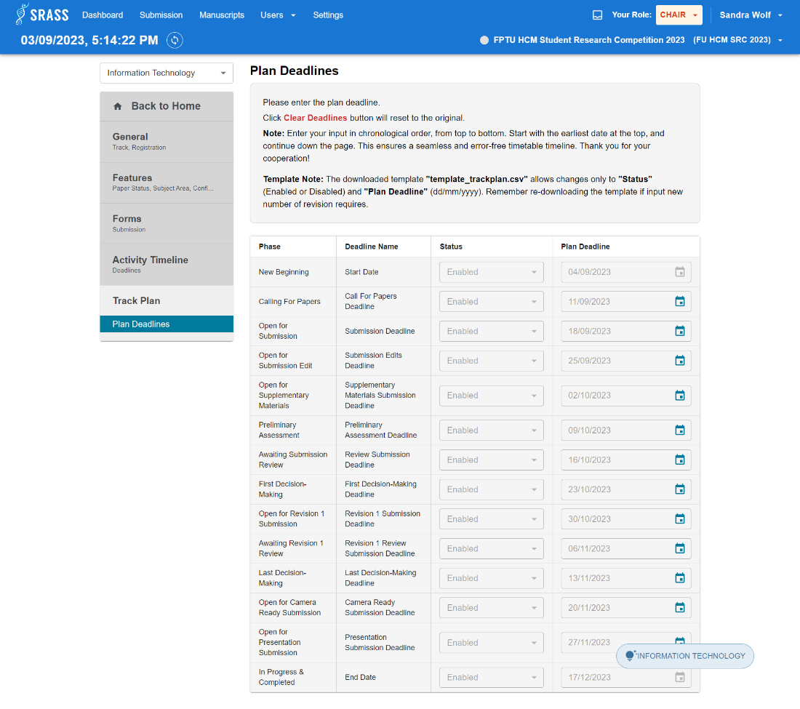

* + This function requires the user to login to the system with the role “**PC Chair**”.
  + First, PC Chair must choose number of revisions to create phases and deadlines.
  + After creating phases and deadlines, PC Chair must fulfil the date for deadline by instruction of system. Another way to fulfil date for deadlines is import csv deadlines and the template supplied by system.
  + After fulfilling deadlines for phases, PC Chair click on “Save Changes” button. Then a pop-up with warning information appears. PC Chair must confirm by click on checkbox and click on “Confirm” button. Then the settings will be saved.

#### 3.2.48 <PC Chair> Email Template Setting

* + **Function trigger:** PC Chair click on the “Settings” on header. Then choose the “Email Template” tab in “General” section.
  + **Function description:** PC Chair can set up email template for phase “Calling For Papers” and “Open For Camera Ready Submission”.
  + **Screen layout:**

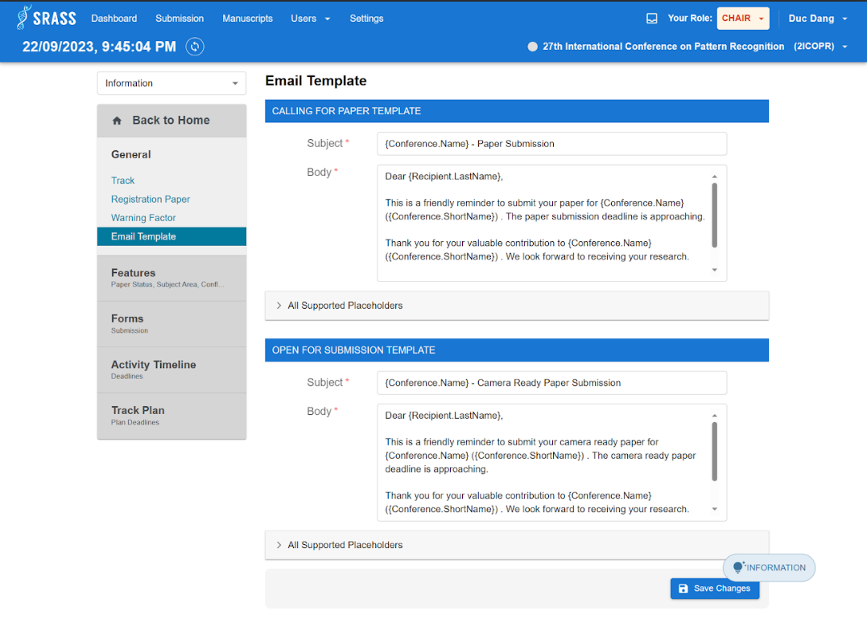

* + This function requires the user to login to the system with the role “**PC Chair**”.
  + There are two type of email template. PC Chair must fulfil information for template:
    - CALLING FOR PAPER TEMPLATE:
      * Subject
      * Body
    - OPEN FOR SUBMISSION TEMPLATE
      * Subject
      * Body
  + PC Chair clicks on “Save Changes” button to save email settings

#### 3.2.49 <Author> Author Console

* + **Function trigger:** Author clicks conference name on “Conferences”.
  + **Function description:** Author can view a list of submissions in the conference.
  + **Screen layout:**

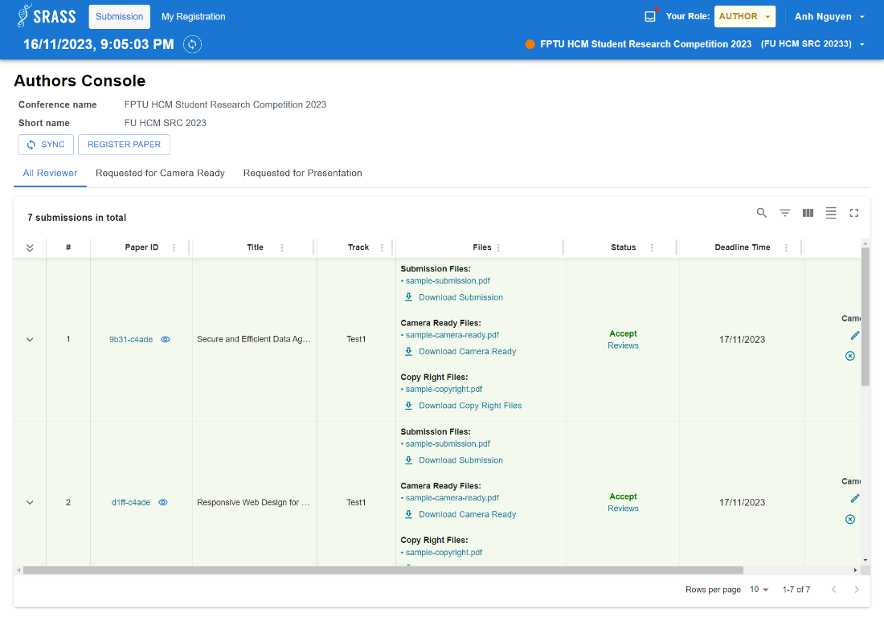

* + This function requires the user to login to the system with the role “**Author**”.
  + If submission has results, the system shows a list of submission in conference included: Paper id, Title, PC Chair note, Abstract, Track, List files, Status, Deadline time. If not, system return a message “No record to display”.
  + The Action column will display actions based on the phase of the conference.
    - “Open for Submission Edit” phase will display actions button: “Edit Submission”, “Delete Submission”, “Edit Conflicts”.
    - “Open for Supplementary Materials” phase will display actions button: “Upload Supplementary”, “Edit Supplementary”, “Delete Supplementary”.
    - “Open for Revision Submission” phase will display actions button: “Upload Revision”, “Edit Revision”, “Delete Revision”.
    - “Open for Camera Ready Submission” phase will display actions button: “Create Camera ready”, “Edit Camera ready”, “Delete Camera ready”.
    - “Open for Presentation Submission” phase will display actions button: “Upload Presentation”, “Edit Presentation”, “Delete Presentation”.

#### 3.2.50 <Author> Upload Supplementary

* + **Function trigger:** Click “Upload Supplementary” button in the “Author Console” table action column.
  + **Function description:** Author can upload supplementary materials file for submission.
  + **Screen layout:**

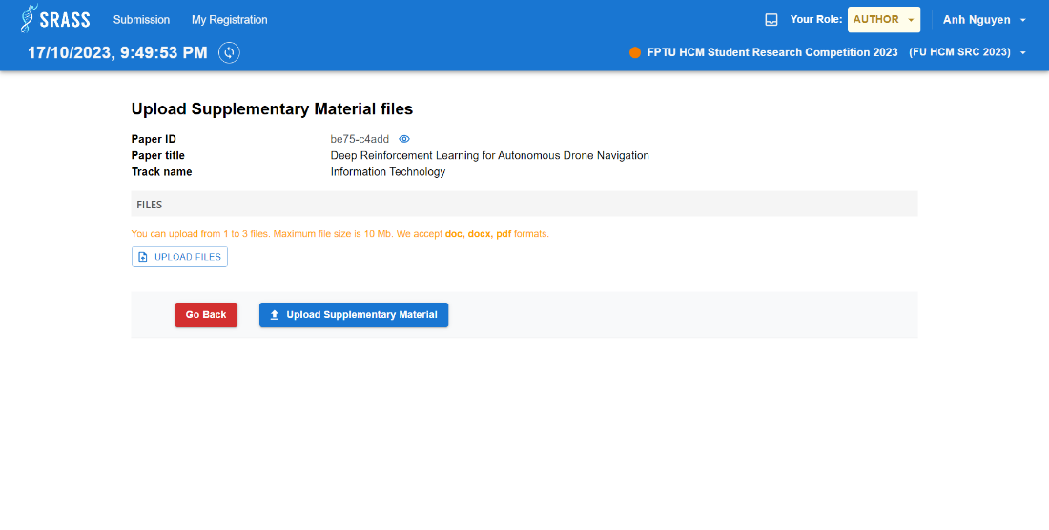

* + This function requires the user to login to the system with the role “**Author**”.
  + This function requires to upload presentation file. Then click button “Upload Supplementary Material” to submit.

#### 3.2.51 <Author> My Registration

* + **Function trigger:** Author clicks “My Registration” on header.
  + **Function description:** Author view their registration submissions.
  + **Screen layout:**

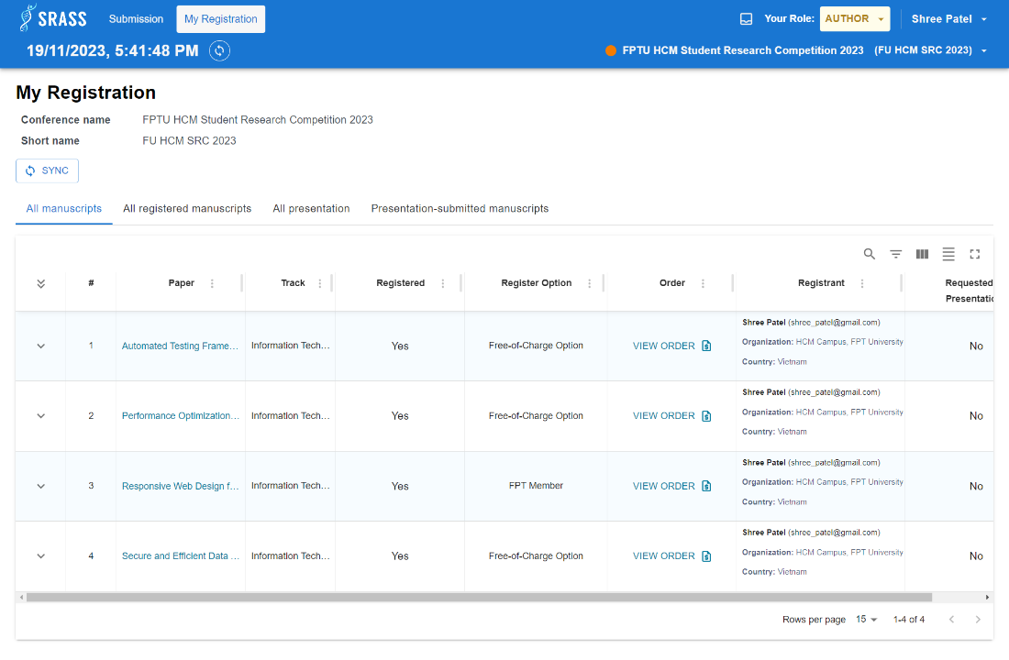

* + This function requires the user to login to the system with the role “**Author**”.
  + If submission has results, the system shows a list of submission in conference included: Paper title, Track name, Primary subject area, Secondary subject area, Authors, Registered, Register option, Order, Registrant, Request for presentation, Presentation completely, Presenters. If not, system return a message “No record to display”.

#### 3.2.52 <Author> Registration

* + **Function trigger:** Author click on the “Register Paper” button in “Submission Console” for author.
  + **Function description:** Authors can register submissions, and whether this costs money depends on the conference configuration.
  + **Screen layout:**

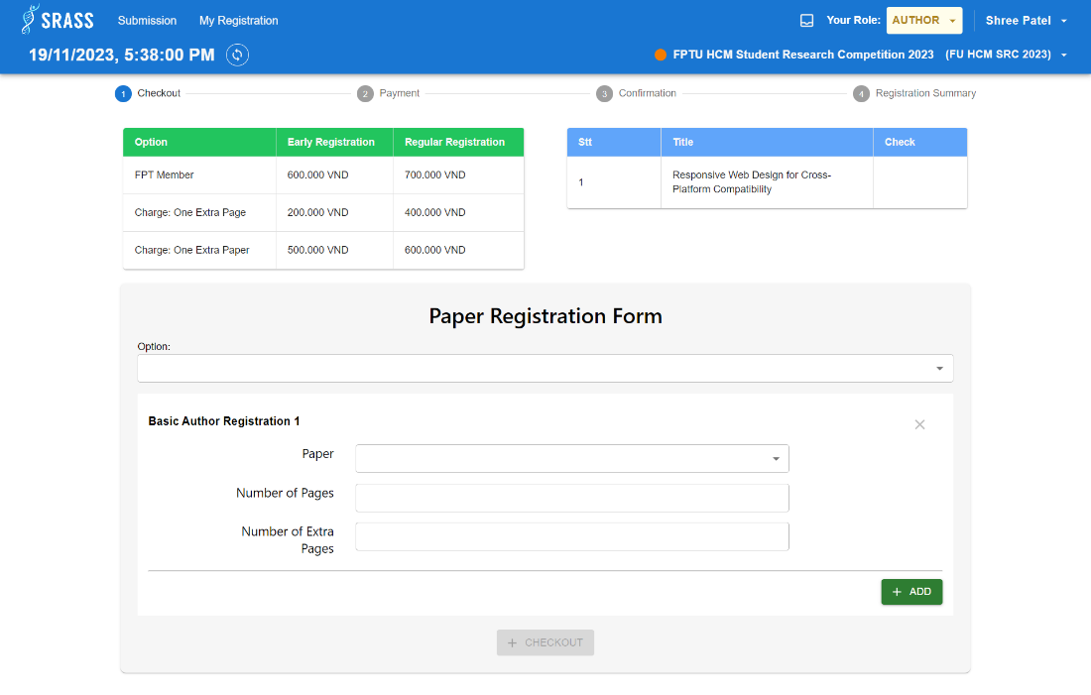 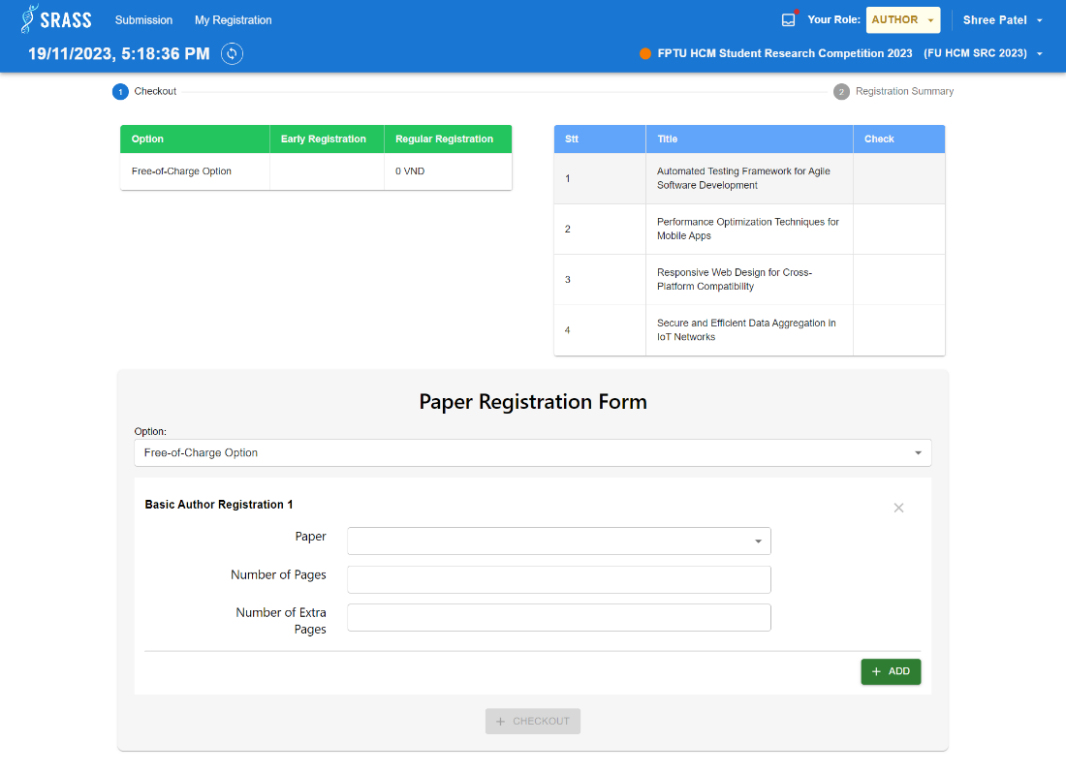

* + This function requires the user to login to the system with the role “**Author**”.
  + The table with header’s green background contains options for selecting submission to register. This has to case:
    - If the configuration of price is not free, it will show options with:
      * Option name.
      * Early Registration Price.
      * Regular Registration Price.
    - If the configuration of price is free, it only shows one option with:
      * Option name.
      * Regular Registration Price is 0VND.
  + The table with header’s green background contains registrable submissions. If the submission is selected, then an icon “Check” appears at the end of submission row.
  + The “Paper Registration Form” is where the Author select the option, then select the submission and enter the pages of submission to register.
  + If Author wants two or more paper for registration, Author can click on “+ ADD” button to add more form to choose more submissions.
  + Author clicks on “CHECK OUT” button to move to next step.

#### 3.2.53 <Author> Payment

* + **Function trigger:** After Author clicking on “CHECK OUT” button at “Registration Paper” page.
  + **Function description:** Author can make a payment after revising the information
  + **Screen layout:**

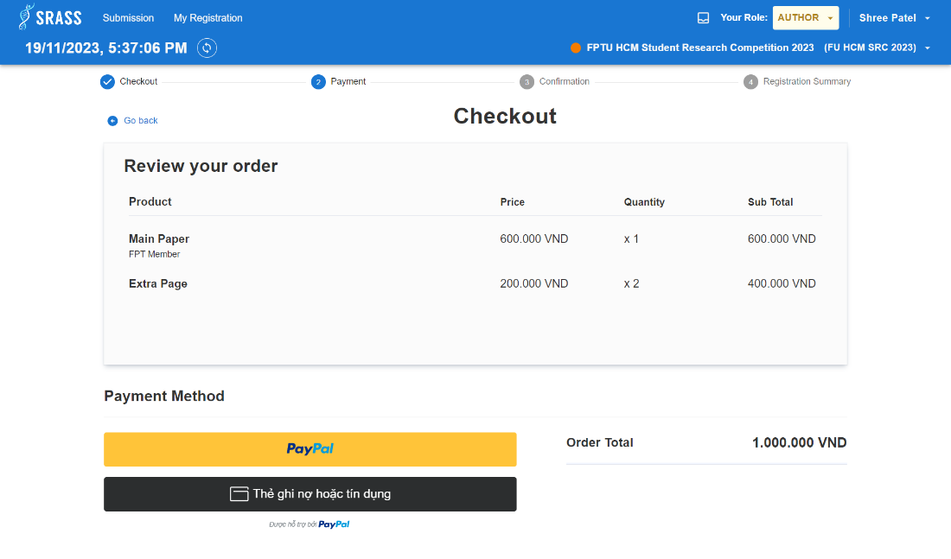

* + This function requires the user to login to the system with the role “**Author**”.
  + Author can make payment after reviewing list information

#### 3.2.54 <Author> Payment Confirmation

* + **Function trigger:** After Author making payment at “Payment” step at “Registration Paper” page.
  + **Function description:** Author can view status the payment
  + **Screen layout:**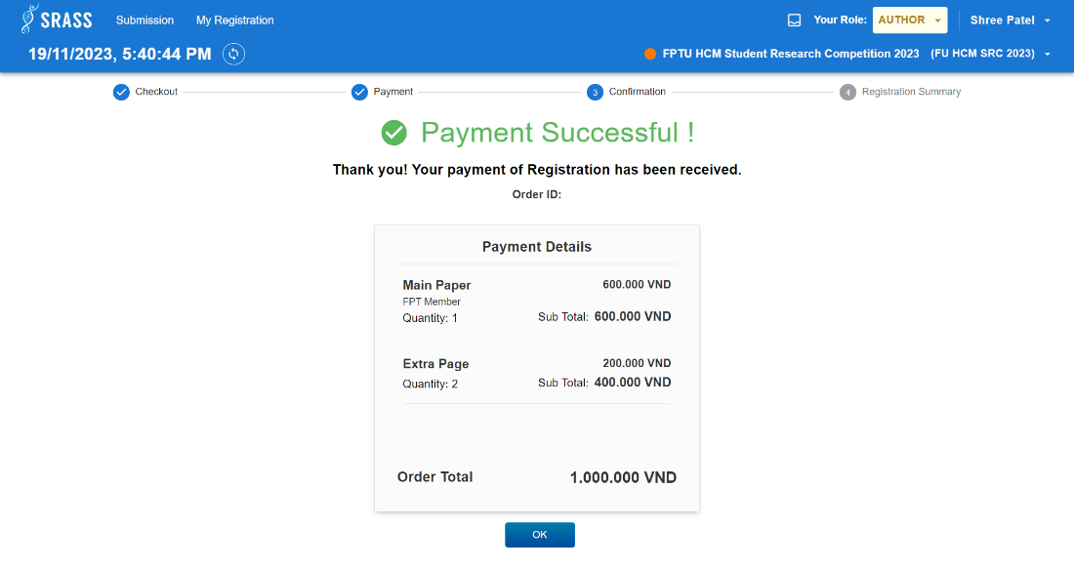
  + This function requires the user to login to the system with the role “**Author**”.
  + Author views the status of payment which can be success or failure
  + Click on “Ok” button to move to “Registration summary” step

#### 3.2.55 <Author> Registration Summary

* + **Function trigger:** After Author confirm the status of payment at “Confirmation” step at “Registration Paper” page.
  + **Function description:** Author can view summary information of all registration submission
  + **Screen layout:**

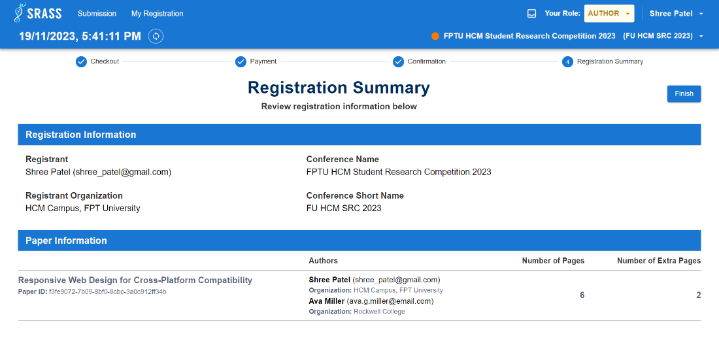

* + This function requires the user to login to the system with the role “**Author**”.
  + Author can view two types of information:
    - Registration Information:
      * Registrant
      * Registrant Organization
      * Conference Name
      * Conference Short Name
    - Paper Information
      * Paper Title
      * Paper Id
      * Authors
      * Number of pages
      * Number of extra pages
  + Click on “Finish” button to go back to “Submission Console” page

#### 3.2.56 <Author> Author View Review

* + **Function trigger:** Author clicks “View Review” button in the “Author Console” table action column.
  + **Function description:** Author can view reviewers' reviews of submission with content such as scores, comments for the author.
  + **Screen layout:**
  + This function requires the user to login to the system with the role “**Author**”.
  + Author can view list of reviews included: average evaluation score, comments for authors.

#### 3.2.57 <Reviewer> Reviewer Console

* + **Function trigger:** Reviewer clicks conference name on “Conferences”.
  + **Function description:** Reviewer can view a list of submissions assigned for review in conference.
  + **Screen layout:**

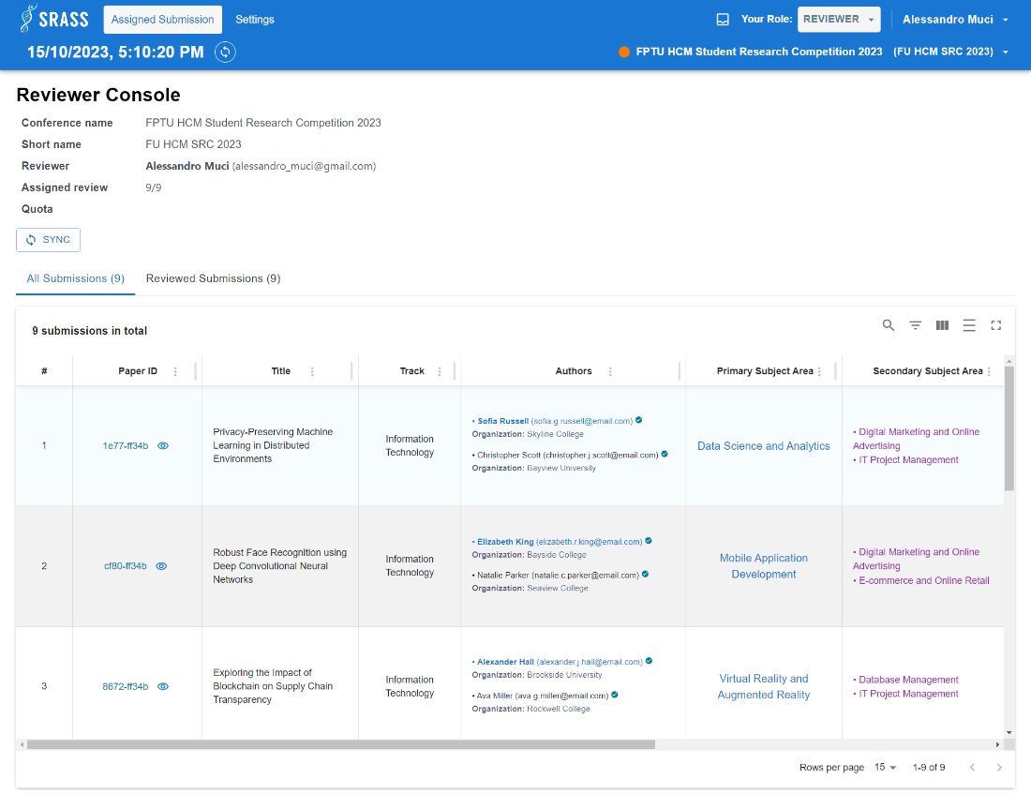

* + This function requires the user to login to the system with the role “**Reviewer**”.
  + Reviewer can view reviewer full name, reviewer email, assigned review, quota of reviewer.
  + Reviewer can click on “All Submissions” tab to view all submissions assigned to reviewer and click on “Reviewed Submissions” tab to view list of submissions that the reviewer has reviewed among the assigned submissions.
  + This function returns a list of submissions assigned to reviewer included: Paper Id, Title, Track, Authors, Primary subject area, Secondary subject area, Submission files, Supplementary materials, Revision files, Deadline Time.

#### 3.2.58 <Reviewer> Reviewer View Review

* + **Function trigger:** Reviewer click “View Review” button in the “Reviewer Console” table action column.
  + **Function description:** Reviewer can view review of submission with content such as scores, suggestions for the PC Chair, and comments for the author.
  + **Screen layout:**

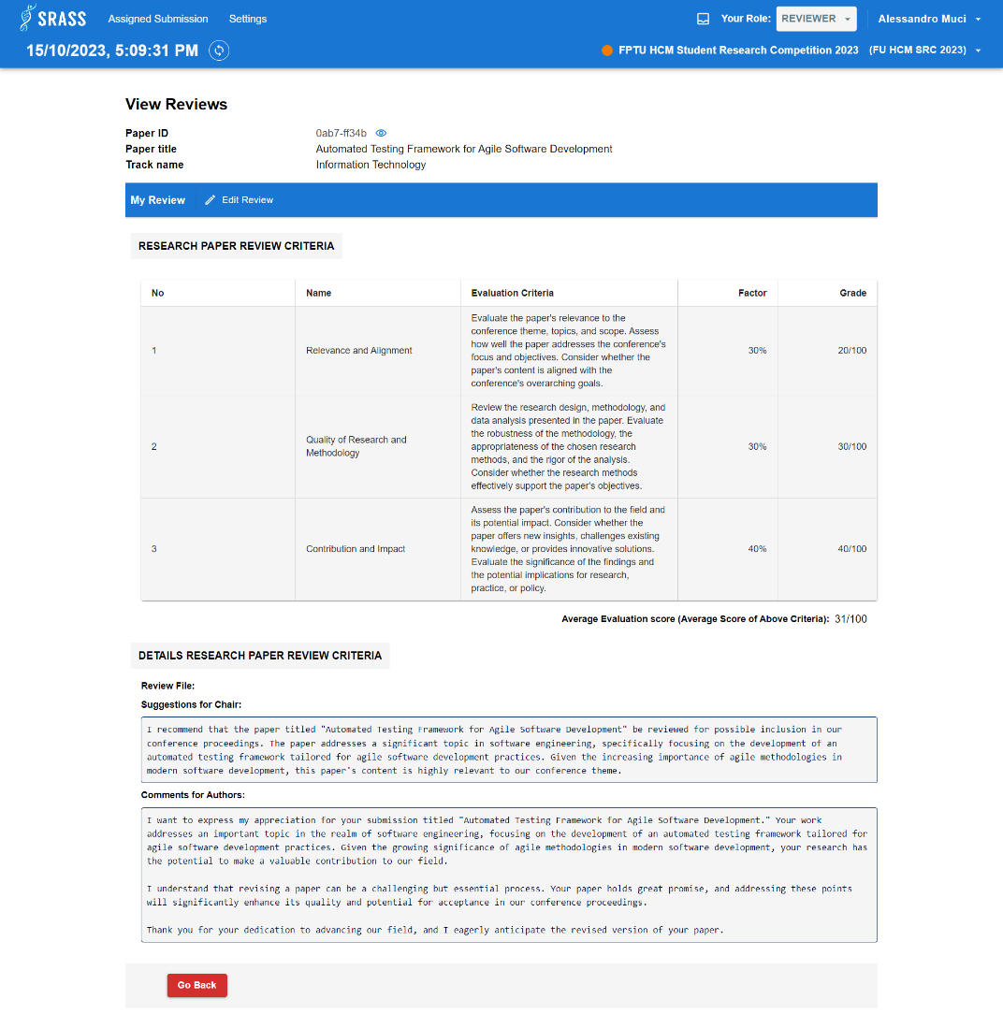

* + This function requires the user to login to the system with the role “**Reviewer**”.
  + Reviewer can view review included: average evaluation score, suggestions for the PC Chair, and comments for the author.

#### 3.2.59 <Reviewer> Enter Review

* + **Function trigger:** Reviewer click “Enter Review” button in the “Reviewer Console” table action column.
  + **Function description:** Reviewer can review the assigned submission.
  + **Screen layout:**

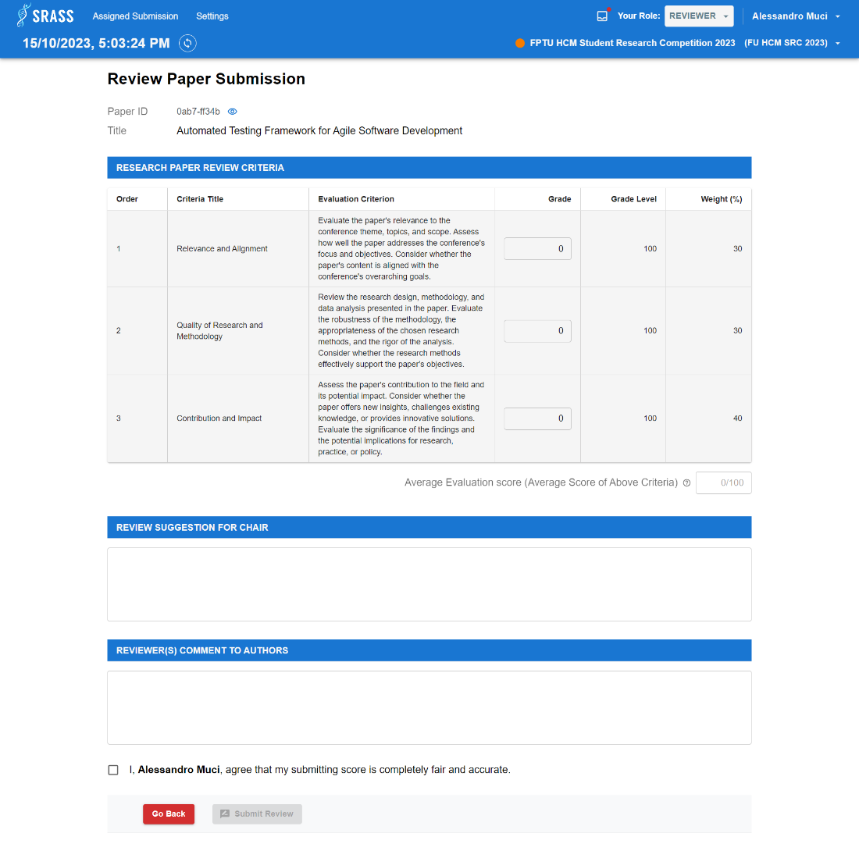

* + This function requires the user to login to the system with the role “**Reviewer**”.
  + Reviewer fills in all required fields included: grades, suggestion for PC Chair, comment for authors.
  + This function requires selecting checkbox to confirm that score submitting is fair and accurate. Then click button “Submit Review” to submit review.

#### 3.2.60 <Reviewer> Define Conflicts

* + **Function trigger:** Reviewer click “Define Conflicts” button in the “Reviewer Console” table action column.
  + **Function description:** Reviewer can define conflicts for submission.
  + **Screen layout:**

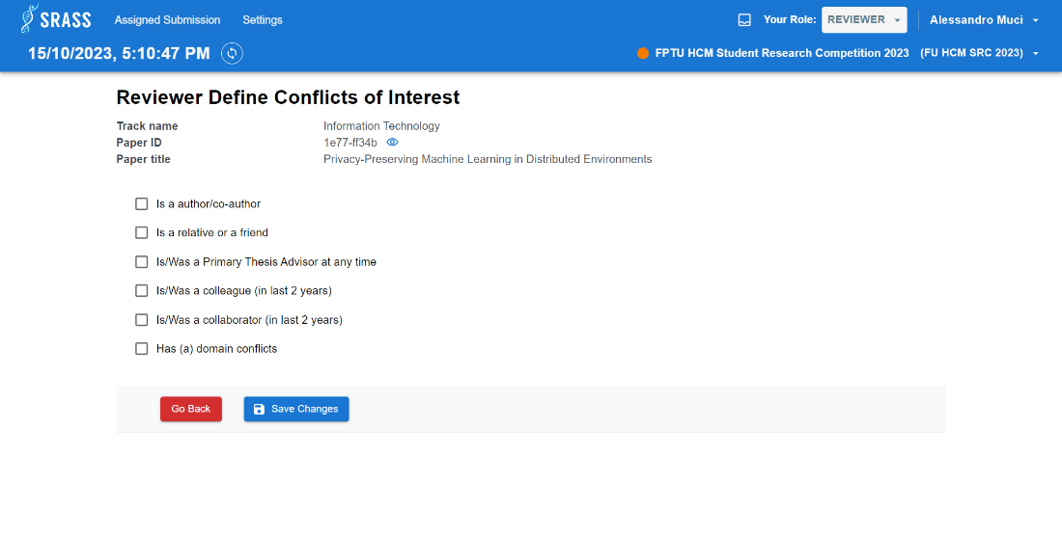

* + This function requires the user to login to the system with the role “**Reviewer**”.
  + Reviewer can select conflict of interest for submission and then click “Save Changes” to save conflicts.

#### 3.2.61 <Reviewer> Reviewer Information Setting

* + **Function trigger:** Reviewer click on the “Settings” on header.
  + **Function description:** Reviewer can manage subject areas and quota in conference.
  + **Screen layout:**

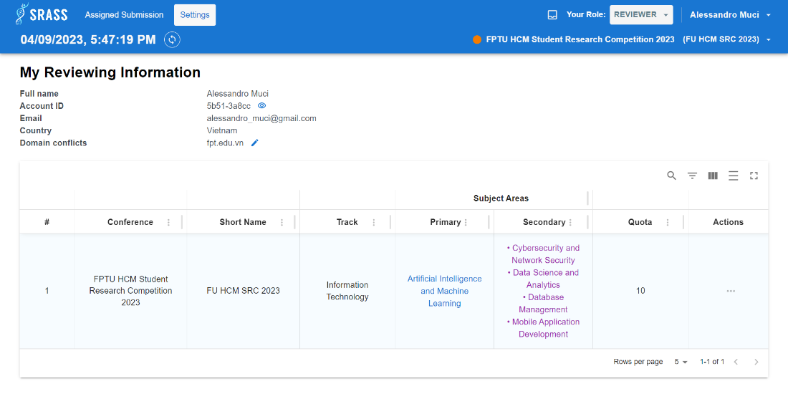

* + This function requires the user to login to the system with the role “**Reviewer**”.
  + Reviewer can view account full name, account Id, email, country, domain conflicts.
  + This function returns a list of conference reviewer attend to included: Conference name, Conference short name, Track name, Primary subject area, Secondary subject area, Quota.

#### 3.2.62 <Reviewer> Reviewer Edit Domain Conflict

* + **Function trigger:** Reviewer click on the  next to domain conflicts.
  + **Function description:** Reviewer can update domain conflict in conference.
  + **Screen layout:**

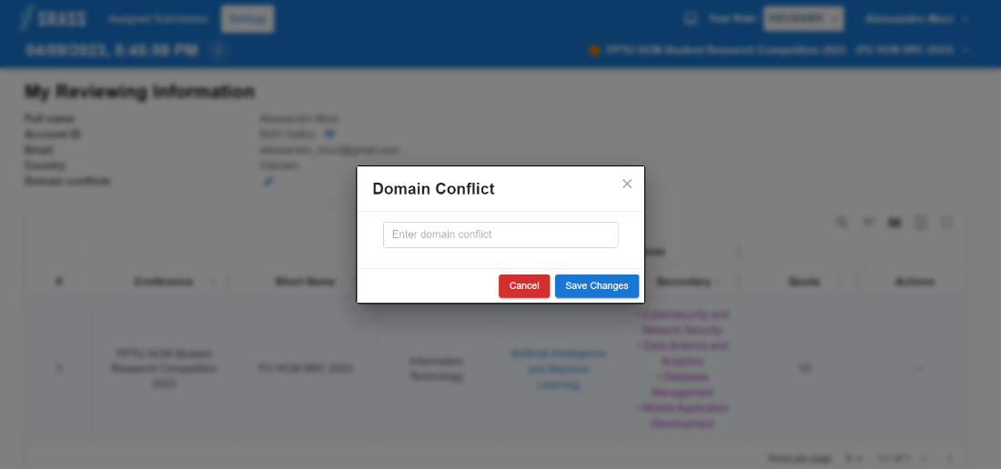

* + This function requires the user to login to the system with the role “**Reviewer**”.
  + Reviewer will edit domain conflict and then click “Save Changes” to update or click “Cancel” to cancel.
  + When clicking “Save Changes”, if success, it will return to “Reviewer Information Setting” screen, else, error message will show.

#### 3.2.63 <Reviewer> Edit Quota

* + **Function trigger:** Reviewer click “Edit Quota” in the “Reviewer Information Setting” table action menu.
  + **Function description:** Reviewer can edit quota in conference.
  + **Screen layout:**

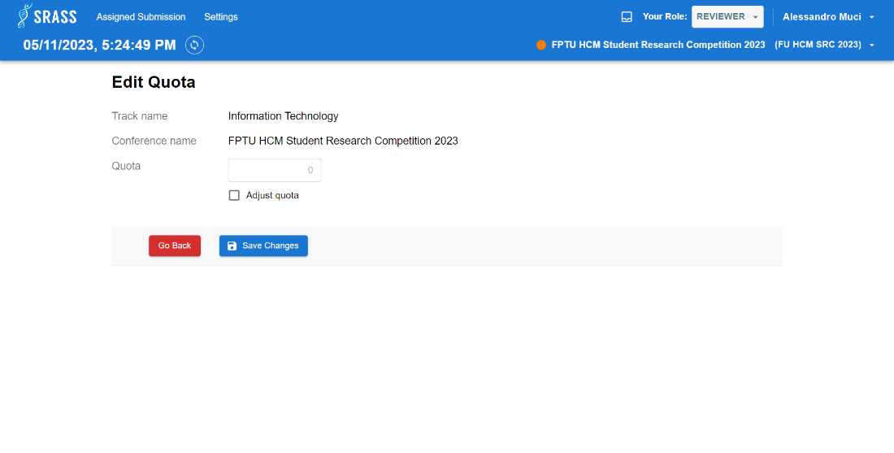

* + This function requires the user to login to the system with the role “**Reviewer**”.
  + Reviewer can select “Adjust quota” checkbox to input quota number.
  + When clicking “Save Changes”, if success, it will return to “Reviewer Information Setting” screen, else, error message will show.

#### 3.2.64 <Reviewer> Select Subject Areas

* + **Function trigger:** Reviewer click “Select Subject Areas” in the “Reviewer Information Setting” table action menu.
  + **Function description:** Reviewer can select subject areas in conference.
  + **Screen layout:**

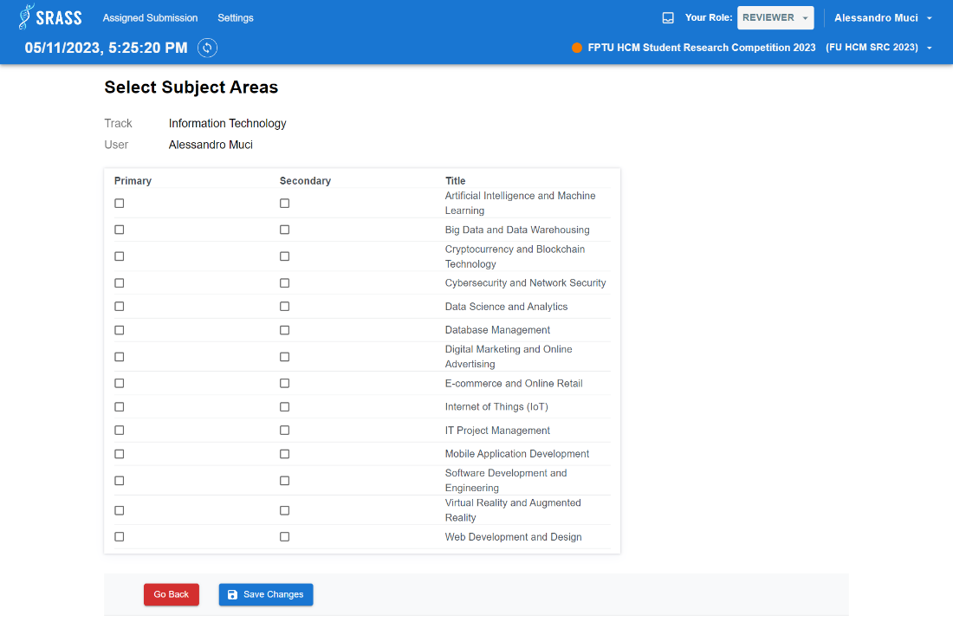

* + This function requires the user to login to the system with the role “**Reviewer**”.
  + This function return list of subject areas in conference, reviewer can select up to 1 primary subject area, and multiple secondary subject areas can be selected.
  + When clicking “Save Changes”, if success, it will return to “Reviewer Information Setting” screen, else, error message will show.

#### 3.2.65 <PC Chair> Notify Open Submission

* + **Function trigger:** PC Chair click on the “Submission” on header, after that PC Chair click on “Actions” button, dropdown will be appeared, then choose the “Notification Open For Submission” button.
  + **Function description:** PC Chair imports the email list to send emails calling for submissions to the conference.
  + **Screen layout:**

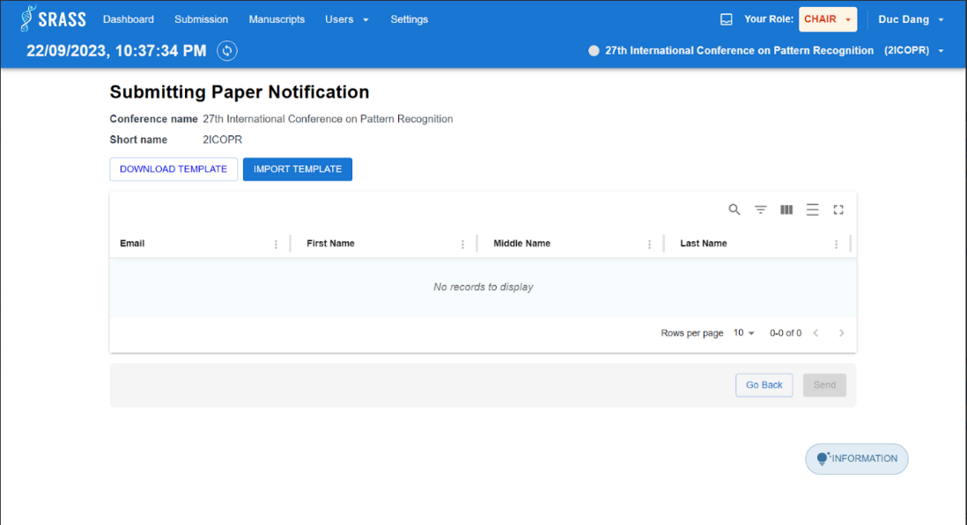

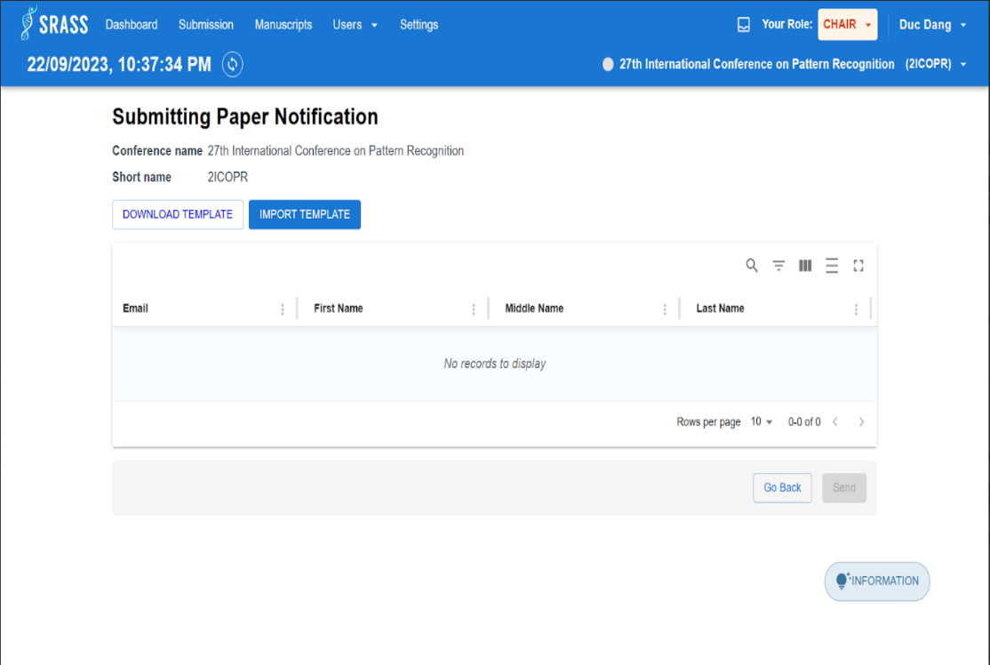

* + This function requires the user to login to the system with the role “PC Chair
  + PC Chair click on “DOWLOAD TEMPLATE” button to download template and fulfil emails information following to template’s structure.
  + After fulfilling emails in template, then PC Chair can click on “IMPORT TEMPLATE” to import list email information.
  + PC Chair click on “Send” button to send list emails.
  + If PC Chair do not want to send emails, PC Chair can click on “Go Back” button to back to “Submission Console” page.

#### 3.2.66 <Admin> Admin Conferences

* + **Function trigger:** Authenticated User after login into system as “admin” role.
  + **Function description:** PC Chair can view all conferences have been created.
  + **Screen layout:**

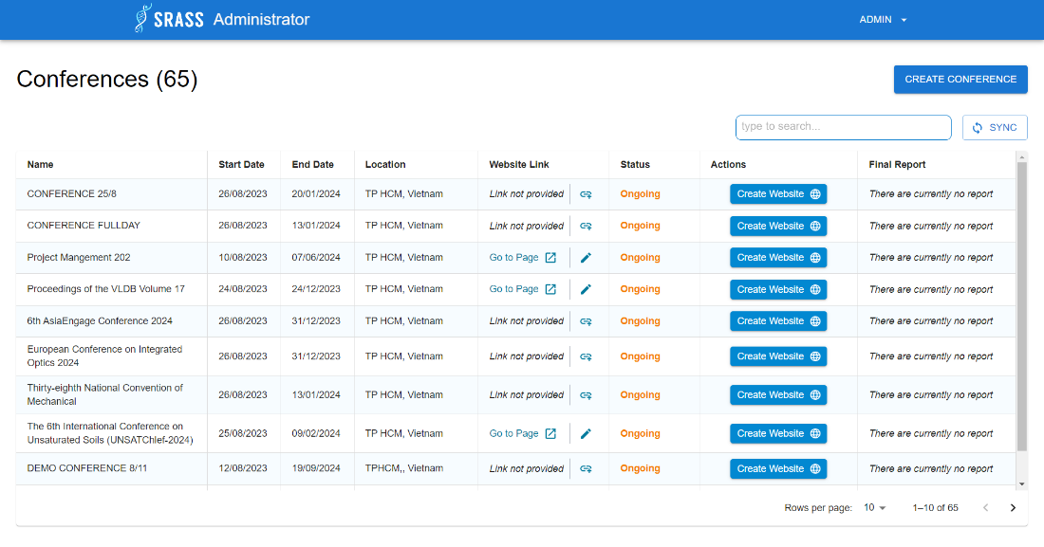

* + This function requires the user to login to the system with the role “**Admin**”.
  + PC Chair can view and search for conferences information.
  + PC Chair can click on “CREATE CONFERENCE” to create new conference.
  + PC Chair can edit the conference website link and create a new content webpage for a conference.
  + If the webpage content of conference is existed, PC Chair can edit or delete the webpage content.
  + After the conference has finished, a “EXPORT FINAL REPORT” appear. Or else “There are currently no report” appear.

#### 3.2.67 <Admin> Create Conference

* + **Function trigger:** Admin click on “CREATE CONFERENCE” at “Conferences” page.
  + **Function description:** PC Chair can create new conference.
  + **Screen layout:**

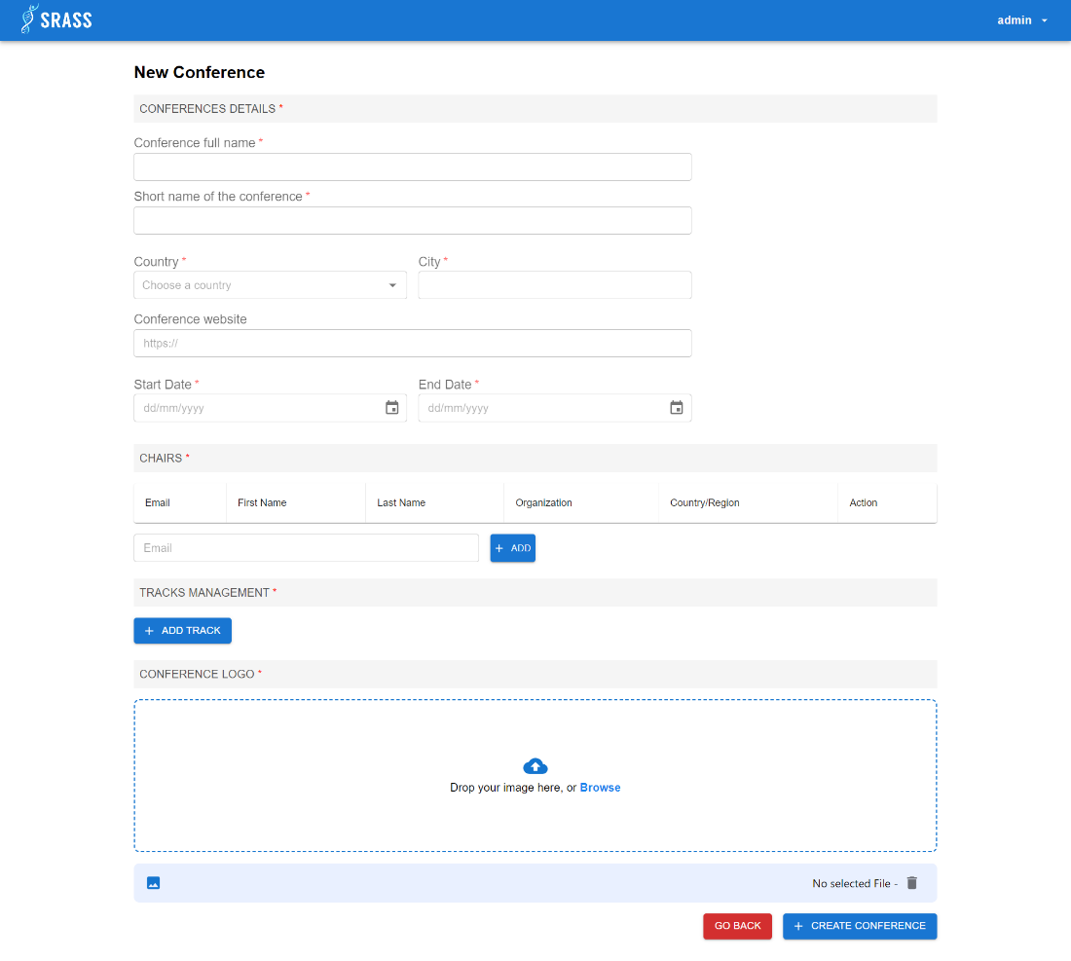

* + This function requires the user to login to the system with the role “**Admin**”
  + To create new conference, Admin must fulfil all required information:
    - Enter Conference full name
    - Enter Conference short name.
    - Select country
    - Enter Country
    - Search user email. Then add user to PC Chairs list
    - Create tracks for conference by clicking on “+ ADD TRACK”
    - Add logo for conference
  + Clicking on “+ CREATE CONFERENCE” to create conference after fulfilling valid information.
  + Clicking on “Go Back” to return “Conferences” page.

#### 3.2.68 <Admin> Website Template Selection

* + **Function trigger:** Admin click on “CREATE WEBSITE” at “Conferences” page.
  + **Function description:** Admin can select template and create navbar for webpage content.
  + **Screen layout:**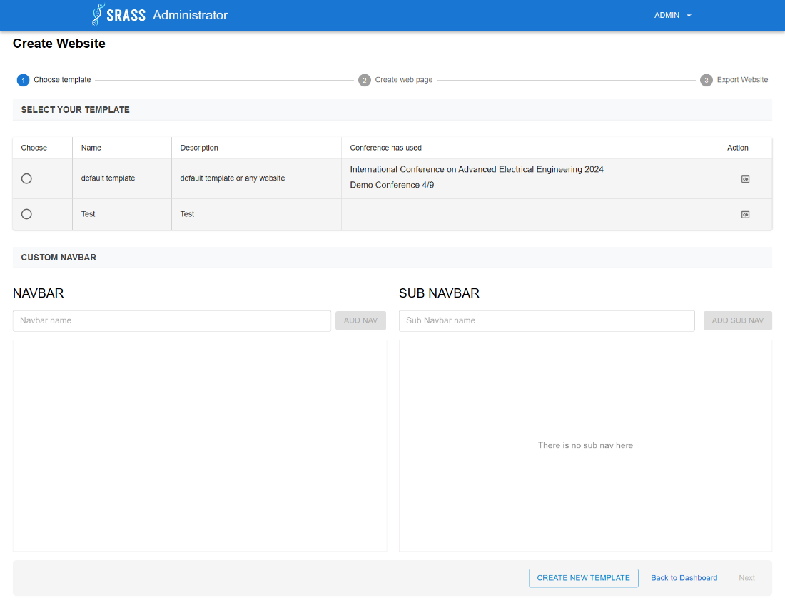

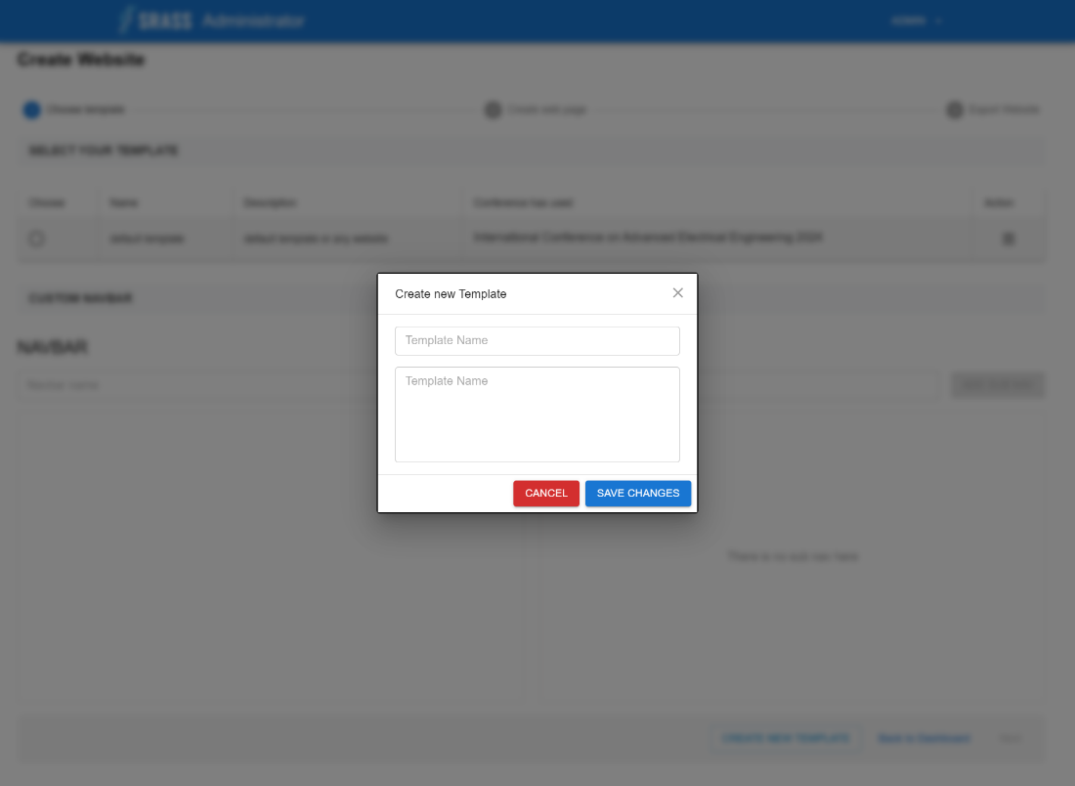

* + This function requires the user to login to the system with the role “**Admin**”.
  + Admin must choose the template, then the default template contains default navbar:
    - Home
    - About
  + Admin can create more navbars based on the default navbars after selecting template.
  + The navbars is divided into two levels:
    - Parent navbar
    - Children navbar will depend on parent navbar
  + PC Chair can create children navbar when only choosing parent navbar.
  + PC Chair can go back to “Conferences” page by clicking on “Back to Dashboard” button.
  + Click “Next” button to move to next step.
  + PC Chair can create new template by clicking on “CREATE NEW TEMPLATE” button. Then the pop up will appear. Then PC Chair must fulfil information:
    - Template Name
    - Template Description
  + PC Chair click on “Save Changes” button on pop up to create new template.

#### 3.2.69 <Admin> Web Page Content Creation

* + **Function trigger:** Admin click “Next” button at “Choose Template” step.
  + **Function description:** Admin can edit the webpage content for creating content in file html.
  + **Screen layout:**

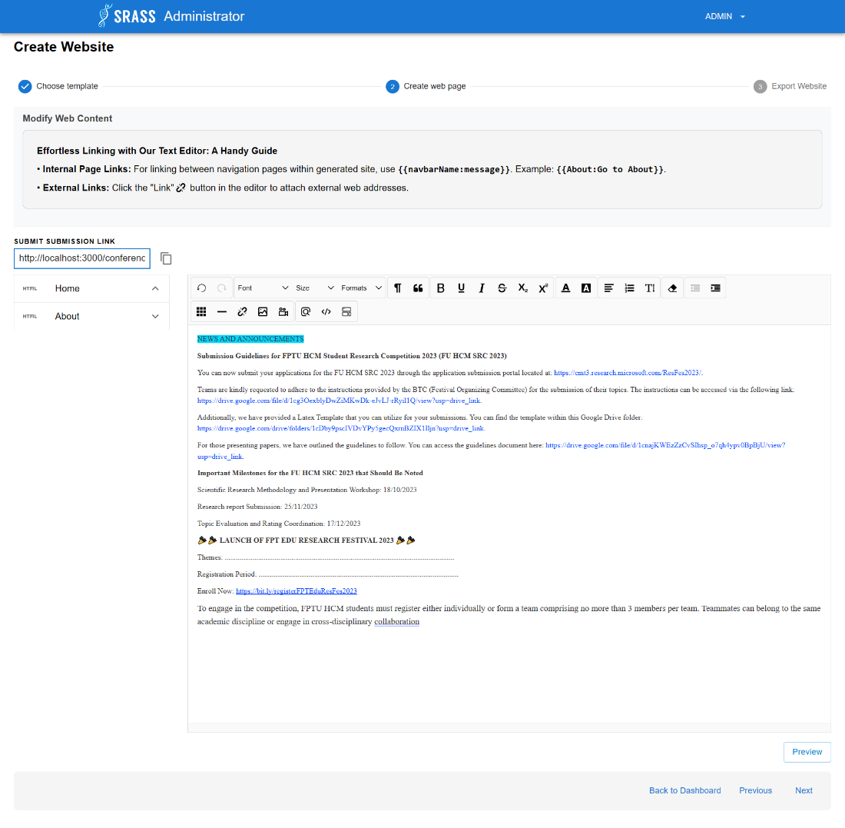

* + This function requires the user to login to the system with the role “**Admin**”.
  + The left site is the list of navbars, the right site is an editor to edit content for selected navbar.
  + There is a guideline for Admin to create link to external page or internal page.
  + Admin can preview the how the webpage looks like by clicking on “Preview”.
  + Admin can click on one of three buttons at the bottom for:
    - “Back to Dashboard” to go back “Conferences” page
    - “Previous” to back to previous step
    - “Next” to move to next step

#### 3.2.70 <Admin> Export Web Page Content

* + **Function trigger:** Admin click “Next” button at “Create web page” step.
  + **Function description:** Admin can export all content has been edited at “Create web page” step to files html corresponding to navbars have been created.
  + **Screen layout:**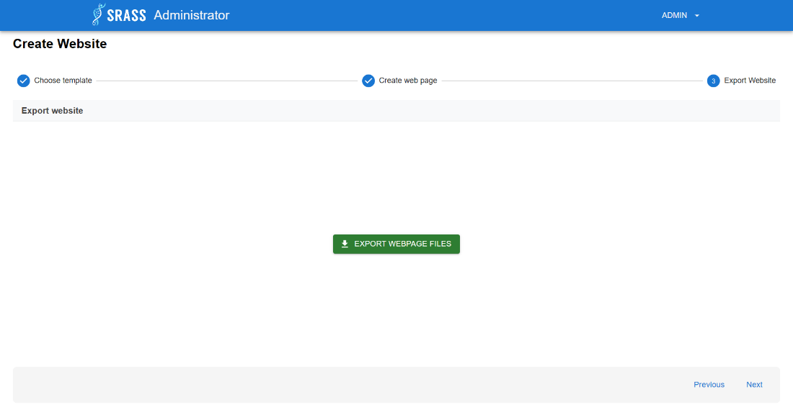
  + This function requires the user to login to the system with the role “**Admin**”.
  + There is “EXPORT WEBPAGE FILES” button for Admin to export files html then go to “Conferences” page.
  + If Admin do not want to export webpage content yet. There are two options:
    - “Previous” button to back previous step
    - “Next” to go to “Conferences” page without exporting

#### 3.2.71 <Authenticated User> Profile Creation

* + **Function trigger:** Authenticated User after login into system as “**Authenticated User**” role. Clicking on “Username” button at the top right at screen. Then choose “Scientist profile”
  + **Function description:** Authenticated User can create "Lecturer Researcher Profile”.
  + **Screen layout:**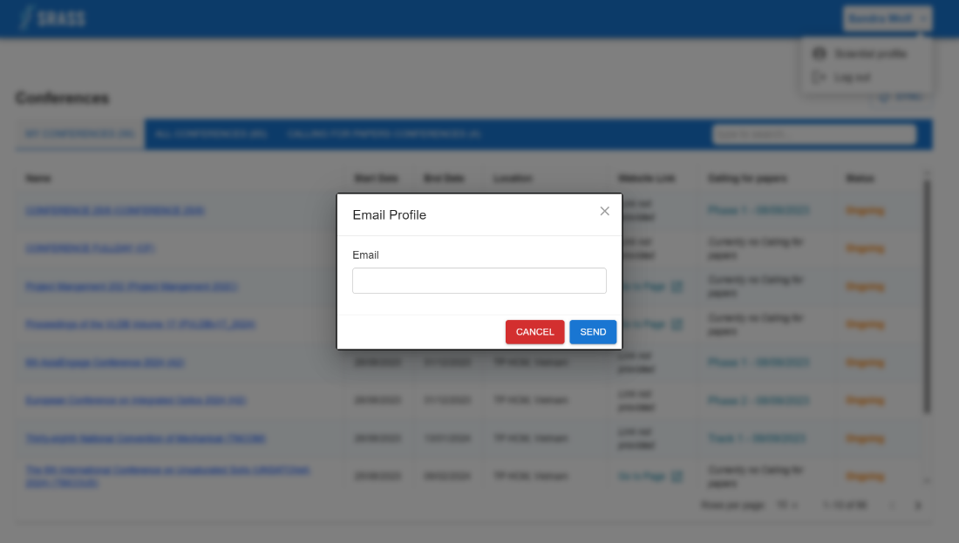
  + This function requires the user to login to the system with the role “**Authenticated User**”.
  + If user has not created profile yet, the pop-up will appear. User must enter the [@fpt.edu.vn](http://@fpt.edu.vn) email then click on “SEND” button to send email. If the email is not [@fpt.edu.vn](http://@fpt.edu.vn), the error will be thrown out.

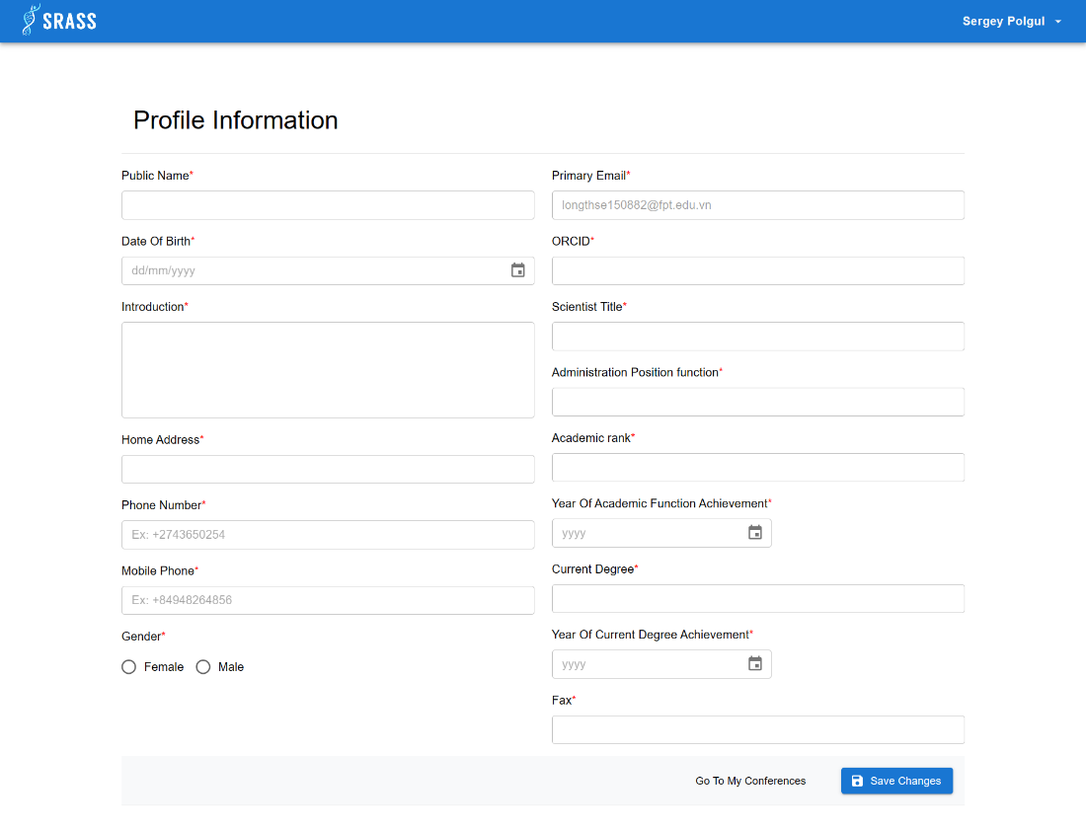

* + After clicking the link on email, it will redirect user to “Profile Information” page to fulfil required information. Then user click on “Save Changes” button to create “Lecturer Researcher Profile”.

#### 3.2.72 <Lecturer> Scientist Profile About

* + **Function trigger:** Authenticated User clicks on “Username” button at the top right at screen, then choose “Scientist profile”. Or after clicking on “Save Changes” button at “Profile Information”. The default is “ABOUT” tab.
  + **Function description:** Authenticated User can manage “Lecturer Researcher Profile” overview information.
  + **Screen layout:**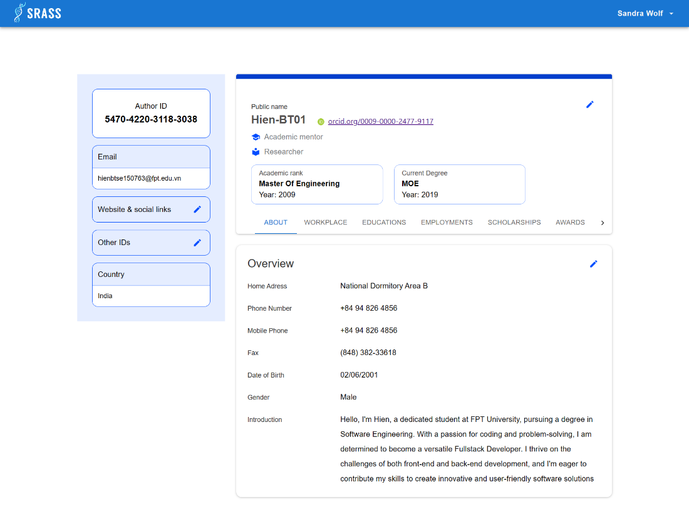

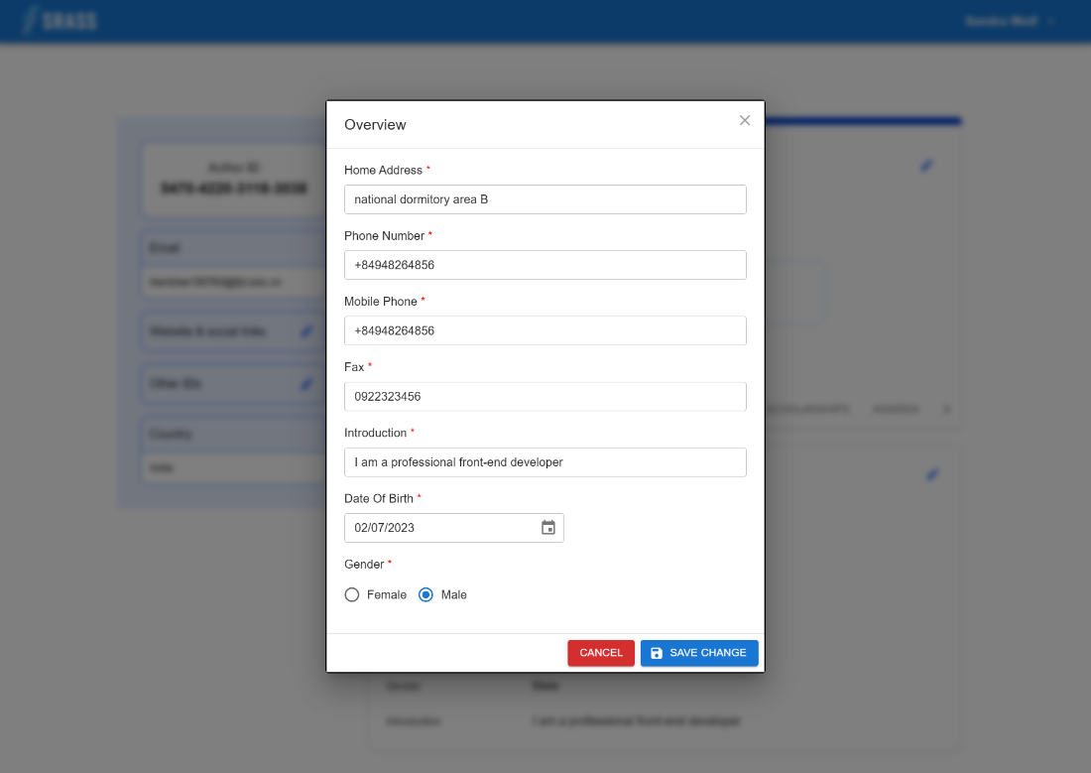

* + This function requires the user to login to the system with the role “**Authenticated User**”.
  + There are two types of information in this screen:
    - The left site:
      * Authenticated user can use id
      * Authenticated user can use their email
      * Authenticated user can view and modify their website & social links
      * Authenticated user can view and modify their other Ids
      * Authenticated user can view country
    - The right site:
      * The top (Academic profile):
        + Authenticated user can view and modify

Public Name (required)

Orcid (required)

Scientist title (required)

Admin position function (required)

Academic rank (required)

Year of academic rank (required)

Current Degree (required)

Year of Current Degree (required)

Also Known as

* + - * The bottom (Overview):
        + Authenticated user can view and modify:

Home Address (required)

Phone Number (required)

Mobile Phone (required)

Fax (required)

Date of Birth (required)

Gender (required)

Introduction (required)

#### 3.2.73 <Lecturer> Profile Workplace

* + **Function trigger:** Authenticated User clicks on ”WORKPLACE” tab in “Scientist Profile” page
  + **Function description:** Authenticated User can manage the “Lecturer Researcher Profile “ current workplace information
  + **Screen layout:**

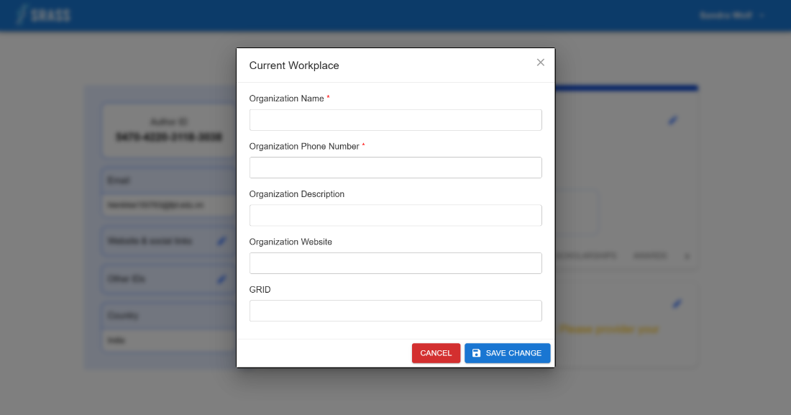

* + 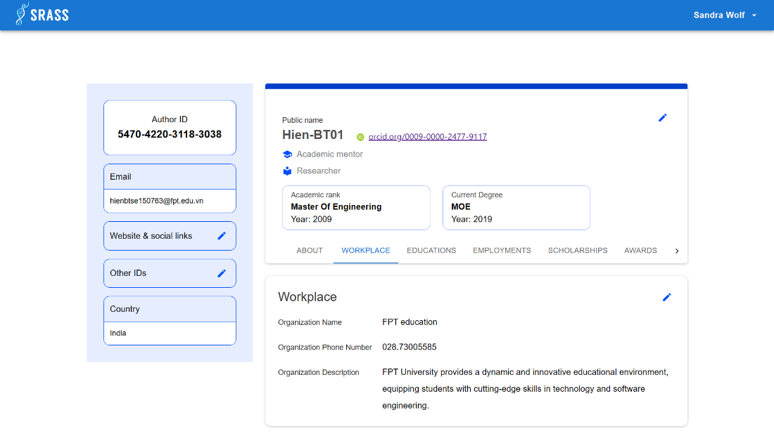

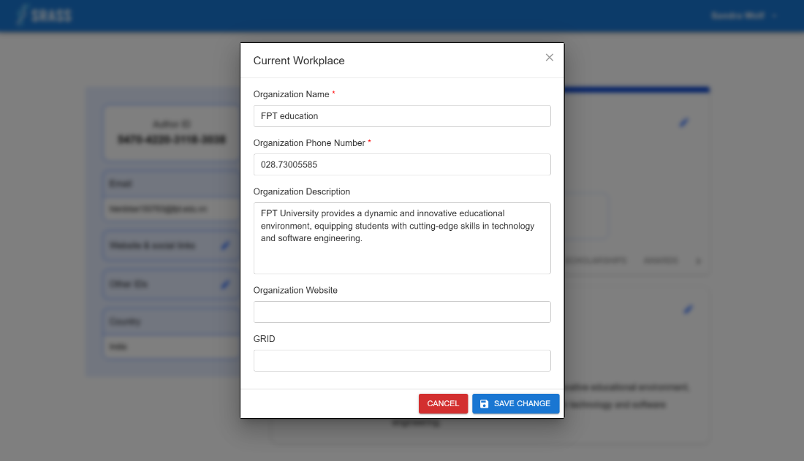

* + This function requires the user to login to the system with the role “**Authenticated User**”.
  + There are two types of information in this screen:
    - The left site:
      * Authenticated user can use id
      * Authenticated user can use their email
      * Authenticated user can view and modify their website & social links
      * Authenticated user can view and modify their other Ids
      * Authenticated user can view country
    - The right site:
      * The top (Academic profile):
        + Authenticated user can view and modify:

Public Name (required)

Orcid (required)

Scientist title (required)

Admin position function (required)

Academic rank (required)

Year of academic rank (required)

Current Degree (required)

Year of Current Degree (required)

Also Known as

* + - * The bottom (Workplace):
        + Authenticated user can view and modify:

Organization name (required)

Organization phone number (required)

Organization description

Organization website

GRID

#### 3.2.74 <Lecturer> Profile Educations

* + **Function trigger:** Authenticated User clicks on ”EDUCATIONS” tab in “Scientist Profile” page
  + **Function description:** Authenticated User can manage the “Lecturer Researcher Profile “ educations information
  + **Screen layout:**

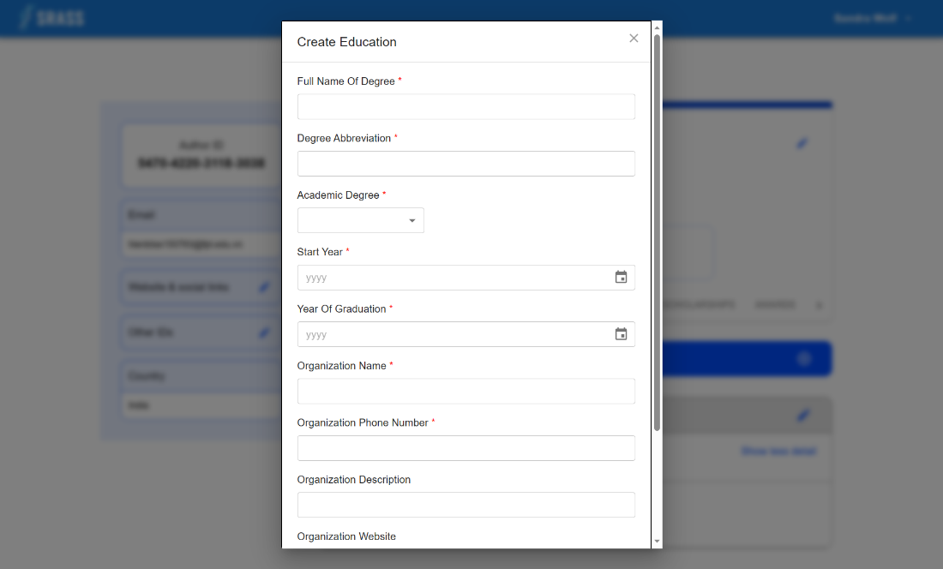 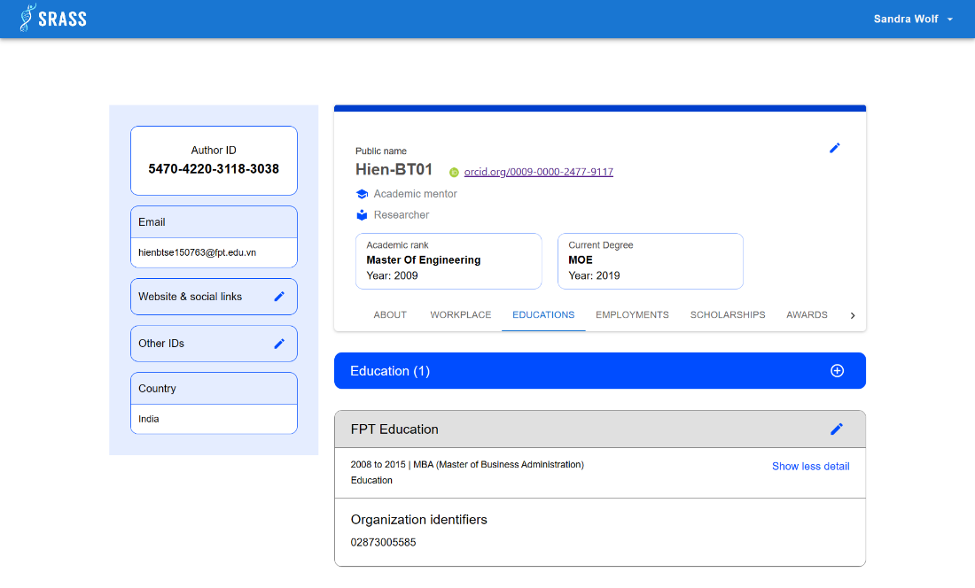

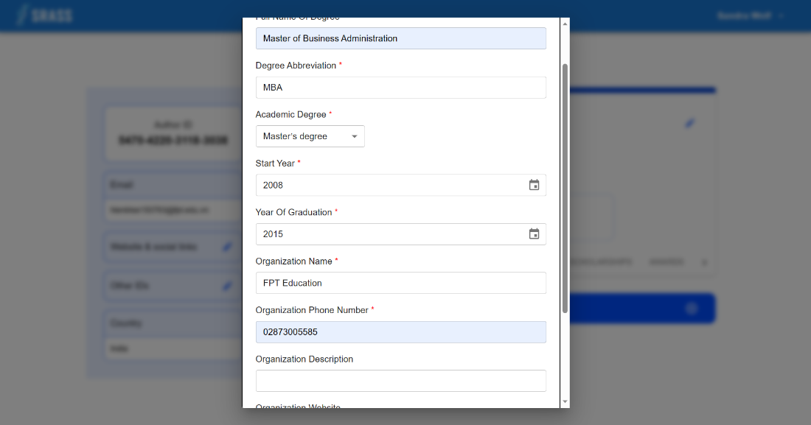

* + This function requires the user to login to the system with the role “**Authenticated User**”.
  + There are two types of information in this screen:
    - The left site:
      * Authenticated user can use id
      * Authenticated user can use their email
      * Authenticated user can view and modify their website & social links
      * Authenticated user can view and modify their other Ids
      * Authenticated user can view country
    - The right site:
      * The top (Academic profile):
        + Authenticated user can view and modify:

Public Name (required)

Orcid (required)

Scientist title (required)

Admin position function (required)

Academic rank (required)

Year of academic rank (required)

Current Degree (required)

Year of Current Degree (required)

Also Known as

* + - * The bottom (Educations):
        + Authenticated user can view and modify:

Full name of degree (required)

Degree Abbreviation (required)

Academic degree (required)

Start year (required)

Year of graduation (required)

Organization name (required)

Organization phone number (required)

Organization description

Organization website

GRID

#### 3.2.75 <Lecturer> Profile Employments

* + **Function trigger:** Authenticated User clicks on ”EMPLOYMENTS” tab in “Scientist Profile” page
  + **Function description:** Authenticated User can manage the “Lecturer Researcher Profile “ employments information
  + **Screen layout:**

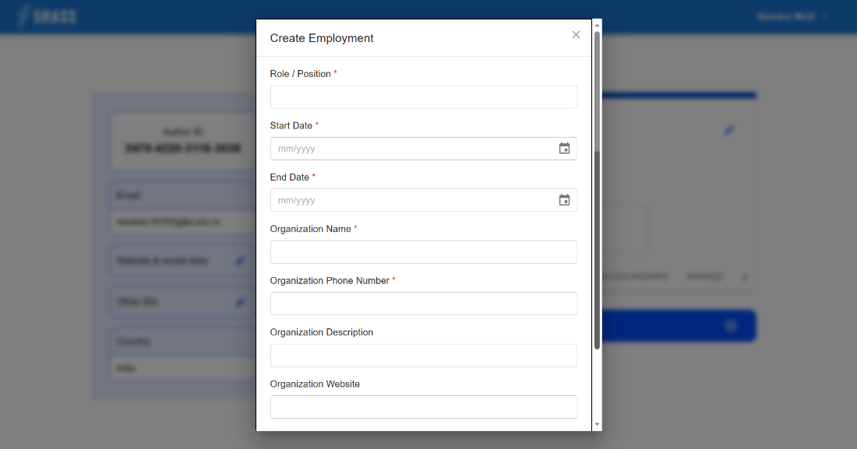 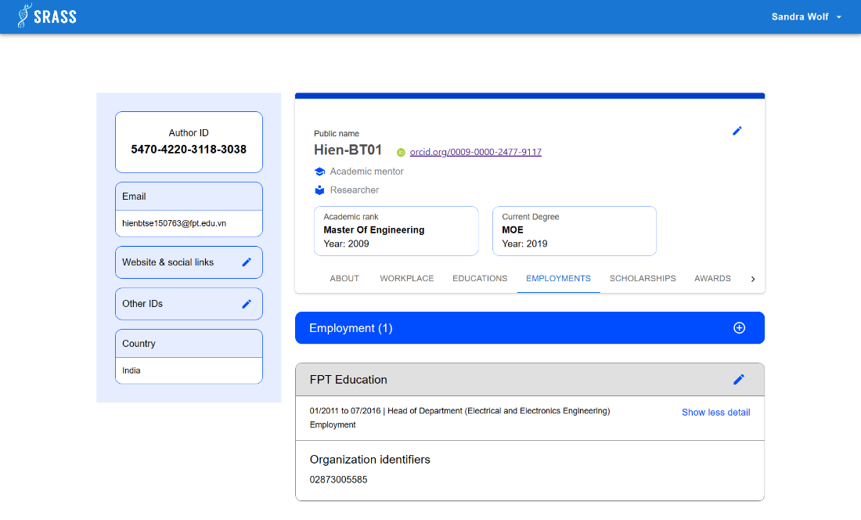

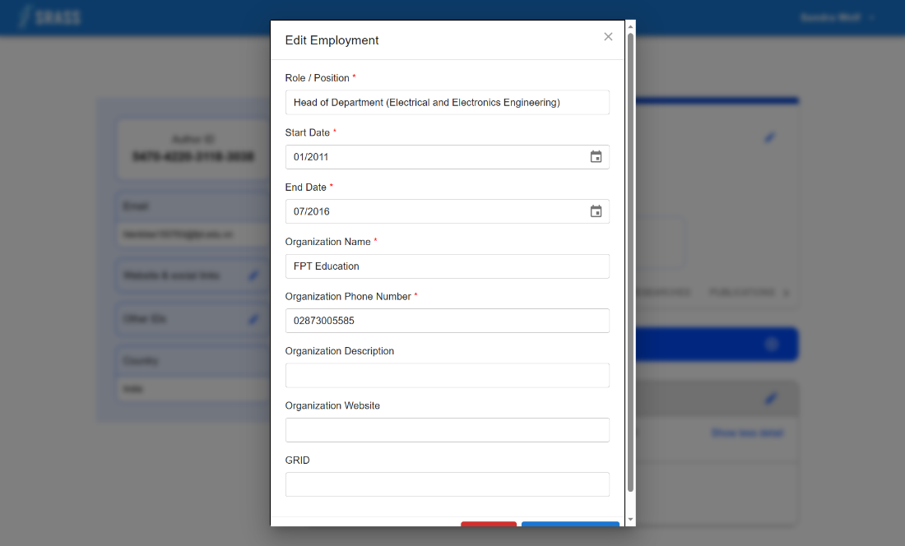

* + This function requires the user to login to the system with the role “**Authenticated User**”.
  + There are two types of information in this screen:
    - The left site:
      * Authenticated user can use id
      * Authenticated user can use their email
      * Authenticated user can view and modify their website & social links
      * Authenticated user can view and modify their other Ids
      * Authenticated user can view country
    - The right site:
      * The top (Academic profile):
        + Authenticated user can view and modify:

Public Name (required)

Orcid (required)

Scientist title (required)

Admin position function (required)

Academic rank (required)

Year of academic rank (required)

Current Degree (required)

Year of Current Degree (required)

Also Known as

* + - * The bottom (Employments):
        + Authenticated user can view and modify:

Role / Position (required)

Start Date (required)

End Date (required)

Organization name (required)

Organization phone number (required)

Organization description

Organization website

GRID

#### 3.2.76 <Lecturer> Profile Scholarships

* + **Function trigger:** Authenticated User clicks on ”SCHOLARSHIPS” tab in “Scientist Profile” page
  + **Function description:** Authenticated User can manage the “Lecturer Researcher Profile “ scholarships information
  + **Screen layout:**

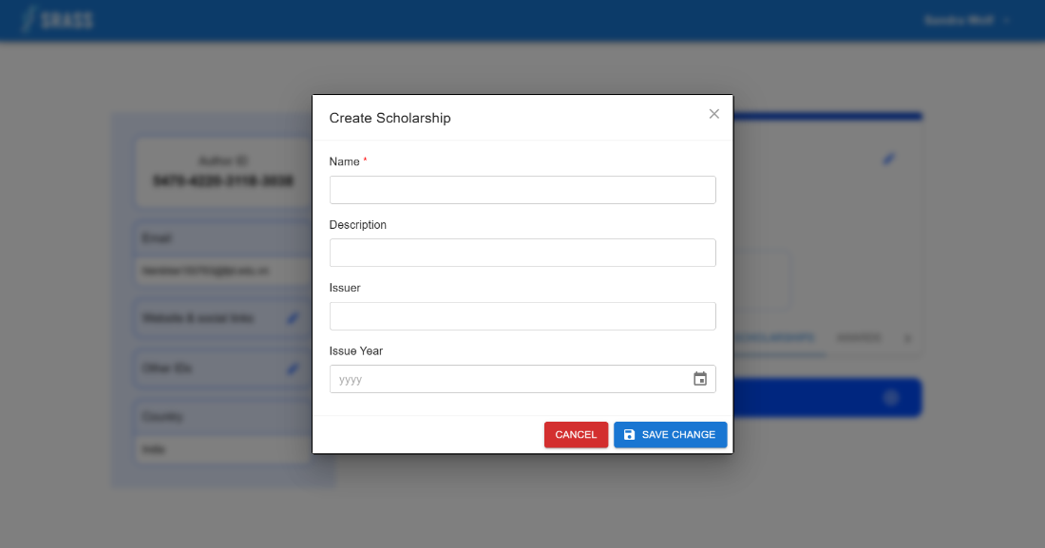 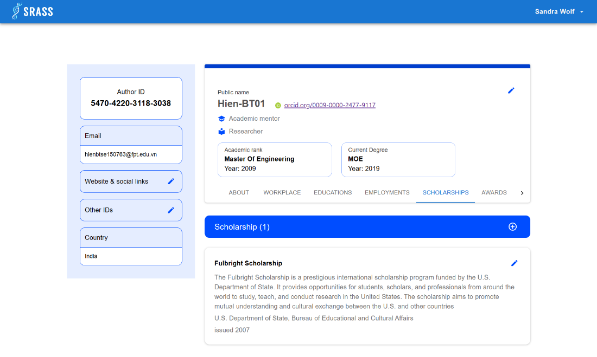

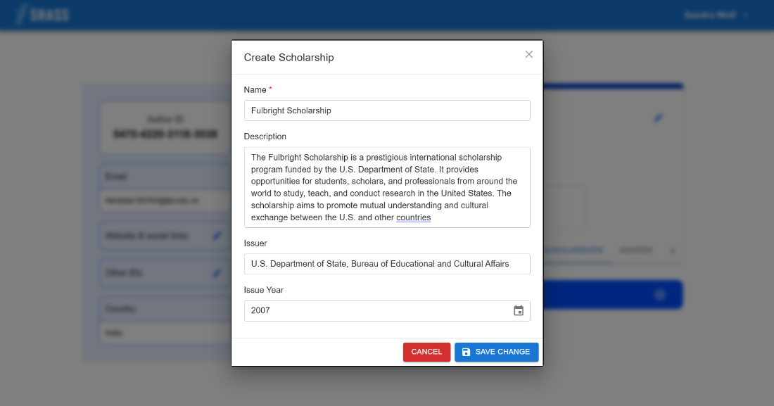

* + This function requires the user to login to the system with the role “**Authenticated User**”.
  + There are two types of information in this screen:
    - The left site:
      * Authenticated user can use id
      * Authenticated user can use their email
      * Authenticated user can view and modify their website & social links
      * Authenticated user can view and modify their other Ids
      * Authenticated user can view country
    - The right site:
      * The top (Academic profile):
        + Authenticated user can view and modify:

Public Name (required)

Orcid (required)

Scientist title (required)

Admin position function (required)

Academic rank (required)

Year of academic rank (required)

Current Degree (required)

Year of Current Degree (required)

Also Known as

* + - * The bottom (Scholarships):
        + Authenticated user can view and modify:

Name (required)

Description

Issuer

Issue Year

#### 3.2.77 <Lecturer> Profile Awards

* + **Function trigger:** Authenticated User clicks on ”AWARDS” tab in “Scientist Profile” page
  + **Function description:** Authenticated User can manage the “Lecturer Researcher Profile “ awards information
  + **Screen layout:**

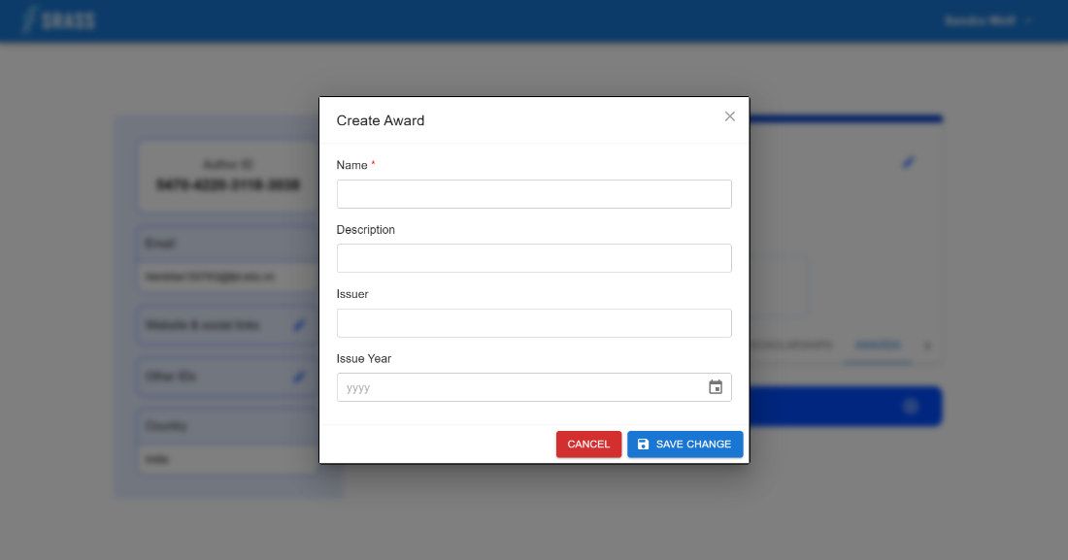 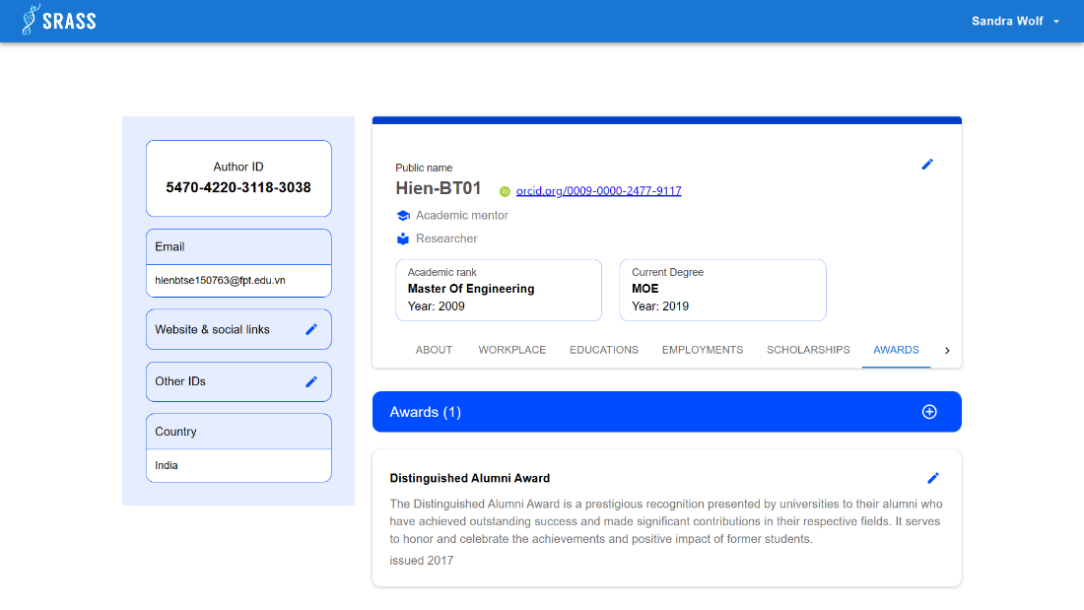

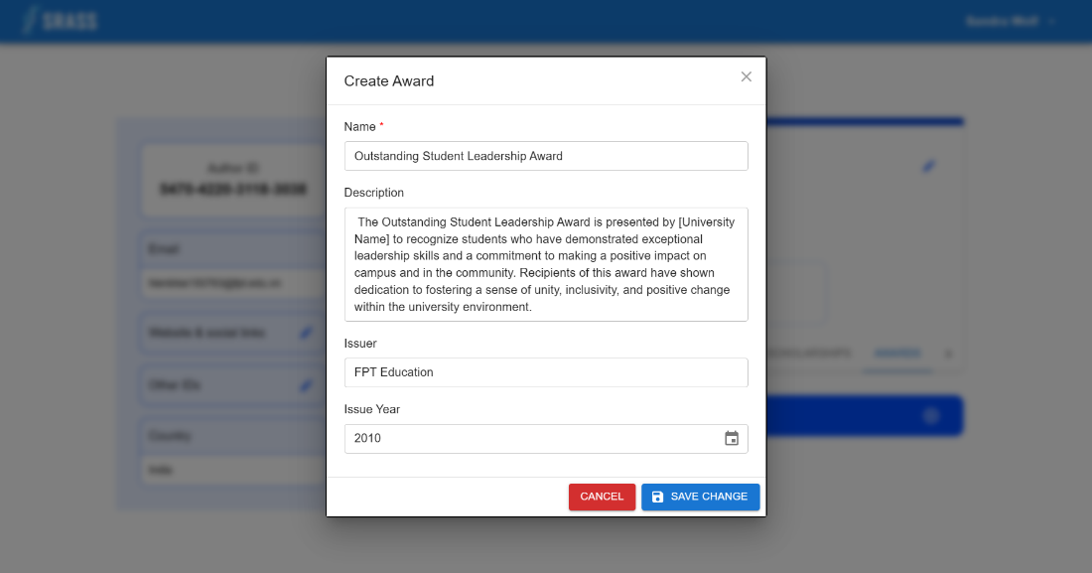

* + This function requires the user to login to the system with the role “**Authenticated User**”.
  + There are two types of information in this screen:
    - The left site:
      * Authenticated user can use id
      * Authenticated user can use their email
      * Authenticated user can view and modify their website & social links
      * Authenticated user can view and modify their other Ids
      * Authenticated user can view country
    - The right site:
      * The top (Academic profile):
        + Authenticated user can view and modify:

Public Name (required)

Orcid (required)

Scientist title (required)

Admin position function (required)

Academic rank (required)

Year of academic rank (required)

Current Degree (required)

Year of Current Degree (required)

Also Known as

* + - * The bottom (Awards):
        + Authenticated user can view and modify:

Name (required)

Description

Issuer

Issue Year

#### 3.2.78 <Lecturer> Profile Skills

* + **Function trigger:** Authenticated User clicks on ”SKILLS” tab in “Scientist Profile” page
  + **Function description:** Authenticated User can manage the “Lecturer Researcher Profile “ skills information
  + **Screen layout:**

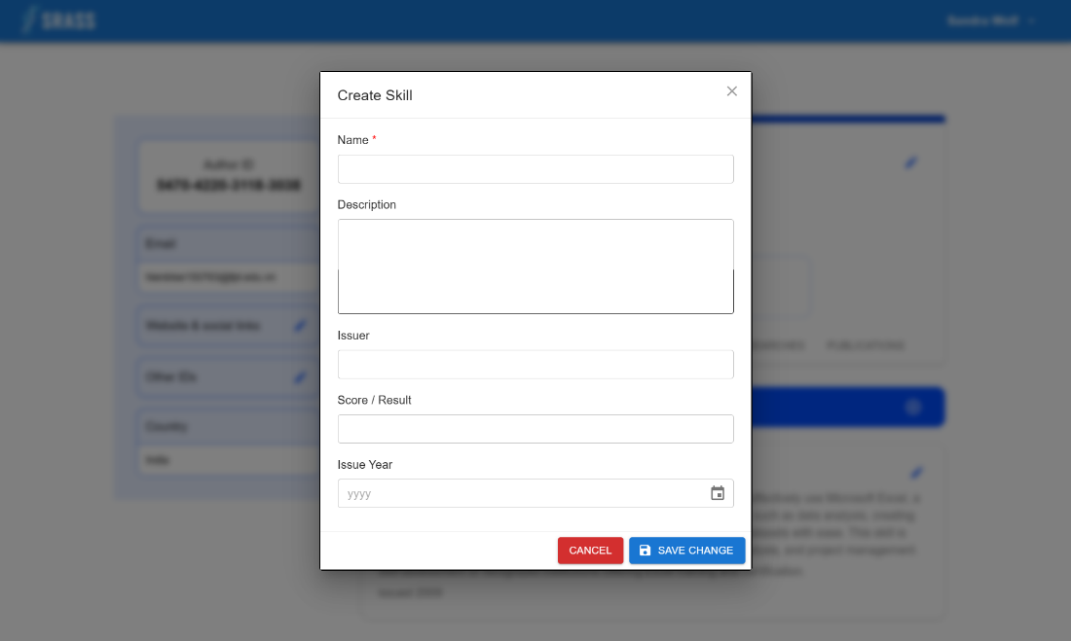 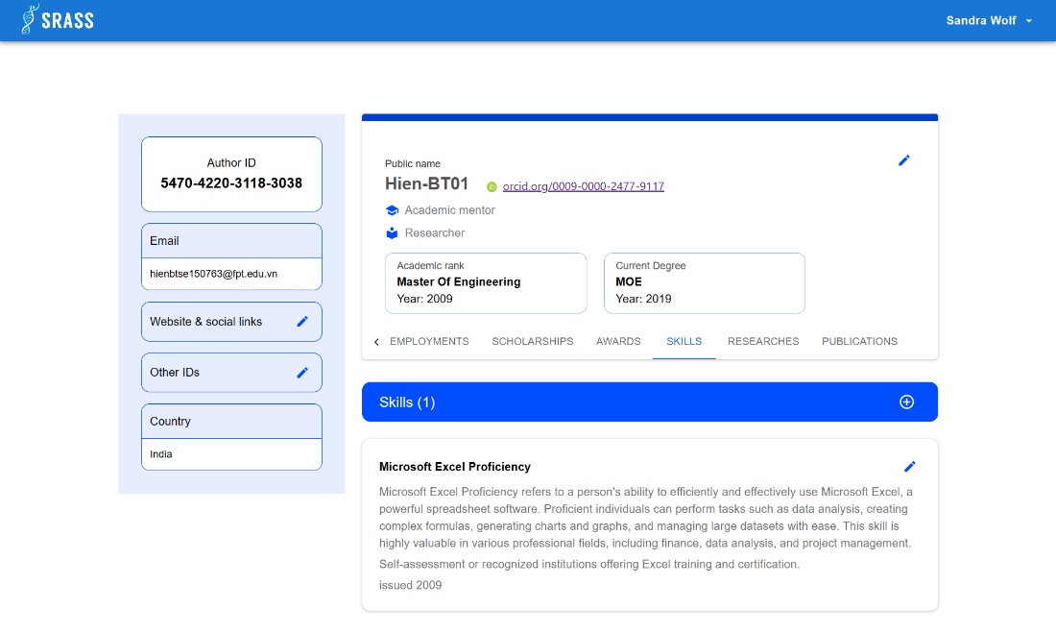

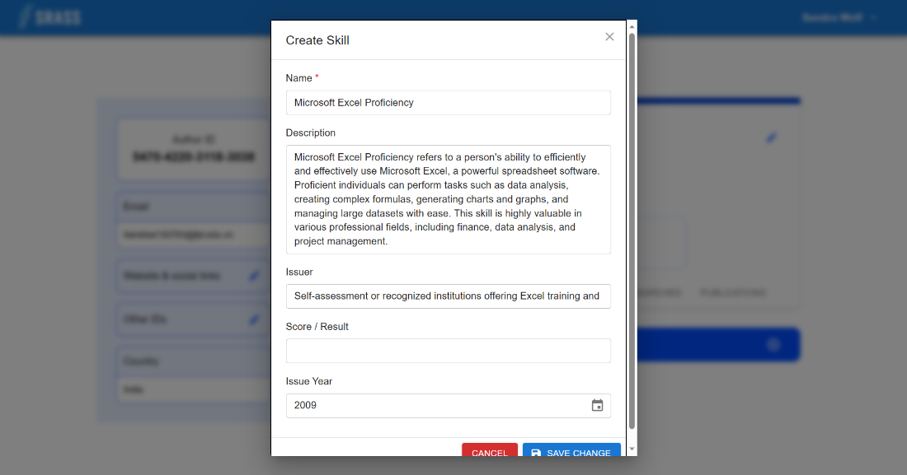

* + This function requires the user to login to the system with the role “**Authenticated User**”.
  + There are two types of information in this screen:
    - The left site:
      * Authenticated user can use id
      * Authenticated user can use their email
      * Authenticated user can view and modify their website & social links
      * Authenticated user can view and modify their other Ids
      * Authenticated user can view country
    - The right site:
      * The top (Academic profile):
        + Authenticated user can view and modify:

Public Name (required)

Orcid (required)

Scientist title (required)

Admin position function (required)

Academic rank (required)

Year of academic rank (required)

Current Degree (required)

Year of Current Degree (required)

Also Known as

* + - * The bottom (Skills):
        + Authenticated user can view and modify:

Name (required)

Description

Issuer

Issue Year

#### 3.2.79 <Lecturer> Profile Researches

* + **Function trigger:** Authenticated User clicks on ”RESEARCHES” tab in “Scientist Profile” page
  + **Function description:** Authenticated User can manage the “Lecturer Researcher Profile “ researches information
  + **Screen layout:**

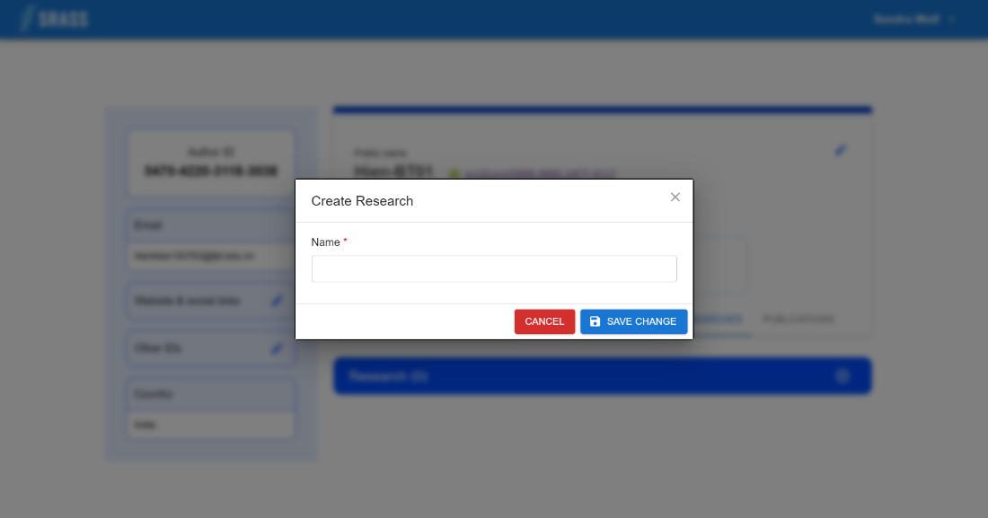 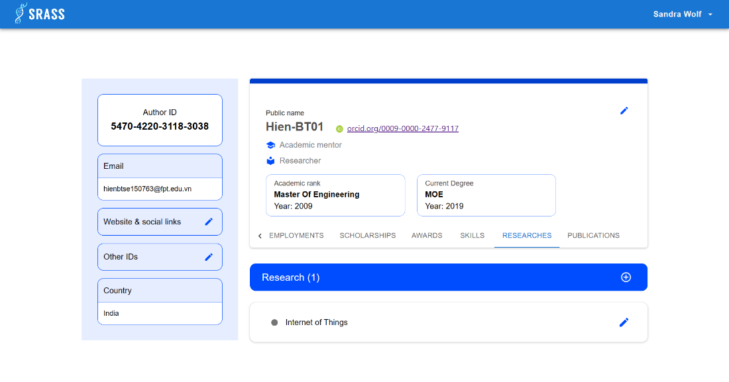

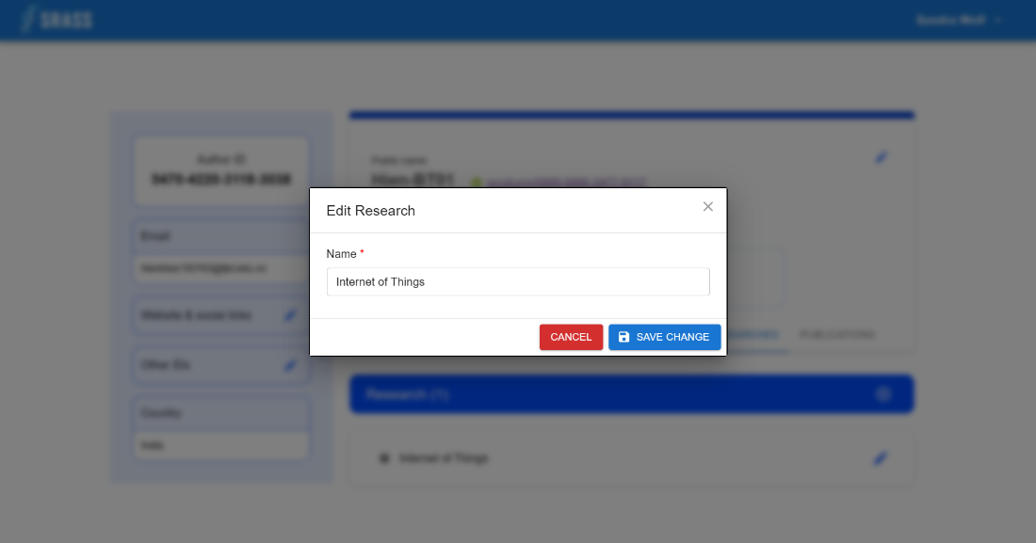

* + This function requires the user to login to the system with the role “**Authenticated User**”.
  + There are two types of information in this screen:
    - The left site:
      * Authenticated user can use id
      * Authenticated user can use their email
      * Authenticated user can view and modify their website & social links
      * Authenticated user can view and modify their other Ids
      * Authenticated user can view country
    - The right site:
      * The top (Academic profile):
        + Authenticated user can view and modify:

Public Name (required)

Orcid (required)

Scientist title (required)

Admin position function (required)

Academic rank (required)

Year of academic rank (required)

Current Degree (required)

Year of Current Degree (required)

Also Known as

* + - * The bottom (Researches):
        + Authenticated user can view and modify:

Name (required)

#### 3.2.80 <Lecturer> Profile Publications

* + **Function trigger:** Authenticated User clicks on ”PUBLICATIONS” tab in “Scientist Profile” page
  + **Function description:** Authenticated User can manage the “Lecturer Researcher Profile“ publications information
  + **Screen layout:**

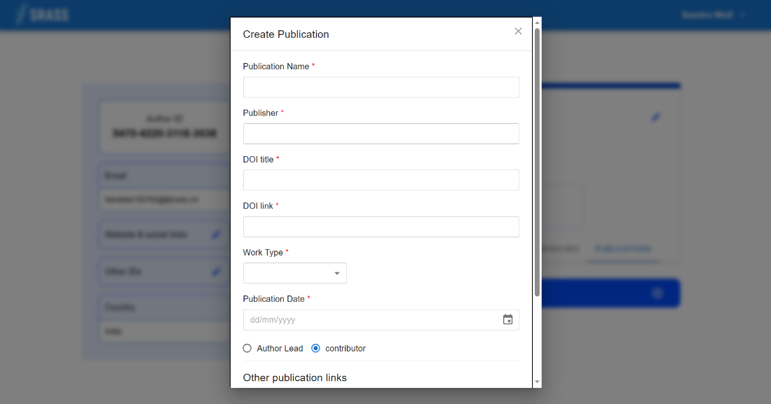

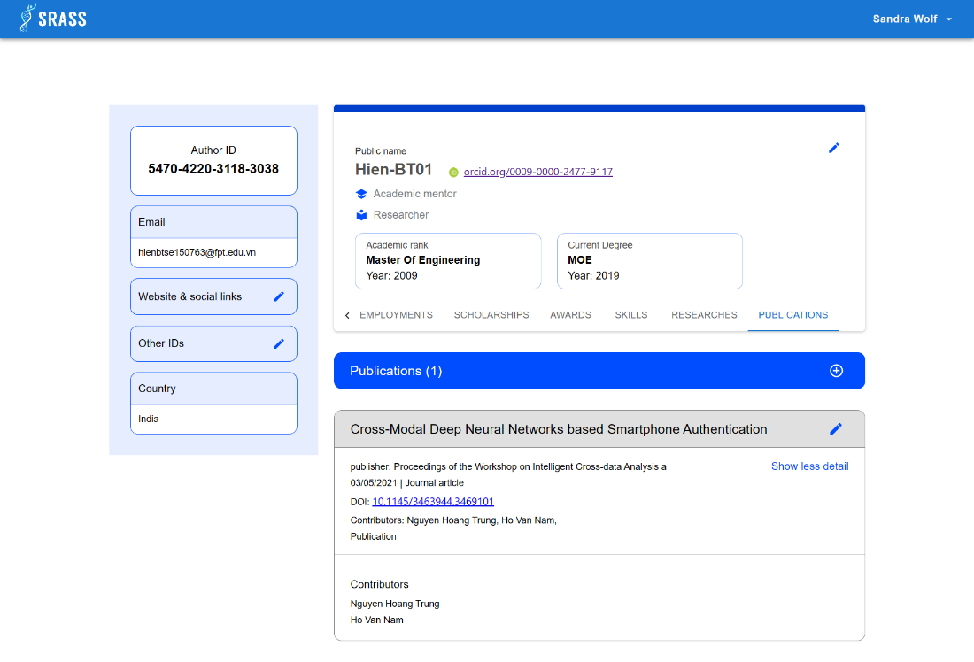

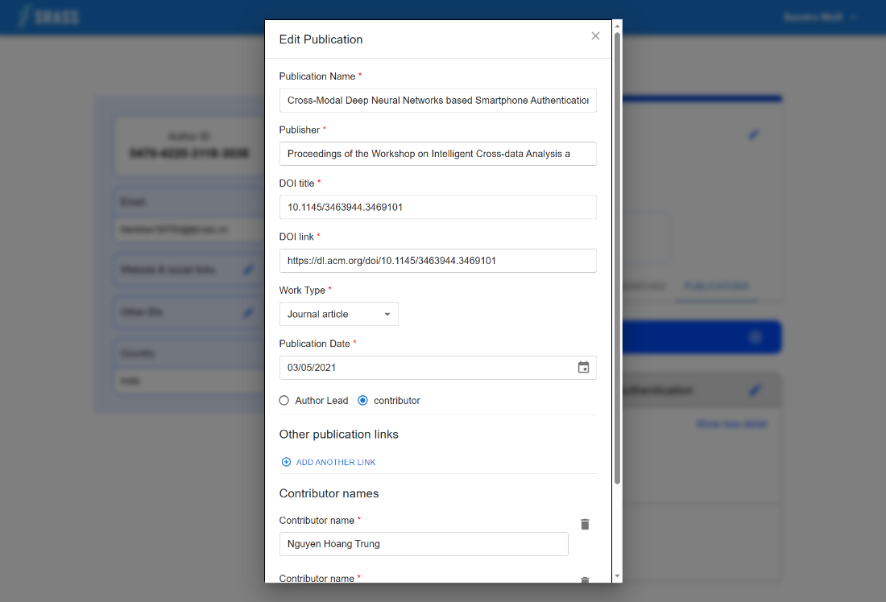

* + This function requires the user to login to the system with the role “**Authenticated User**”.
  + There are two types of information in this screen:
    - The left site:
      * Authenticated user can use id
      * Authenticated user can use their email
      * Authenticated user can view and modify their website & social links
      * Authenticated user can view and modify their other Ids
      * Authenticated user can view country
    - The right site:
      * The top (Academic profile):
        + Authenticated user can view and modify:

Public Name (required)

Orcid (required)

Scientist title (required)

Admin position function (required)

Academic rank (required)

Year of academic rank (required)

Current Degree (required)

Year of Current Degree (required)

Also Known as

* + - * The bottom (Publications):
        + Authenticated user can view and modify

Publication Name (required)

Publisher (required)

DOI title (required)

DOI link (required)

Work type (required)

Publication date (required)

Author lead / contributor

Other publication links

Contributor names (required)

## 4. Non-Functional Requirements

**4.1 External Interfaces**

**4.1.1 User Interfaces**

* UI-1: The language used in the application is English.
* UI-2: The system will notify the user through a snackbar whenever an error occurs.

**4.1.2 Communications Interfaces**

* CI-1: HTTP ver1.1 Protocol is used for communication between web browsers and servers.

**4.2 Quality Attributes**

**4.2.1 Usability**

* The language for all users is English.
* SRASS will need less than two days of training for PC Chair and Admin to use.
* Authors and reviewers can easily utilize SRASS with minimal guidance, requiring less than 30 minutes to become proficient in its operation.

**4.2.2 Security**

* SRASS is segmented into four distinct roles: PC Chair, Admin, Author, and Reviewer. Each role is restricted to accessing and using only the specific set of functions allocated to it.
* Before any data is saved to the database, it is imperative that validation procedures are applied to ensure its accuracy and integrity.
* The system consistently performs authorization and authentication checks before executing any functionality.
* Employing SHA-256 as the hashing algorithm for password encryption.

**4.2.3 Maintainability**

* SRASS has been divided into various components and modules, which will facilitate future maintenance efforts and enhance overall system manageability.
* Having clear code conventions significantly contributes to making source code both readable and maintainable.

## 5. Requirement Appendix

### 5.1 Business Rules

| **ID** | **Rule Definition** |
| --- | --- |
| BR-01 | Email confirmation is required to fulfill sign-up activity |
| BR-02 | The program committee monitors a conference's status and progress based on information of the approved conference plan included in the system. |
| BR-03 | The conference final report file will be ready when the conference ends |
| BR-04 | Each conference has at least 1 track or multiple tracks |
| BR-05 | Chair can delete a track if the track does not have any related incumbents |
| BR-06 | Every track needs to define a track plan before progressing to the call for papers phase. The number of revisions needs to be predefined and CANNOT be changed after confirmation. The order of deadlines list CANNOT be changed also |
| BR-07 | An activity deadline can be extended any time until 1 day before the current deadline. The new deadline value CANNOT exceed the next upcoming deadline. Once a deadline has passed, the user CANNOT extend the activity deadline. |
| BR-08 | An activity deadline can be explicitly marked as complete before the deadline. |
| BR-09 | PC chair can delete a subject area if it is not involved with any submissions |
| BR-10 | Authors can only submit a paper when the conference is open for submission. But PC chair can submit a paper on behalf of the authors when necessary, even when the conference has completed the [Open for submissions] phase. |
| BR-11 | Conflicts of interest in the system are a predefined set of the following cases: + Is an author/co-author + Is a relative or a friend + Is/Was a Primary Thesis Advisor at any time + Is/Was a colleague (in last 2 years) + Is/Was a collaborator (in last 2 years) + Has (a) domain conflicts |
| BR-12 | After notifying the result to authors, papers in one of the following statuses CANNOT be changed to any other paper status: - Desk Reject - Accept - Reject The [Revision] notified status implies that their revised version can be submitted when the conference progresses to the revision submission phase. The [Awaiting decision] notified status implies that the papers have not been decided yet and can be changed to another status on the decision marking phase by PC chairs. |
| BR-13 | To support PC chairs in assigning reviewers to submissions, the reviewer is arranged in descending order of recommendation level. The basic idea for the arrangement follows the algorithm specified at [ALG-02]. |
| BR-14 | To ensure the quality of the conference papers evaluation, the reviews of each conference should be checked by the algorithm specified at [ALG-03] to detect potential review issues. |
| BR-15 | The corresponding author of a qualified paper needs to register their paper to the list of expected-to-be-in-the-conference-proceeding manuscripts |
| BR-16 | The corresponding author can submit the presentation and specify presenters for the paper if the paper is qualified to be published and make a presentation at the conference. |
| BR-17 | The conference management general procedure summarizes important activities specified in the [Common Requirements] section |
| BR-18 | The system only allows a user to create a profile if they have the registered email with the domain [fe.edu.vn] |

### 5.2 Common Requirements

*The Common Requirements below are the original copies copied from the content of the business side.

| STT | QUY TRÌNH | MÔ TẢ |
| --- | --- | --- |
| 1 | Quản lý tài khoản người dùng | Người dùng cần sử dụng địa chỉ email để xác thực tài khoản thông qua email. |
| 2 | Theo dõi và điều phối các hoạt động nộp bài tham gia hội nghị | 1. Ban chuyên môn hội nghị khoa học đưa những thông tin liên quan từ kế hoạch tổ chức hội nghị đã có vào hệ thống để theo dõi.  2. Hệ thống hỗ trợ việc tiếp nhận bài tham gia hội nghị, theo dõi và cập nhật trạng thái tương ứng với kết quả từ quy trình nộp, đánh giá và ra quyết định với những bài báo tham gia hội nghị.  3. Hỗ trợ việc tổng hợp thông tin liên quan đến hoạt động nộp bài, đánh giá và ra quyết định với những bài báo tham gia hội nghị. |
| 3 | Thu thập, tổng hợp và lưu trữ các bài báo hội nghị dự kiến được đưa vào kỷ yếu hội nghị | 1. Hệ thống tiếp nhận và lưu trữ những bài báo hội nghị đủ điều kiện và được yêu cầu nộp bản thảo chỉnh sửa (camera-ready).  2. Tác giả nộp bài (corressponding author) của những bài báo được chấp nhận thực hiện đóng tiền phí hội nghị để bản thảo được đưa vào kỷ yếu hội nghị.  3. Đối với những bài báo tham gia hội nghị đủ điều kiện được công bố trong hội nghị, hệ thống hỗ trợ tiếp nhận tài liệu thuyết trình và danh sách diễn giả cho từng bài. |
| 4 | (**) Quản lý hồ sơ lý lịch nghiên cứu khoa học của giảng viên trường Đại học FPT Hồ Chí Minh | 1. Giảng viên trường Đại học FPT Hồ Chí Minh tạo lập Lý lịch khoa học trên hệ thống.  2. Giảng viên trường Đại học FPT Hồ Chí Minh quản lý và cập nhật Lý lịch khoa học của mình khi có nhu cầu, đặc biệt là công bố khoa học. |
| 5 | (**) Hỗ trợ tạo lập trang thông tin cho các hội nghị khoa học | Hệ thống hỗ trợ tạo lập website hội nghị khoa học để hiển thị công khai thông tin hội nghị. |
| 6 | Những ràng buộc liên quan | + Mỗi hội nghị một hoặc nhiều tiểu ban.  + Mỗi tiểu ban của hội nghị sẽ có bản tiến độ các công việc riêng biệt tuy nhiên thời hạn cho các công việc này không được vượt quá thời điểm hội nghị kết thúc |

**5.3 Algorithms**

**ALG-01: Subject Area Relevance Score Calculation**

Subject Area Relevance Score takes into account overlap between subject areas (primary, secondary) provided by reviewers and authors for their papers as follows. Higher values of relevance denote a better match between a reviewer and a paper. There are 4 cases of subject area overlap we considered:

* Paper and reviewer exact match on Primary: pp (1 if match, 0 otherwise)
* Primary subject area of reviewer matches secondary subject area of paper: ps (1 if match, 0 otherwise)
* Primary subject area of paper matches secondary subject area of reviewer: sp (1 if match, 0 otherwise)
* Secondary subject area of reviewer overlaps with secondary subject area of paper: ss is calculated by the formula:

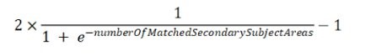

The PC Chairs can configure the factor for each case, denoted as F(case).

The general formula for calculating a subject area relevance score is as follows:



By default,

F(pp) = 0.80, F(sp) = 0.16, F(ps) = 0.16, F(ss) = 0.04

Default Relevance Formula is

0.80pp + 0.16ps + 0.16sp + 0.04ss

**ALG-02: Reviewer Suggestion Ranking Algorithm**

When dealing with each submission,

Arrange the reviewers in descending order of groups (a higher group index indicates stronger recommendations). Reviewers are categorized based on the following evaluation criteria:

* Group 1: Reviewers with conflicts (either submission conflict or reviewer conflict) related to the submission and are already at or over their assigned quota.
* Group 2: Reviewers with conflicts (either submission conflict or reviewer conflict) related to the submission but still have quota available (their assigned submissions are less than the reviewer quota).
* Group 3: Reviewers without any conflicts (neither submission conflict nor reviewer conflict) related to the submission and have a remaining quota.

Within each group, further sort the reviewers in ascending order based on their subject area relevance scores (calculated by the formula at ALG-01). This implies that the higher relevance scores indicate stronger recommendations

**ALG-03: Review Issues Detection Algorithm**

Review issues detection algorithm is based on the following statements from customers:

“If the percentage of reviews having the average evaluation score below the predefined threshold for average evaluation score is greater than the predefined warning threshold percentage then the conference is believed to have issues about reviewing.”

In order to make it clearer, we denote:

* the predefined threshold for evaluation average score is Xthreshold_evaluation_score
* The predefined warning threshold for percentage is Ythreshold_percentage
* The domain of Xthreshold_evaluation_score is: 0 <= Xthreshold_evaluation_score < 100
* The domain of Ythreshold_percentage is: 0 < Ythreshold_percentage <= 100

For each conference, we denote:

* The evaluation average score of a review in a conference is denoted by x
* The number of reviews in a conference fulfill a condition is denoted as a function F(condition)

Then the statement can be stated that:

A conference is believed to have issues of reviewing if we found that:

F(x < Xthreshold_evaluation_score) / F(x) * 100 > Ythreshold_percentage

**5.4 General Procedure**

